Objective
This variant combines FFT high-pass filtering with a spectral cutoff chosen by Binary Segmentation (BinSeg) on the power spectrum.
We will: - Load and visualize a simple anomaly dataset - Configure and run hanr_fft_binseg - Inspect detections, evaluate, and plot residual magnitudes and thresholds

Method at a glance
FFT Binseg regression anomaly detection: FFT-based high-pass filtering with a cutoff selected via Binary Segmentation on the power spectrum. Frequencies below the detected spectral changepoint are suppressed; anomalies are flagged from the residual magnitude and thresholded using harutils().

What you will do
- understand the purpose of the example and when the technique is useful
- follow the workflow from data loading to model fitting and detection
- inspect the evaluation outputs and the diagnostic plots produced by Harbinger

Walkthrough
# Install Harbinger (if needed)
#install.packages("harbinger")
# Load required packages
library(daltoolbox)
library(harbinger)
# Load example anomaly datasets
data(examples_anomalies)
# Select a simple anomaly dataset
dataset <- examples_anomalies$simple
head(dataset)
## serie event
## 1 1.0000000 FALSE
## 2 0.9689124 FALSE
## 3 0.8775826 FALSE
## 4 0.7316889 FALSE
## 5 0.5403023 FALSE
## 6 0.3153224 FALSE
# Plot the raw time series
har_plot(harbinger(), dataset$serie)
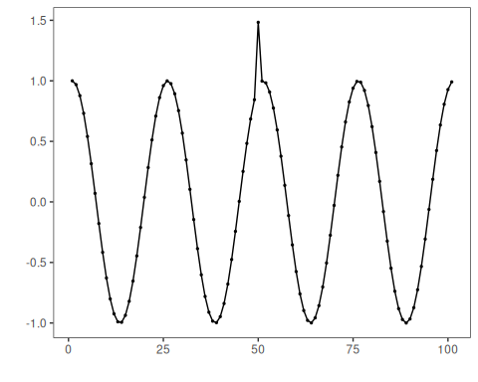
# Configure the FFT+BinSeg detector
model <- hanr_fft_binseg()
# Fit the detector
model <- fit(model, dataset$serie)
# Run detection
detection <- detect(model, dataset$serie)
# Show detected anomaly indices
print(detection |> dplyr::filter(event == TRUE))
## idx event type
## 1 50 TRUE anomaly
# Evaluate detections against labels
evaluation <- evaluate(model, detection$event, dataset$event)
print(evaluation$confMatrix)
## event
## detection TRUE FALSE
## TRUE 1 0
## FALSE 0 100
# Plot detections vs. ground truth
har_plot(model, dataset$serie, detection, dataset$event)
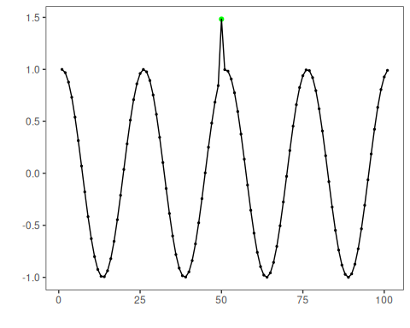
# Plot residual magnitude and decision thresholds
har_plot(model, attr(detection, "res"), detection, dataset$event, yline = attr(detection, "threshold"))
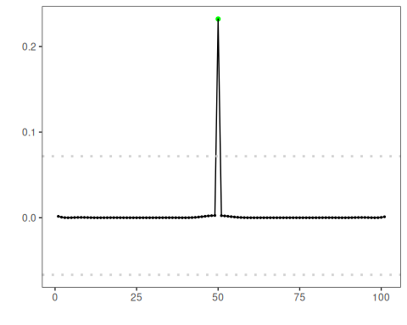

References
- Sobrinho, E. P., et al. Fine-Tuning Detection Criteria for Enhancing Anomaly Detection in Time Series. SBBD, 2025. doi:10.5753/sbbd.2025.247063

