Objective
This variant adapts a moving average window from the dominant frequency (FFT) to smooth the series, then flags large deviations of the high-frequency component. Steps:
- Load and visualize a simple anomaly dataset
- Configure and run hanr_fft_sma
- Inspect detections, evaluate, and plot residual magnitudes and thresholds

Method at a glance
FFT SMA regression anomaly detection: Adaptive FFT + moving average: estimates a dominant frequency from the spectrum to set the smoothing window, computes residuals (original minus smoothed), and flags large residuals as anomalies with harutils() thresholding.

What you will do
- understand the purpose of the example and when the technique is useful
- follow the workflow from data loading to model fitting and detection
- inspect the evaluation outputs and the diagnostic plots produced by Harbinger

Walkthrough
# Install Harbinger (if needed)
#install.packages("harbinger")
# Load required packages
library(daltoolbox)
library(harbinger)
# Load example anomaly datasets
data(examples_anomalies)
# Select a simple anomaly dataset
dataset <- examples_anomalies$simple
head(dataset)
## serie event
## 1 1.0000000 FALSE
## 2 0.9689124 FALSE
## 3 0.8775826 FALSE
## 4 0.7316889 FALSE
## 5 0.5403023 FALSE
## 6 0.3153224 FALSE
# Plot the raw time series
har_plot(harbinger(), dataset$serie)
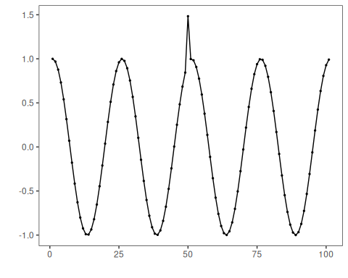
# Configure the FFT+SMA detector
model <- hanr_fft_sma()
# Fit the detector
model <- fit(model, dataset$serie)
# Run detection
detection <- detect(model, dataset$serie)
## Warning in serie - ts_sma: longer object length is not a multiple of shorter object length
# Show detected anomaly indices
print(detection |> dplyr::filter(event == TRUE))
## idx event type
## 1 50 TRUE anomaly
# Evaluate detections against labels
evaluation <- evaluate(model, detection$event, dataset$event)
print(evaluation$confMatrix)
## event
## detection TRUE FALSE
## TRUE 1 0
## FALSE 0 100
# Plot detections vs. ground truth
har_plot(model, dataset$serie, detection, dataset$event)
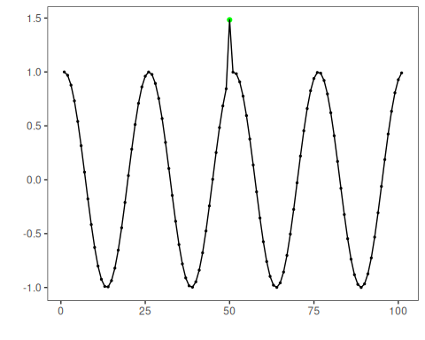
# Plot residual magnitude and decision thresholds
har_plot(model, attr(detection, "res"), detection, dataset$event, yline = attr(detection, "threshold"))
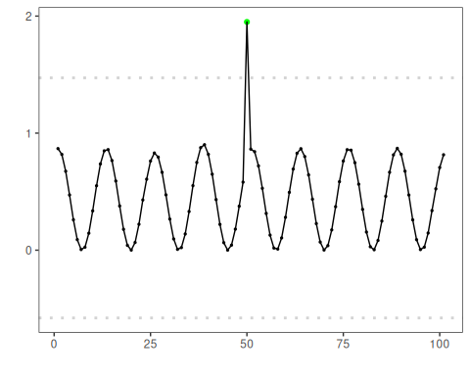

References
- Sobrinho, E. P., et al. Fine-Tuning Detection Criteria for Enhancing Anomaly Detection in Time Series. SBBD, 2025. doi:10.5753/sbbd.2025.247063

