Objective
This notebook demonstrates anomaly detection with hanr_histogram(). The goal is to show how a simple histogram-based density rule can flag rare observations without fitting a forecasting model.

Method at a glance
hanr_histogram() builds a histogram of the observed values and labels points as anomalies when they fall into low-density bins or outside the observed bin range. It is a useful baseline because it focuses only on the empirical distribution of the series.

What you will do
- load a labeled anomaly dataset from Harbinger
- inspect the raw series before modeling
- configure the histogram detector and run detection
- compare the detected events with the ground truth
- visualize the result with har_plot()

Walkthrough
# Install Harbinger (if needed)
#install.packages("harbinger")
# Load required packages
library(daltoolbox)
library(harbinger)
# Load example anomaly datasets
data(examples_anomalies)
# Select a simple anomaly dataset
dataset <- examples_anomalies$simple
head(dataset)
## serie event
## 1 1.0000000 FALSE
## 2 0.9689124 FALSE
## 3 0.8775826 FALSE
## 4 0.7316889 FALSE
## 5 0.5403023 FALSE
## 6 0.3153224 FALSE
# Plot the raw time series
har_plot(harbinger(), dataset$serie, event = dataset$event)
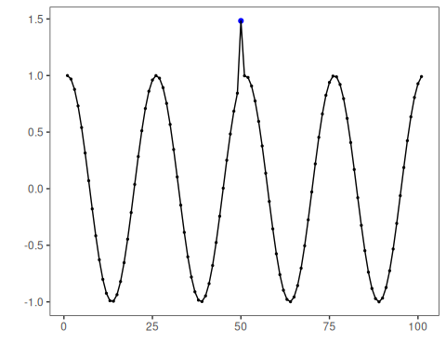
# Configure the histogram-based anomaly detector
# The density threshold controls how rare a bin must be to trigger an anomaly
model <- hanr_histogram(density_threshold = 0.05)
# Fit is a no-op here, but keeping the same workflow is useful for comparison
model <- fit(model, dataset$serie)
# Run detection
detection <- detect(model, dataset$serie)
# Show the detected anomaly indices
print(detection |> dplyr::filter(event == TRUE))
## idx event type
## 1 1 TRUE anomaly
## 2 50 TRUE anomaly
# Evaluate detections against the labeled events
evaluation <- evaluate(model, detection$event, dataset$event)
print(evaluation$confMatrix)
## event
## detection TRUE FALSE
## TRUE 1 1
## FALSE 0 99
# Plot detections and ground truth on the same series
har_plot(model, dataset$serie, detection, dataset$event)
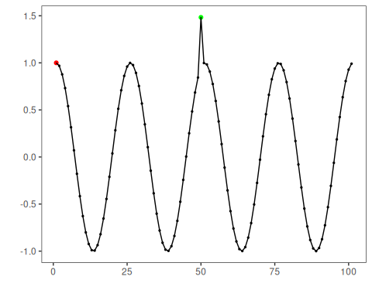

References
- Ogasawara, E., Salles, R., Porto, F., Pacitti, E. Event Detection in Time Series. Springer, 2025. doi:10.1007/978-3-031-75941-3

