Objective
REMD combines EMD-based decomposition with ARIMA modeling on the high-frequency component to detect anomalies.
In this tutorial we: - Load and visualize a simple anomaly dataset - Configure and run the REMD detector (hanr_remd) - Inspect detections, evaluate, and plot residual magnitudes

Method at a glance
REMD regression anomaly detection: REMD combines Empirical Mode Decomposition with ARIMA modeling: IMFs capture nonstationary structure and ARIMA models residual dynamics. Large residual magnitudes signal anomalies and are thresholded via harutils().

What you will do
- understand the purpose of the example and when the technique is useful
- follow the workflow from data loading to model fitting and detection
- inspect the evaluation outputs and the diagnostic plots produced by Harbinger

Walkthrough
# Install Harbinger (if needed)
#install.packages("harbinger")
# Load required packages
library(daltoolbox)
library(harbinger)
# Load example anomaly datasets
data(examples_anomalies)
# Select a simple anomaly dataset
dataset <- examples_anomalies$simple
head(dataset)
## serie event
## 1 1.0000000 FALSE
## 2 0.9689124 FALSE
## 3 0.8775826 FALSE
## 4 0.7316889 FALSE
## 5 0.5403023 FALSE
## 6 0.3153224 FALSE
# Plot the raw time series
har_plot(harbinger(), dataset$serie)
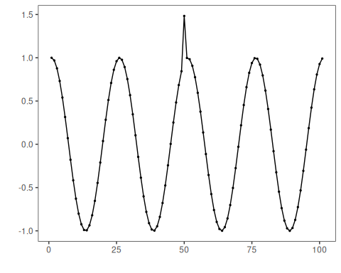
# Configure the REMD detector
model <- hanr_remd()
# Fit the detector
model <- fit(model, dataset$serie)
# Run detection
detection <- detect(model, dataset$serie)
# Show detected anomaly indices
print(detection |> dplyr::filter(event == TRUE))
## idx event type
## 1 51 TRUE anomaly
## 2 53 TRUE anomaly
# Evaluate detections against labels
evaluation <- evaluate(model, detection$event, dataset$event)
print(evaluation$confMatrix)
## event
## detection TRUE FALSE
## TRUE 0 2
## FALSE 1 98
# Plot detections vs. ground truth
har_plot(model, dataset$serie, detection, dataset$event)
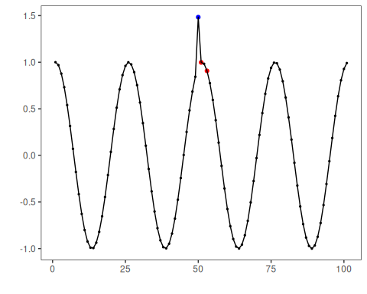
# Plot residual magnitude and decision thresholds
har_plot(model, attr(detection, "res"), detection, dataset$event, yline = attr(detection, "threshold"))
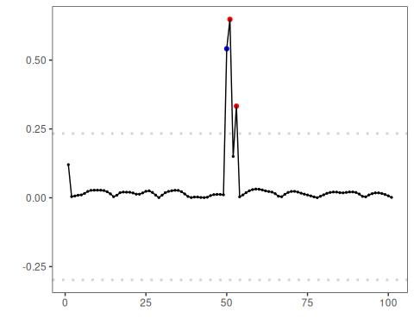

References
- Souza, J., et al. REMD: A Novel Hybrid Anomaly Detection Method Based on EMD and ARIMA. IJCNN, 2024. doi:10.1109/IJCNN60899.2024.10651192

