Objective
This Rmd applies the Residual Error-based Detector (hanr_rt) to identify anomalies in a univariate time series. The pipeline fits a baseline model, scores residuals, and flags points exceeding an adaptive threshold. Steps: load packages/data, visualize, define and fit the model, detect, evaluate, and plot results and residuals.

Method at a glance
RTAD regression anomaly detector: RTAD adapts to local dynamics using EMD-derived components and robust dispersion within sliding windows. Points with large deviations relative to the modeled behavior are flagged as anomalies; thresholds use harutils().

What you will do
- understand the purpose of the example and when the technique is useful
- follow the workflow from data loading to model fitting and detection
- inspect the evaluation outputs and the diagnostic plots produced by Harbinger

Walkthrough
# Install Harbinger (only once, if needed)
#install.packages("harbinger")
# Load required packages
library(daltoolbox)
library(harbinger)
# Load example datasets bundled with harbinger
data(examples_anomalies)
# Select a simple synthetic time series with labeled anomalies
dataset <- examples_anomalies$simple
head(dataset)
## serie event
## 1 1.0000000 FALSE
## 2 0.9689124 FALSE
## 3 0.8775826 FALSE
## 4 0.7316889 FALSE
## 5 0.5403023 FALSE
## 6 0.3153224 FALSE
# Plot the time series
har_plot(harbinger(), dataset$serie)
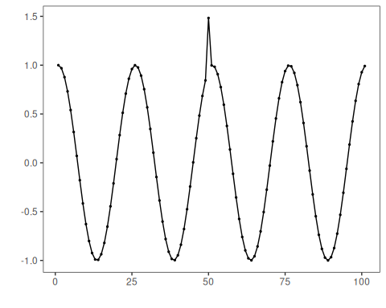
# Define Residual Error-based Detector (hanr_rt)
model <- hanr_rtad()
# Fit the model
model <- fit(model, dataset$serie)
# Detect anomalies (compute residuals and events)
detection <- detect(model, dataset$serie)
# Show only timestamps flagged as events
print(detection |> dplyr::filter(event==TRUE))
## idx event type
## 1 50 TRUE anomaly
# Evaluate detections against ground-truth labels
evaluation <- evaluate(model, detection$event, dataset$event)
print(evaluation$confMatrix)
## event
## detection TRUE FALSE
## TRUE 1 0
## FALSE 0 100
# Plot detections over the series
har_plot(model, dataset$serie, detection, dataset$event)
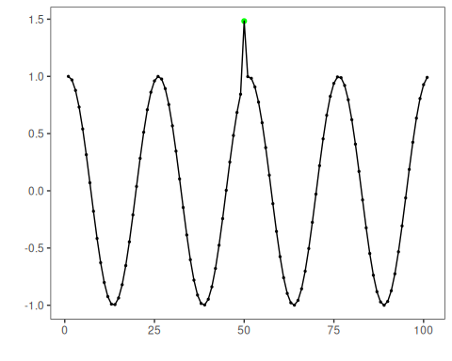
# Plot residual scores and threshold
har_plot(model, attr(detection, "res"), detection, dataset$event, yline = attr(detection, "threshold"))
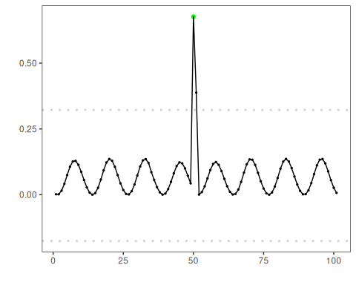

References
- Ogasawara, E., Salles, R., Porto, F., Pacitti, E. Event Detection in Time Series. Springer, 2025. doi:10.1007/978-3-031-75941-3

