Objective
The wavelet-based detector decomposes the series into multi-resolution detail bands (MODWT) and flags large aggregated high-frequency energy as anomalies. Steps:
- Load and visualize a simple anomaly dataset
- Configure and run hanr_wavelet
- Inspect detections, evaluate, and plot residual magnitudes and thresholds

Method at a glance
Wavelet regression anomaly detection: Multi-resolution analysis via MODWT wavelet decomposition; detail coefficients are aggregated to form a magnitude signal. Large localized energy indicates anomalies, with thresholding via harutils().

What you will do
- understand the purpose of the example and when the technique is useful
- follow the workflow from data loading to model fitting and detection
- inspect the evaluation outputs and the diagnostic plots produced by Harbinger

Walkthrough
# Install Harbinger (if needed)
#install.packages("harbinger")
# Load required packages
library(daltoolbox)
library(harbinger)
# Load example anomaly datasets
data(examples_anomalies)
# Select a simple anomaly dataset
dataset <- examples_anomalies$simple
head(dataset)
## serie event
## 1 1.0000000 FALSE
## 2 0.9689124 FALSE
## 3 0.8775826 FALSE
## 4 0.7316889 FALSE
## 5 0.5403023 FALSE
## 6 0.3153224 FALSE
# Plot the raw time series
har_plot(harbinger(), dataset$serie)
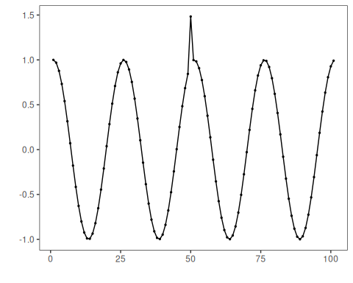
# Configure the wavelet-based detector
model <- hanr_wavelet()
# Fit the detector
model <- fit(model, dataset$serie)
# Run detection
detection <- detect(model, dataset$serie)
# Show detected anomaly indices
print(detection |> dplyr::filter(event == TRUE))
## idx event type
## 1 50 TRUE anomaly
# Evaluate detections against labels
evaluation <- evaluate(model, detection$event, dataset$event)
print(evaluation$confMatrix)
## event
## detection TRUE FALSE
## TRUE 1 0
## FALSE 0 100
# Plot detections vs. ground truth
har_plot(model, dataset$serie, detection, dataset$event)
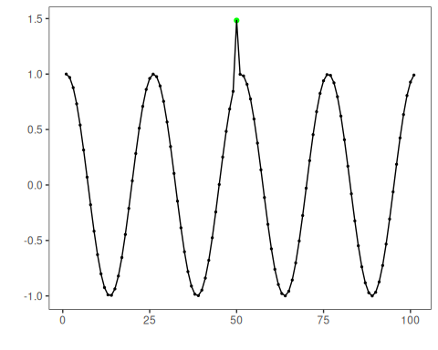
# Plot residual magnitude and decision thresholds
har_plot(model, attr(detection, "res"), detection, dataset$event, yline = attr(detection, "threshold"))
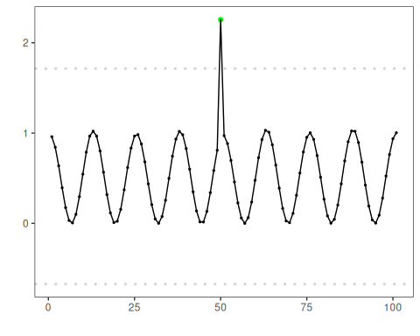

References
- Mallat, S. (1989). A theory for multiresolution signal decomposition: The wavelet representation. IEEE TPAMI, 11(7), 674–693.

