Objective
Binary Segmentation (BinSeg) recursively identifies multiple change points by splitting the series at the strongest change and repeating. In this tutorial we will:
- Load a dataset with change points and visualize it
- Configure and run the BinSeg detector (hcp_binseg)
- Inspect detections and evaluate against ground truth
- Plot the detections on the series

Method at a glance
BinSeg: Binary Segmentation recursively partitions the series around the largest detected change until a maximum number of change points or a stopping criterion is met. It is a fast heuristic widely used in practice. Harbinger wraps the changepoint implementation and returns detected indices with plotting and evaluation utilities.

What you will do
- understand the purpose of the example and when the technique is useful
- follow the workflow from data loading to model fitting and detection
- inspect the evaluation outputs and the diagnostic plots produced by Harbinger

Walkthrough
# Install Harbinger (if needed)
#install.packages("harbinger")
# Load required packages
library(daltoolbox)
library(harbinger)
# Load example change-point datasets
data(examples_changepoints)
# Select a dataset ("complex" contains multiple regimes)
dataset <- examples_changepoints$complex
head(dataset)
## serie event
## 1 0.3129618 FALSE
## 2 0.5944808 FALSE
## 3 0.8162731 FALSE
## 4 0.9560557 FALSE
## 5 0.9997847 FALSE
## 6 0.9430667 FALSE
# Plot the time series to visualize regimes
har_plot(harbinger(), dataset$serie)
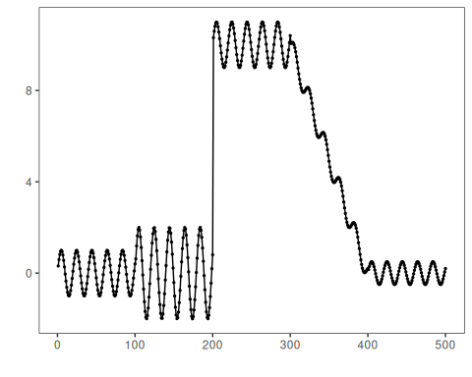
# Configure BinSeg; Q is the max number of change points to search
model <- hcp_binseg(Q = 10)
# Fit the detector (keeps parameters on object)
model <- fit(model, dataset$serie)
# Run detection over the series
detection <- detect(model, dataset$serie)
# Show detected change-point indices
print(detection |> dplyr::filter(event == TRUE))
## idx event type
## 1 101 TRUE changepoint
## 2 200 TRUE changepoint
## 3 312 TRUE changepoint
## 4 327 TRUE changepoint
## 5 349 TRUE changepoint
## 6 368 TRUE changepoint
## 7 389 TRUE changepoint
# Evaluate detections against labeled events
evaluation <- evaluate(model, detection$event, dataset$event)
print(evaluation$confMatrix)
## event
## detection TRUE FALSE
## TRUE 1 6
## FALSE 3 490
# Plot detections and ground truth
har_plot(model, dataset$serie, detection, dataset$event)
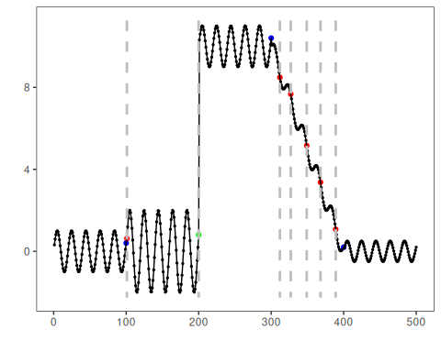

References
- Vostrikova, L. (1981). Detecting “disorder” in multidimensional random processes. Soviet Mathematics Doklady, 24, 55–59.
- Killick, R., Fearnhead, P., Eckley, I. A. (2012). Optimal detection of changepoints with a linear computational cost. Journal of the American Statistical Association, 107(500), 1590–1598.

