Objective
ChangeFinder-ARIMA detects change points by modeling residual deviations and smoothing them over a sliding window. In this tutorial we will:
- Load and visualize a simple change-point dataset
- Configure the ChangeFinder-ARIMA detector with a window size
- Inspect detections, evaluate, and plot residuals with thresholds

Method at a glance
ChangeFinder with ARIMA: ChangeFinder with ARIMA models residual deviations and applies a second-stage smoothing/thresholding to highlight structural changes. Implementation wraps ARIMA from forecast and uses harutils() for thresholds.

What you will do
- understand the purpose of the example and when the technique is useful
- follow the workflow from data loading to model fitting and detection
- inspect the evaluation outputs and the diagnostic plots produced by Harbinger

Walkthrough
# Install Harbinger (if needed)
#install.packages("harbinger")
# Load required packages
library(daltoolbox)
library(harbinger)
# Load example change-point datasets
data(examples_changepoints)
# Select the simple dataset
dataset <- examples_changepoints$simple
head(dataset)
## serie event
## 1 0.00 FALSE
## 2 0.25 FALSE
## 3 0.50 FALSE
## 4 0.75 FALSE
## 5 1.00 FALSE
## 6 1.25 FALSE
# Plot the raw time series
har_plot(harbinger(), dataset$serie)
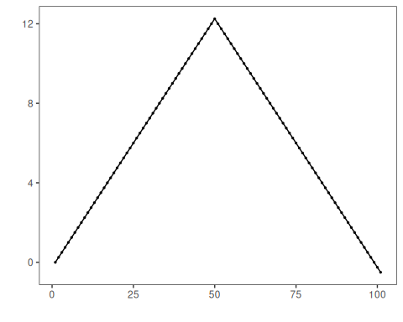
# Configure ChangeFinder-ARIMA (sw_size controls smoothing window)
model <- hcp_cf_arima(sw_size = 10)
# Fit the detector
model <- fit(model, dataset$serie)
# Run detection
detection <- detect(model, dataset$serie)
# Show detected change points
print(detection |> dplyr::filter(event == TRUE))
## idx event type
## 1 51 TRUE anomaly
# Evaluate detections against labels
evaluation <- evaluate(model, detection$event, dataset$event)
print(evaluation$confMatrix)
## event
## detection TRUE FALSE
## TRUE 0 1
## FALSE 1 99
# Plot detections vs. ground truth
har_plot(model, dataset$serie, detection, dataset$event)
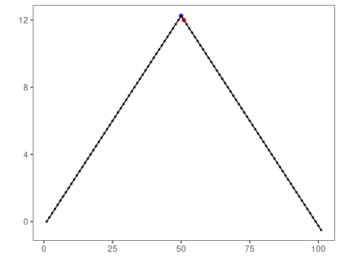
# Plot residual magnitude and decision thresholds
har_plot(model, attr(detection, "res"), detection, dataset$event, yline = attr(detection, "threshold"))
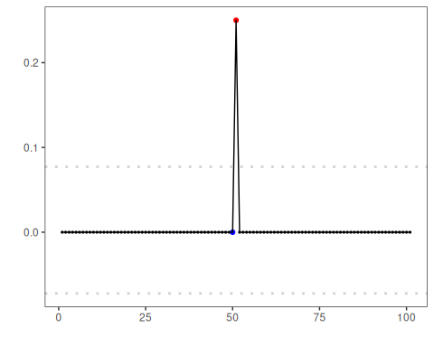

References
- Takeuchi, J., Yamanishi, K. (2006). A unifying framework for detecting outliers and change points from time series. IEEE TKDE. doi:10.1109/TKDE.2006.1599387

