Objective
This notebook demonstrates change-point detection using Conformal Forecasting with a Linear Regression forecaster (hcp_cf_lr). The method scores deviations from short-term predictions and flags structural changes when nonconformity exceeds a learned threshold. Steps: load packages/data, visualize, define model (window size), fit, detect, evaluate, and plot both detections and residuals.

Method at a glance
ChangeFinder with linear regression: ChangeFinder with linear regression models residual deviations and applies a second-stage smoothing/thresholding to expose structural changes. Thresholding is done via harutils().

What you will do
- understand the purpose of the example and when the technique is useful
- follow the workflow from data loading to model fitting and detection
- inspect the evaluation outputs and the diagnostic plots produced by Harbinger

Walkthrough
# Install Harbinger (only once, if needed)
#install.packages("harbinger")
# Load required packages
library(daltoolbox)
library(harbinger)
# Load example datasets bundled with harbinger
data(examples_changepoints)
# Select a simple synthetic time series with labeled change-points
dataset <- examples_changepoints$simple
head(dataset)
## serie event
## 1 0.00 FALSE
## 2 0.25 FALSE
## 3 0.50 FALSE
## 4 0.75 FALSE
## 5 1.00 FALSE
## 6 1.25 FALSE
# Plot the time series
har_plot(harbinger(), dataset$serie)
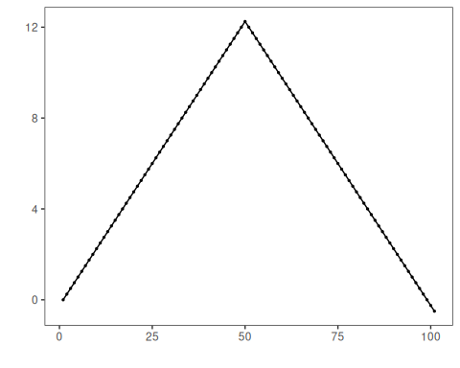
# Define Conformal Forecasting (Linear Regression) change-point model
# - sw_size controls the sliding window length
model <- hcp_cf_lr(sw_size = 10)
# Fit the model
model <- fit(model, dataset$serie)
# Detect change-points
detection <- detect(model, dataset$serie)
# Show only timestamps flagged as events
print(detection |> dplyr::filter(event==TRUE))
## [1] idx event type
## <0 rows> (or 0-length row.names)
# Evaluate detections against ground-truth labels
evaluation <- evaluate(model, detection$event, dataset$event)
print(evaluation$confMatrix)
## event
## detection TRUE FALSE
## TRUE 0 0
## FALSE 1 100
# Plot detections over the series
har_plot(model, dataset$serie, detection, dataset$event)
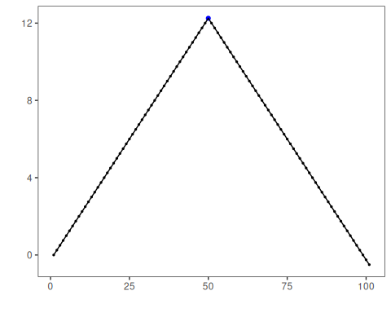
# Plot residual scores and threshold
har_plot(model, attr(detection, "res"), detection, dataset$event, yline = attr(detection, "threshold"))
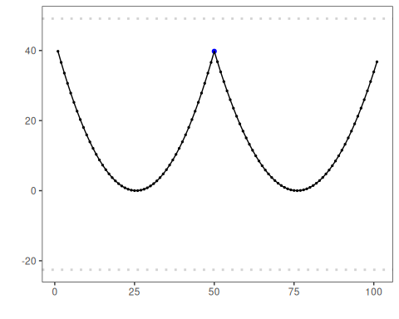

References
- Takeuchi, J., Yamanishi, K. (2006). A unifying framework for detecting outliers and change points from time series. IEEE TKDE. doi:10.1109/TKDE.2006.1599387

