Objective
The Chow-style structural break test estimates a linear model and finds breakpoints using F statistics. In this tutorial we:
- Load and visualize a simple change-point dataset
- Configure the Chow detector (hcp_chow)
- Inspect detections and evaluate against labels

Method at a glance
Chow tests: Chow tests for structural breaks in linear models using F-statistics over candidate breakpoints and returns estimated break locations. Harbinger wraps strucchange F-stats/breakpoints.

What you will do
- understand the purpose of the example and when the technique is useful
- follow the workflow from data loading to model fitting and detection
- inspect the evaluation outputs and the diagnostic plots produced by Harbinger

Walkthrough
# Install Harbinger (if needed)
#install.packages("harbinger")
# Load required packages
library(daltoolbox)
library(harbinger)
# Load example change-point datasets
data(examples_changepoints)
# Select the simple dataset
dataset <- examples_changepoints$simple
head(dataset)
## serie event
## 1 0.00 FALSE
## 2 0.25 FALSE
## 3 0.50 FALSE
## 4 0.75 FALSE
## 5 1.00 FALSE
## 6 1.25 FALSE
# Plot the raw time series
har_plot(harbinger(), dataset$serie)
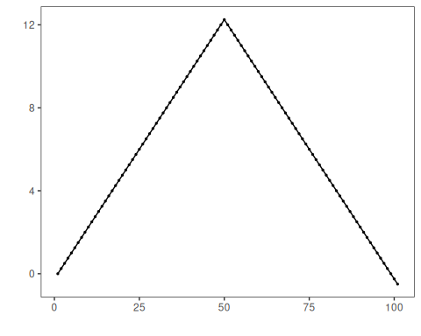
# Configure the Chow detector
model <- hcp_chow()
# Fit the detector (no training required)
model <- fit(model, dataset$serie)
# Run detection
detection <- detect(model, dataset$serie)
# Show detected change points
print(detection |> dplyr::filter(event == TRUE))
## idx event type
## 1 50 TRUE changepoint
# Evaluate detections against labels
evaluation <- evaluate(model, detection$event, dataset$event)
print(evaluation$confMatrix)
## event
## detection TRUE FALSE
## TRUE 1 0
## FALSE 0 100
# Plot detections vs. ground truth
har_plot(model, dataset$serie, detection, dataset$event)
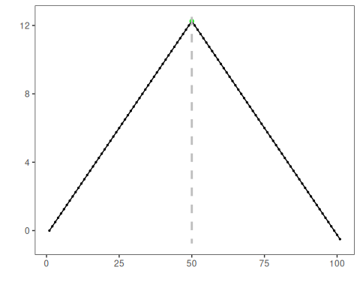

References
- Zeileis, A., Leisch, F., Kleiber, C., Hornik, K. (2002). strucchange: An R package for testing for structural change in linear regression models. Journal of Statistical Software, 7(2). doi:10.18637/jss.v007.i02

