Objective
Generalized Fluctuation Tests (GFT) assess structural changes by examining stability of regression fits across time. In this tutorial we:
- Load and visualize a simple change-point dataset
- Configure and run the GFT-based detector (hcp_gft)
- Inspect detections, evaluate, and plot results

Method at a glance
GFT: Generalized fluctuation tests assess stability of regression parameters over time using strucchange::breakpoints(), returning estimated break dates under information criteria.

What you will do
- understand the purpose of the example and when the technique is useful
- follow the workflow from data loading to model fitting and detection
- inspect the evaluation outputs and the diagnostic plots produced by Harbinger

Walkthrough
# Install Harbinger (if needed)
#install.packages("harbinger")
# Load required packages
library(daltoolbox)
library(harbinger)
# Load example change-point datasets
data(examples_changepoints)
# Select the simple dataset
dataset <- examples_changepoints$simple
head(dataset)
## serie event
## 1 0.00 FALSE
## 2 0.25 FALSE
## 3 0.50 FALSE
## 4 0.75 FALSE
## 5 1.00 FALSE
## 6 1.25 FALSE
# Plot the raw time series
har_plot(harbinger(), dataset$serie)
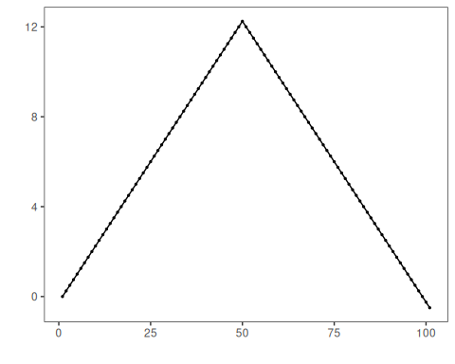
# Configure the GFT detector
model <- hcp_gft()
# Fit the detector (no training required)
model <- fit(model, dataset$serie)
# Run detection
detection <- detect(model, dataset$serie)
# Show detected change points
print(detection |> dplyr::filter(event == TRUE))
## idx event type
## 1 49 TRUE changepoint
## 2 64 TRUE changepoint
# Evaluate detections against labels
evaluation <- evaluate(model, detection$event, dataset$event)
print(evaluation$confMatrix)
## event
## detection TRUE FALSE
## TRUE 0 2
## FALSE 1 98
# Plot detections vs. ground truth
har_plot(model, dataset$serie, detection, dataset$event)
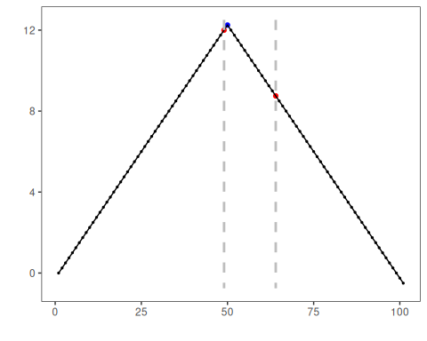

References
- Zeileis, A., Leisch, F., Kleiber, C., Hornik, K. (2002). strucchange: An R package for testing for structural change in linear regression models. Journal of Statistical Software, 7(2). doi:10.18637/jss.v007.i02
- Zeileis, A., Kleiber, C., Krämer, W., Hornik, K. (2003). Testing and dating of structural changes in practice. Computational Statistics & Data Analysis, 44(1), 109–123.

