Objective
PELT (Pruned Exact Linear Time) finds multiple change points efficiently by pruning candidates under a penalized cost. In this tutorial we:
- Load and visualize a simple change-point dataset
- Configure and run the PELT detector (hcp_pelt)
- Inspect detections, evaluate, and plot results

Method at a glance
PELT: PELT performs optimal partitioning of the time series under a penalized cost function while pruning candidate change locations to achieve near-linear time under suitable penalties. In Harbinger this wraps the changepoint package implementation and returns detected change indices along with evaluation helpers.

What you will do
- understand the purpose of the example and when the technique is useful
- follow the workflow from data loading to model fitting and detection
- inspect the evaluation outputs and the diagnostic plots produced by Harbinger

Walkthrough
# Install Harbinger (if needed)
#install.packages("harbinger")
# Load required packages
library(daltoolbox)
library(harbinger)
# Load example change-point datasets
data(examples_changepoints)
# Select the simple dataset
dataset <- examples_changepoints$simple
head(dataset)
## serie event
## 1 0.00 FALSE
## 2 0.25 FALSE
## 3 0.50 FALSE
## 4 0.75 FALSE
## 5 1.00 FALSE
## 6 1.25 FALSE
# Plot the raw time series
har_plot(harbinger(), dataset$serie)
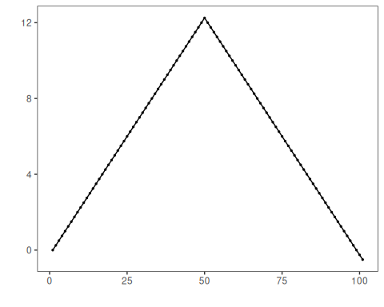
# Configure the PELT detector
model <- hcp_pelt()
# Fit the detector (no training required)
model <- fit(model, dataset$serie)
# Run detection
detection <- detect(model, dataset$serie)
# Show detected change points
print(detection |> dplyr::filter(event == TRUE))
## idx event type
## 1 9 TRUE changepoint
## 2 19 TRUE changepoint
## 3 29 TRUE changepoint
## 4 39 TRUE changepoint
## 5 60 TRUE changepoint
## 6 71 TRUE changepoint
## 7 81 TRUE changepoint
## 8 91 TRUE changepoint
# Evaluate detections against labels
evaluation <- evaluate(model, detection$event, dataset$event)
print(evaluation$confMatrix)
## event
## detection TRUE FALSE
## TRUE 0 8
## FALSE 1 92
# Plot detections vs. ground truth
har_plot(model, dataset$serie, detection, dataset$event)
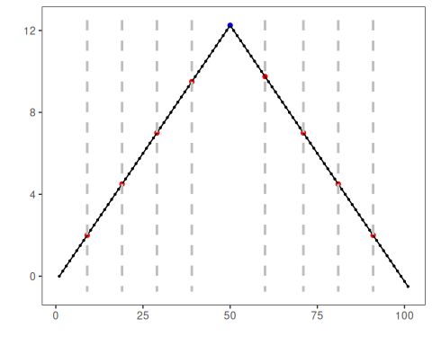

References
- Killick, R., Fearnhead, P., Eckley, I. A. (2012). Optimal detection of changepoints with a linear computational cost. Journal of the American Statistical Association, 107(500), 1590–1598.

