Objective
Seminal Change Point (SCP) compares regression fits with and without the central observation in sliding windows to highlight break locations. In this tutorial we:
- Load and visualize a simple change-point dataset
- Configure the SCP detector (hcp_scp)
- Inspect detections, evaluate, and plot residual magnitude with thresholds

Method at a glance
SCP: Seminal Change Point compares linear regression fits with and without the central observation in sliding windows; large deviations around a center indicate a change location.

What you will do
- understand the purpose of the example and when the technique is useful
- follow the workflow from data loading to model fitting and detection
- inspect the evaluation outputs and the diagnostic plots produced by Harbinger

Walkthrough
# Install Harbinger (if needed)
#install.packages("harbinger")
# Load required packages
library(daltoolbox)
library(harbinger)
# Load example change-point datasets
data(examples_changepoints)
# Select the simple dataset
dataset <- examples_changepoints$simple
head(dataset)
## serie event
## 1 0.00 FALSE
## 2 0.25 FALSE
## 3 0.50 FALSE
## 4 0.75 FALSE
## 5 1.00 FALSE
## 6 1.25 FALSE
# Plot the raw time series
har_plot(harbinger(), dataset$serie)
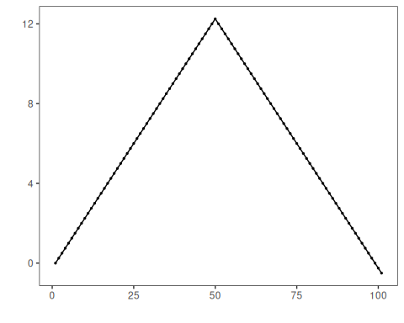
# Configure SCP (sw controls window; here 30)
model <- hcp_scp(sw=30)
# Fit the detector
model <- fit(model, dataset$serie)
# Run detection
detection <- detect(model, dataset$serie)
# Show detected change points
print(detection |> dplyr::filter(event == TRUE))
## idx event type
## 1 50 TRUE changepoint
# Evaluate detections against labels
evaluation <- evaluate(model, detection$event, dataset$event)
print(evaluation$confMatrix)
## event
## detection TRUE FALSE
## TRUE 1 0
## FALSE 0 100
# Plot detections vs. ground truth
har_plot(model, dataset$serie, detection, dataset$event)
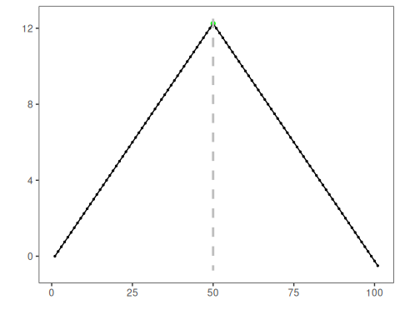
# Plot residual magnitude and decision thresholds
har_plot(model, attr(detection, "res"), detection, dataset$event, yline = attr(detection, "threshold"))
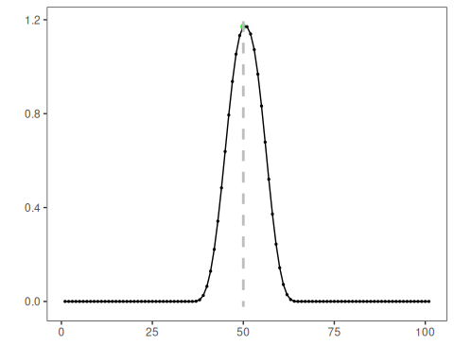

References
- Ogasawara, E., Salles, R., Porto, F., Pacitti, E. Event Detection in Time Series. Springer, 2025. doi:10.1007/978-3-031-75941-3

