Custom Sequence-Anomaly Detector

Objective
The goal of this example is to show a customization that is especially important for collective or sequence anomalies: the detector should return the anomalous range itself, not only a single representative timestamp inside that range.
This notebook complements the custom range-aware evaluator. The two ideas belong together: if the target phenomenon is an anomalous interval, both detection and evaluation should operate on intervals.

Why this method matters
Many anomaly workflows start by scoring each timestamp separately and then applying a post-processing rule that keeps only one point per contiguous group. That is often acceptable for isolated point anomalies, but it can be a poor representation for collective anomalies.
When the anomaly is a sequence, collapsing the whole segment to one point creates two problems:
- it hides the duration of the abnormal behavior;
- it makes it harder to use interval-aware metrics and to reason about overlap with the ground truth.
This custom example therefore focuses on a different post-processing philosophy: once an anomalous run is detected, keep the full run.

Method at a glance
The detector computes a rolling median baseline and a rolling MAD scale. It then converts each observation into a robust local z-score. Consecutive points whose score exceeds a threshold are grouped into anomalous runs, and only runs with at least min_run points are kept.
The key customization is not only the scoring function, but the post-processing rule: instead of choosing the first or highest point in each group, the detector marks the whole contiguous interval as anomalous.
# installation
# install.packages(c("harbinger", "daltoolbox"))
library(daltoolbox)
library(harbinger)
hanr_sequence_mad_custom <- function(window_size = 11, z_threshold = 3, min_run = 3) {
obj <- harbinger()
obj$window_size <- window_size
obj$z_threshold <- z_threshold
obj$min_run <- min_run
class(obj) <- append("hanr_sequence_mad_custom", class(obj))
obj
}
detect.hanr_sequence_mad_custom <- function(obj, serie, ...) {
obj <- obj$har_store_refs(obj, serie)
y <- as.numeric(obj$serie)
k <- obj$window_size
if (k %% 2 == 0) {
k <- k + 1
}
baseline <- zoo::rollmedian(y, k = k, fill = NA, align = "center")
local_mad <- zoo::rollapply(
y,
width = k,
FUN = function(v) stats::mad(v, constant = 1),
fill = NA,
align = "center"
)
# Use the nearest observed values on the borders so the whole series can be scored
baseline <- zoo::na.locf(baseline, na.rm = FALSE)
baseline <- zoo::na.locf(baseline, fromLast = TRUE, na.rm = FALSE)
local_mad <- zoo::na.locf(local_mad, na.rm = FALSE)
local_mad <- zoo::na.locf(local_mad, fromLast = TRUE, na.rm = FALSE)
local_mad[local_mad == 0 | is.na(local_mad)] <- 1e-8
score <- abs(y - baseline) / local_mad
raw_flags <- score > obj$z_threshold
# Build contiguous runs of TRUE values and keep only sufficiently long runs
idx_true <- which(raw_flags)
runs <- if (length(idx_true) == 0) list(integer(0)) else split(idx_true, cumsum(c(1, diff(idx_true) != 1)))
range_flags <- rep(FALSE, length(y))
for (run in runs) {
if (length(run) >= obj$min_run) {
range_flags[run] <- TRUE
}
}
detection <- obj$har_restore_refs(obj, anomalies = range_flags, res = score)
attr(detection, "threshold") <- obj$z_threshold
detection
}
To compare interval-aware evaluation in the same notebook, we define a small range-based evaluator that scores overlap between detected ranges and true ranges.
har_eval_range_custom <- function(alpha = 0.5) {
obj <- daltoolbox::dal_base()
obj$alpha <- alpha
class(obj) <- append("har_eval_range_custom", class(obj))
obj
}
to_ranges <- function(flags) {
flags <- as.logical(flags)
flags[is.na(flags)] <- FALSE
idx <- which(flags)
if (length(idx) == 0) {
return(data.frame(start = integer(0), end = integer(0), length = integer(0)))
}
groups <- split(idx, cumsum(c(1, diff(idx) != 1)))
starts <- vapply(groups, min, integer(1))
ends <- vapply(groups, max, integer(1))
data.frame(start = starts, end = ends, length = ends - starts + 1)
}
range_overlap <- function(a_start, a_end, b_start, b_end) {
max(0, min(a_end, b_end) - max(a_start, b_start) + 1)
}
evaluate.har_eval_range_custom <- function(obj, detection, event, ...) {
det_ranges <- to_ranges(detection)
evt_ranges <- to_ranges(event)
if (nrow(det_ranges) == 0 || nrow(evt_ranges) == 0) {
return(list(precision = 0, recall = 0, F1 = 0, alpha = obj$alpha))
}
recall_scores <- numeric(nrow(evt_ranges))
for (i in seq_len(nrow(evt_ranges))) {
overlaps <- mapply(
range_overlap,
evt_ranges$start[i], evt_ranges$end[i],
det_ranges$start, det_ranges$end
)
best_overlap <- max(overlaps)
existence_reward <- as.numeric(best_overlap > 0)
overlap_reward <- best_overlap / evt_ranges$length[i]
recall_scores[i] <- obj$alpha * existence_reward + (1 - obj$alpha) * overlap_reward
}
precision_scores <- numeric(nrow(det_ranges))
for (i in seq_len(nrow(det_ranges))) {
overlaps <- mapply(
range_overlap,
det_ranges$start[i], det_ranges$end[i],
evt_ranges$start, evt_ranges$end
)
precision_scores[i] <- max(overlaps) / det_ranges$length[i]
}
precision <- mean(precision_scores)
recall <- mean(recall_scores)
F1 <- if ((precision + recall) == 0) 0 else 2 * precision * recall / (precision + recall)
list(precision = precision, recall = recall, F1 = F1, alpha = obj$alpha)
}
We use the sequence example because it naturally motivates collective anomaly detection.
data(examples_anomalies)
dataset <- examples_anomalies$sequence
har_plot(harbinger(), dataset$serie, event = dataset$event)
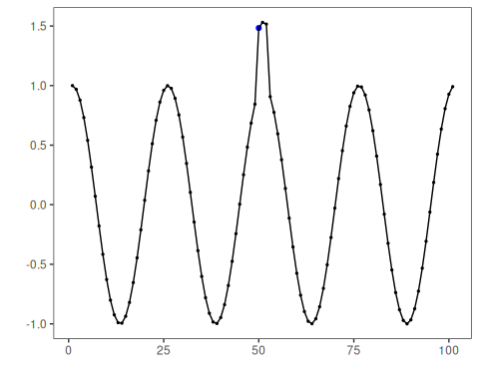
model <- hanr_sequence_mad_custom(window_size = 9, z_threshold = 2.5, min_run = 2)
detection <- detect(model, dataset$serie)
head(detection[detection$event, ])
## idx event type
## 51 51 TRUE anomaly
## 52 52 TRUE anomaly
# Plot the detected anomalous interval against the labeled sequence anomaly
har_plot(model, dataset$serie, detection, dataset$event)
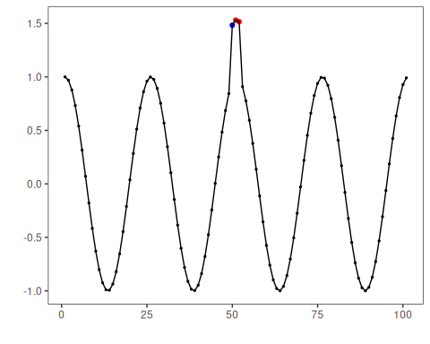
# Compare pointwise and range-aware evaluation
evaluate(har_eval(), detection$event, dataset$event)$confMatrix
## event
## detection TRUE FALSE
## TRUE 0 2
## FALSE 1 98
evaluate(har_eval_range_custom(alpha = 0.5), detection$event, dataset$event)
## $precision
## [1] 0
##
## $recall
## [1] 0
##
## $F1
## [1] 0
##
## $alpha
## [1] 0.5
This example makes the modeling choice explicit: sequence anomalies are better represented as ranges. Once the detector returns the whole anomalous interval, the downstream plots and the range-aware evaluator become much more informative.

References
- Chandola, V., Banerjee, A., Kumar, V. (2009). Anomaly Detection: A Survey. ACM Computing Surveys, 41(3), 15.
- Sørbø, S., Ruocco, M. (2024). Navigating the metric maze: a taxonomy of evaluation metrics for anomaly detection in time series. Data Mining and Knowledge Discovery, 38, 1027-1068. https://doi.org/10.1007/s10618-023-00988-8

