Custom Transformation

Objective
The goal of this example is to show how to create a custom transformation that can be applied before the detection workflow starts.
The point of the example is to motivate why one may want to change the series before choosing a detector at all. In many event-detection tasks, the raw signal contains small impulsive spikes or local noise that make downstream interpretation harder.

Why this method matters
The median filter is a classic transformation for attenuating isolated spikes while preserving broader level changes and trend structure better than a simple mean smoother in some situations. That makes it a good teaching example when the reader needs intuition about preprocessing before detection.
This custom notebook matters because:
- it shows that customization in Harbinger is not limited to detectors;
- it introduces the idea that signal conditioning can improve interpretability;
- it gives a concrete example of a transformation that is easy to understand visually.

Method at a glance
The transformation applies stats::runmed() to the numeric series and then feeds the filtered output into a regular Harbinger detector. The custom part is only the signal transformation; the rest of the workflow stays unchanged.
The transformation implemented here is a median filter. It is useful for reducing isolated spikes before an anomaly detector is applied. The integration contract is small because a simple transformation only needs a constructor and a transform() method when no fitted state is required.
# installation
# install.packages(c("harbinger", "daltoolbox"))
library(daltoolbox)
library(harbinger)
har_fil_median_custom <- function(k = 5) {
if (k %% 2 == 0) {
k <- k + 1
}
obj <- daltoolbox::dal_transform()
obj$k <- k
class(obj) <- append("har_fil_median_custom", class(obj))
obj
}
transform.har_fil_median_custom <- function(obj, data, ...) {
result <- stats::runmed(as.numeric(data), k = obj$k, endrule = "keep")
result[is.na(result)] <- as.numeric(data)[is.na(result)]
result
}
We first visualize the raw series, then apply the custom filter to attenuate local spikes.
data(examples_anomalies)
dataset <- examples_anomalies$simple
har_plot(harbinger(), dataset$serie, event = dataset$event)
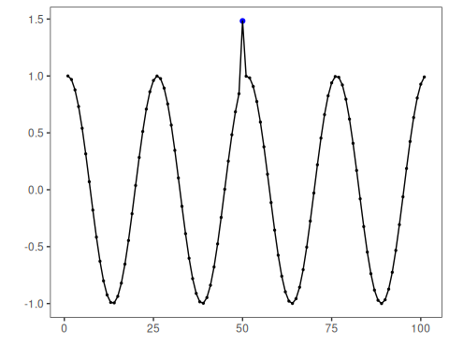
filter_custom <- har_fil_median_custom(k = 5)
serie_filtered <- transform(filter_custom, dataset$serie)
har_plot(harbinger(), serie_filtered, event = dataset$event)
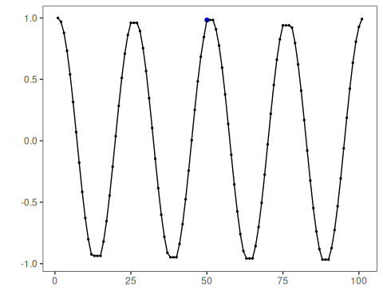
Once the transformation is defined, it can be inserted before a regular detector. Here we use hanr_arima() because it remains stable after smoothing and makes the downstream comparison easier to interpret.
model <- hanr_arima()
model <- fit(model, as.numeric(serie_filtered))
detection <- detect(model, as.numeric(serie_filtered))
har_plot(model, as.numeric(serie_filtered), detection, dataset$event)
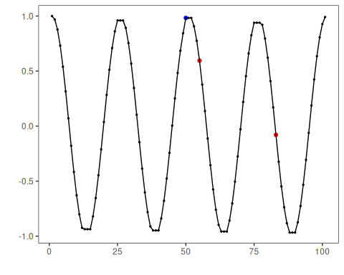
This example shows the usual role of a custom transformation in Harbinger: change the signal representation first, and then feed the transformed series into the downstream detection workflow.

References
- Tukey, J. W. (1977). Exploratory Data Analysis. Addison-Wesley.

