Objective
This notebook shows how to load the full gecco dataset with loadfulldata(), inspect how many series are available, verify whether the collection is univariate or multivariate, and plot the first signal with har_plot().

Method at a glance
The purpose here is exploratory orientation. Before modeling, the reader can confirm how the dataset object is organized and which column should be used as the first signal in a quick inspection. To keep the visualization readable, the plot shows at most the first 1000 observations of the first series.

What you will do
- load the bundled gecco object and replace it with the full dataset
- count the available series in the collection
- inspect the signal columns present in the first series
- plot a didactic preview of the first available signal with its event labels

Walkthrough
library(harbinger)
dataset_summary <- function(x) {
first_series <- x[[1]]
meta_cols <- c("idx", "event", "type", "seq", "seqlen")
signal_cols <- setdiff(names(first_series), meta_cols)
dataset_type <- if ("value" %in% names(first_series) || length(signal_cols) == 1) "univariate" else "multivariate"
plot_column <- if ("value" %in% names(first_series)) "value" else signal_cols[1]
list(
n_series = length(x),
dataset_type = dataset_type,
signal_cols = signal_cols,
plot_column = plot_column,
preview_size = min(1000, nrow(first_series)),
first_series = first_series
)
}
show_dataset <- function(x, name) {
info <- dataset_summary(x)
cat("Dataset:", name, "\n")
cat("Number of series:", info$n_series, "\n")
cat("Dataset type:", info$dataset_type, "\n")
cat("Signals in the first series:", paste(info$signal_cols, collapse = ", "), "\n")
cat("Column plotted with har_plot():", info$plot_column, "\n")
cat("Plot preview length:", info$preview_size, "observations\n")
invisible(info)
}
plot_dataset_preview <- function(info) {
preview <- info$first_series[seq_len(info$preview_size), , drop = FALSE]
har_plot(
harbinger(),
preview[[info$plot_column]],
event = preview$event
)
}
data(gecco)
gecco <- loadfulldata(gecco)
gecco_info <- show_dataset(gecco, "gecco")
## Dataset: gecco
## Number of series: 10
## Dataset type: univariate
## Signals in the first series: value
## Column plotted with har_plot(): value
## Plot preview length: 1000 observations
plot_dataset_preview(gecco_info)
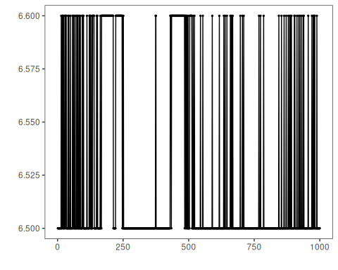

References
- GECCO Challenge 2018 material for water-quality event detection.
- Ogasawara, E., Salles, R., Porto, F., Pacitti, E. Event Detection in Time Series. Springer, 2025. doi:10.1007/978-3-031-75941-3

