Objective
This notebook shows how to inspect the MIT-BIH Arrhythmia datasets included in Harbinger. For each ECG lead object, it loads the full dataset with loadfulldata(), reports how many series are available, confirms the structure, and plots the first available signal with har_plot().

Method at a glance
The MIT-BIH objects are separate dataset collections by lead. This notebook helps the reader see how those objects are organized before building anomaly or event-detection experiments on the ECG signals. To keep the ECG plots readable, each preview is restricted to at most the first 1000 observations.

What you will do
- load the full MIT-BIH collections for each lead
- count how many series are available in each object
- inspect the signal columns and sequence metadata in the first series
- plot a shorter preview of the first signal together with the labeled events

Walkthrough
library(harbinger)
dataset_summary <- function(x) {
first_series <- x[[1]]
meta_cols <- c("idx", "event", "type", "seq", "seqlen")
signal_cols <- setdiff(names(first_series), meta_cols)
dataset_type <- if ("value" %in% names(first_series) || length(signal_cols) == 1) "univariate" else "multivariate"
plot_column <- if ("value" %in% names(first_series)) "value" else signal_cols[1]
list(
n_series = length(x),
dataset_type = dataset_type,
signal_cols = signal_cols,
plot_column = plot_column,
preview_size = min(1000, nrow(first_series)),
first_series = first_series
)
}
show_dataset <- function(x, name) {
info <- dataset_summary(x)
cat("Dataset:", name, "\n")
cat("Number of series:", info$n_series, "\n")
cat("Dataset type:", info$dataset_type, "\n")
cat("Signals in the first series:", paste(info$signal_cols, collapse = ", "), "\n")
cat("Column plotted with har_plot():", info$plot_column, "\n")
cat("Plot preview length:", info$preview_size, "observations\n")
invisible(info)
}
plot_dataset_preview <- function(info) {
preview <- info$first_series[seq_len(info$preview_size), , drop = FALSE]
har_plot(
harbinger(),
preview[[info$plot_column]],
event = preview$event
)
}

mit_bih_MLII
data(mit_bih_MLII)
mit_bih_MLII <- loadfulldata(mit_bih_MLII)
mit_mlii_info <- show_dataset(mit_bih_MLII, "mit_bih_MLII")
## Dataset: mit_bih_MLII
## Number of series: 5
## Dataset type: univariate
## Signals in the first series: value
## Column plotted with har_plot(): value
## Plot preview length: 1000 observations
plot_dataset_preview(mit_mlii_info)
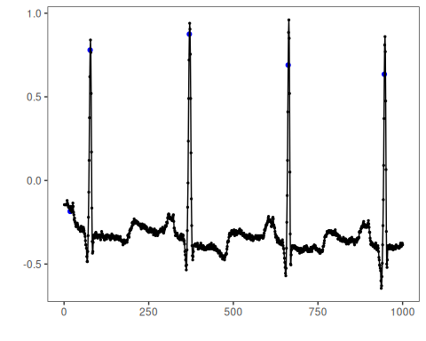

mit_bih_V1
data(mit_bih_V1)
mit_bih_V1 <- loadfulldata(mit_bih_V1)
mit_v1_info <- show_dataset(mit_bih_V1, "mit_bih_V1")
## Dataset: mit_bih_V1
## Number of series: 5
## Dataset type: univariate
## Signals in the first series: value
## Column plotted with har_plot(): value
## Plot preview length: 1000 observations
plot_dataset_preview(mit_v1_info)
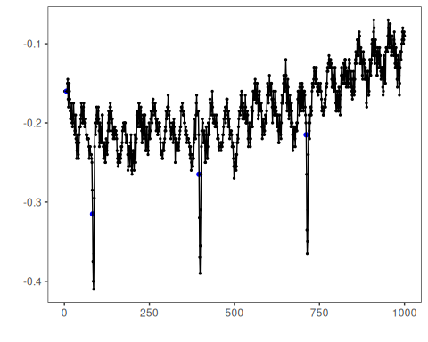

mit_bih_V2
data(mit_bih_V2)
mit_bih_V2 <- loadfulldata(mit_bih_V2)
mit_v2_info <- show_dataset(mit_bih_V2, "mit_bih_V2")
## Dataset: mit_bih_V2
## Number of series: 4
## Dataset type: univariate
## Signals in the first series: value
## Column plotted with har_plot(): value
## Plot preview length: 1000 observations
plot_dataset_preview(mit_v2_info)
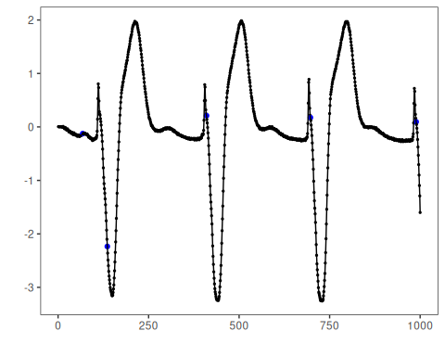

mit_bih_V5
data(mit_bih_V5)
mit_bih_V5 <- loadfulldata(mit_bih_V5)
mit_v5_info <- show_dataset(mit_bih_V5, "mit_bih_V5")
## Dataset: mit_bih_V5
## Number of series: 5
## Dataset type: univariate
## Signals in the first series: value
## Column plotted with har_plot(): value
## Plot preview length: 1000 observations
plot_dataset_preview(mit_v5_info)
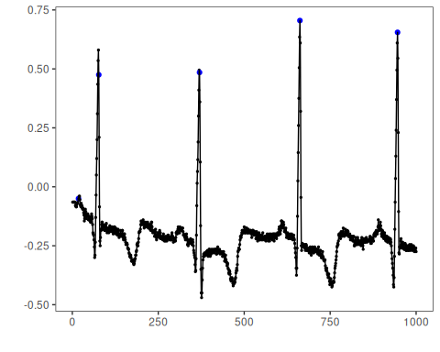

References
- Moody, G. B., Mark, R. G. (2001). The impact of the MIT-BIH Arrhythmia Database.
- Ogasawara, E., Salles, R., Porto, F., Pacitti, E. Event Detection in Time Series. Springer, 2025. doi:10.1007/978-3-031-75941-3

