Objective
This notebook introduces the Yahoo Webscope S5 benchmark datasets available in Harbinger. For each dataset object, the goal is to load the full collection with loadfulldata(), count the available series, identify the data as univariate or multivariate, and plot the first available signal with har_plot().

Method at a glance
This is a dataset-orientation notebook. It does not fit a detector. Instead, it shows how to inspect the dataset structure before choosing a modeling strategy. To keep the figures didactic, each plot is capped at the first 1000 observations of the selected series.

What you will do
- load the packaged mini object and replace it with the full dataset
- count how many series are available in each benchmark object
- identify whether the collection is univariate or multivariate
- plot a short preview of the first available signal and its event labels

Walkthrough
library(harbinger)
dataset_summary <- function(x) {
first_series <- x[[1]]
meta_cols <- c("idx", "event", "type", "seq", "seqlen")
signal_cols <- setdiff(names(first_series), meta_cols)
dataset_type <- if ("value" %in% names(first_series) || length(signal_cols) == 1) {
"univariate"
} else {
"multivariate"
}
plot_column <- if ("value" %in% names(first_series)) "value" else signal_cols[1]
list(
n_series = length(x),
dataset_type = dataset_type,
signal_cols = signal_cols,
plot_column = plot_column,
preview_size = min(1000, nrow(first_series)),
first_series = first_series
)
}
show_dataset <- function(x, name) {
info <- dataset_summary(x)
cat("Dataset:", name, "\n")
cat("Number of series:", info$n_series, "\n")
cat("Dataset type:", info$dataset_type, "\n")
cat("Signals in the first series:", paste(info$signal_cols, collapse = ", "), "\n")
cat("Column plotted with har_plot():", info$plot_column, "\n")
cat("Plot preview length:", info$preview_size, "observations\n")
invisible(info)
}
plot_dataset_preview <- function(info) {
preview <- info$first_series[seq_len(info$preview_size), , drop = FALSE]
har_plot(
harbinger(),
preview[[info$plot_column]],
event = preview$event
)
}

A1Benchmark
A1Benchmark contains real-world labeled univariate series from Yahoo Webscope S5.
data(A1Benchmark)
A1Benchmark <- loadfulldata(A1Benchmark)
a1_info <- show_dataset(A1Benchmark, "A1Benchmark")
## Dataset: A1Benchmark
## Number of series: 67
## Dataset type: univariate
## Signals in the first series: value
## Column plotted with har_plot(): value
## Plot preview length: 1000 observations
plot_dataset_preview(a1_info)
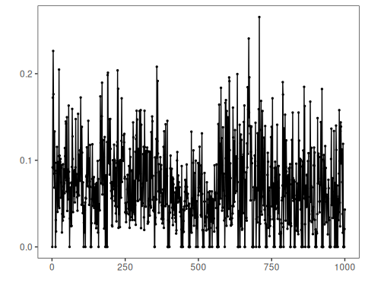

A2Benchmark
A2Benchmark contains synthetic labeled univariate series designed for anomaly-detection benchmarking.
data(A2Benchmark)
A2Benchmark <- loadfulldata(A2Benchmark)
a2_info <- show_dataset(A2Benchmark, "A2Benchmark")
## Dataset: A2Benchmark
## Number of series: 100
## Dataset type: univariate
## Signals in the first series: value
## Column plotted with har_plot(): value
## Plot preview length: 1000 observations
plot_dataset_preview(a2_info)
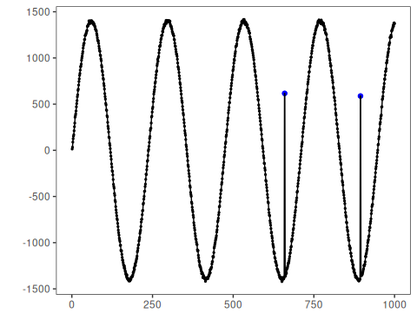

A3Benchmark
A3Benchmark contains synthetic Yahoo series with labeled anomalous observations.
data(A3Benchmark)
A3Benchmark <- loadfulldata(A3Benchmark)
a3_info <- show_dataset(A3Benchmark, "A3Benchmark")
## Dataset: A3Benchmark
## Number of series: 100
## Dataset type: univariate
## Signals in the first series: value
## Column plotted with har_plot(): value
## Plot preview length: 1000 observations
plot_dataset_preview(a3_info)
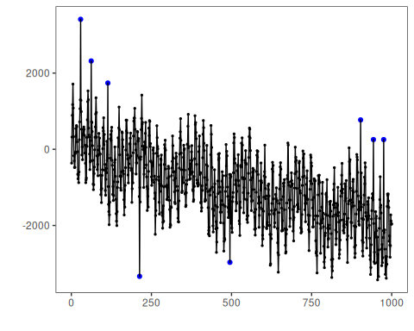

A4Benchmark
A4Benchmark combines synthetic anomalies and structural changes in the Yahoo benchmark family.
data(A4Benchmark)
A4Benchmark <- loadfulldata(A4Benchmark)
a4_info <- show_dataset(A4Benchmark, "A4Benchmark")
## Dataset: A4Benchmark
## Number of series: 100
## Dataset type: univariate
## Signals in the first series: value
## Column plotted with har_plot(): value
## Plot preview length: 1000 observations
plot_dataset_preview(a4_info)
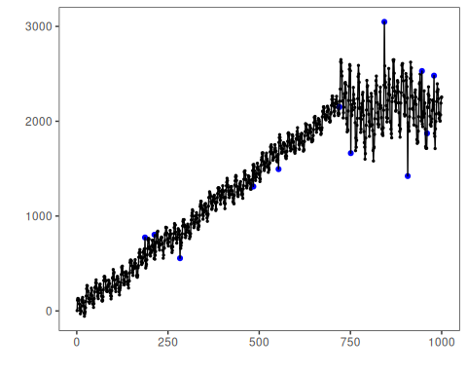

References
- Yahoo Webscope S5 benchmark documentation and downstream studies on labeled anomaly detection.
- Ogasawara, E., Salles, R., Porto, F., Pacitti, E. Event Detection in Time Series. Springer, 2025. doi:10.1007/978-3-031-75941-3

