Objective
The goal of this notebook is to present a complete Harbinger workflow: loading an example dataset, configuring the method used in the notebook, running the analysis, and interpreting the resulting outputs and plots.

Method at a glance
This notebook tours common time-series anomaly patterns (point/isolated, contextual, collective/sequence, regime variance shifts) using Harbinger’s base pipeline. For each dataset, we fit a detector, run detection, and visualize predictions against ground truth. The goal is to illustrate how different patterns appear in residual magnitude and plots, and how Harbinger’s unified interface helps compare detectors consistently.

What you will do
- understand the purpose of the example and when the technique is useful
- follow the workflow from data loading to model fitting and detection
- inspect the evaluation outputs and the diagnostic plots produced by Harbinger

Walkthrough
# Install Harbinger (if needed)
#install.packages("harbinger")
# Load required packages
library(daltoolbox)
library(harbinger)
# Load example anomaly datasets and create a base object
data(examples_anomalies)
model <- harbinger()
# Simple anomalies: isolated spikes
dataset <- examples_anomalies$simple
model <- fit(model, dataset$serie)
detection <- detect(model, dataset$serie)
har_plot(model, dataset$serie, detection, dataset$event)
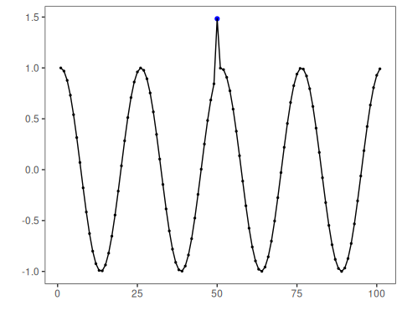
# Contextual anomalies: depend on local context
dataset <- examples_anomalies$contextual
model <- fit(model, dataset$serie)
detection <- detect(model, dataset$serie)
har_plot(model, dataset$serie, detection, dataset$event)
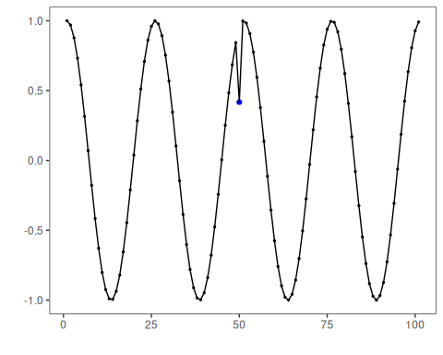
# Trend with anomalies
dataset <- examples_anomalies$trend
model <- fit(model, dataset$serie)
detection <- detect(model, dataset$serie)
har_plot(model, dataset$serie, detection, dataset$event)
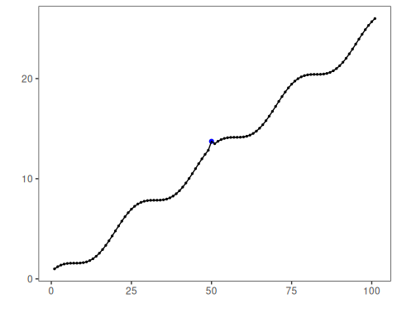
# Multiple anomalies
dataset <- examples_anomalies$multiple
model <- fit(model, dataset$serie)
detection <- detect(model, dataset$serie)
har_plot(model, dataset$serie, detection, dataset$event)
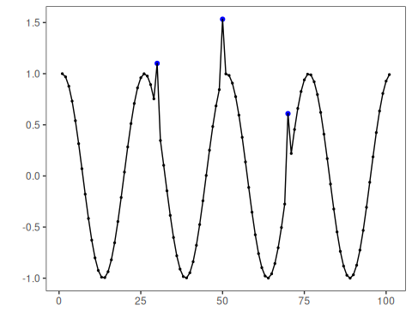
# Anomalous repeating sequences
dataset <- examples_anomalies$sequence
model <- fit(model, dataset$serie)
detection <- detect(model, dataset$serie)
har_plot(model, dataset$serie, detection, dataset$event)
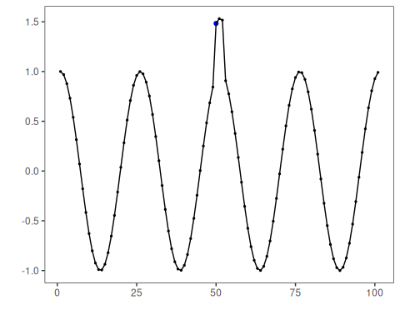
# Train/Test split
dataset <- examples_anomalies$tt
model <- fit(model, dataset$serie)
detection <- detect(model, dataset$serie)
har_plot(model, dataset$serie, detection, dataset$event)
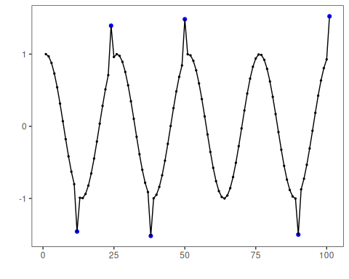
# Train/Test warped
dataset <- examples_anomalies$tt_warped
model <- fit(model, dataset$serie)
detection <- detect(model, dataset$serie)
har_plot(model, dataset$serie, detection, dataset$event)
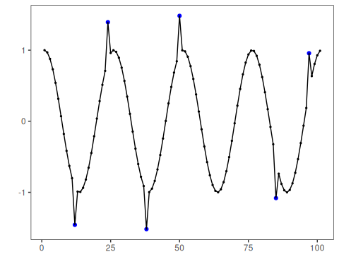
# Increasing amplitude over time
dataset <- examples_anomalies$increasing_amplitude
model <- fit(model, dataset$serie)
detection <- detect(model, dataset$serie)
har_plot(model, dataset$serie, detection, dataset$event)
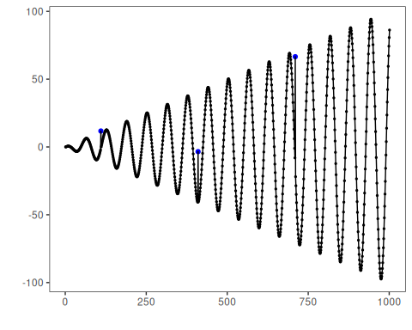
# Decreasing amplitude over time
dataset <- examples_anomalies$decreasing_amplitude
model <- fit(model, dataset$serie)
detection <- detect(model, dataset$serie)
har_plot(model, dataset$serie, detection, dataset$event)
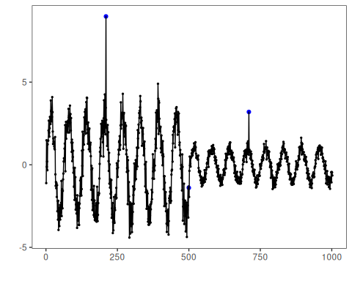
# Volatile variance
dataset <- examples_anomalies$volatile
model <- fit(model, dataset$serie)
detection <- detect(model, dataset$serie)
har_plot(model, dataset$serie, detection, dataset$event)
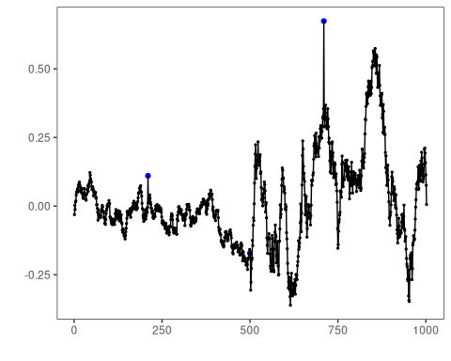

References
- Ogasawara, E., Salles, R., Porto, F., Pacitti, E. Event Detection in Time Series. Springer, 2025. doi:10.1007/978-3-031-75941-3
- Chandola, V., Banerjee, A., Kumar, V. (2009). Anomaly detection: A survey. ACM Computing Surveys, 41(3), 1–58.

