Objective
The goal of this notebook is to present a complete Harbinger workflow: loading an example dataset, configuring the method used in the notebook, running the analysis, and interpreting the resulting outputs and plots.

Method at a glance
This notebook demonstrates Harbinger utility distance functions for summarizing residual magnitudes (L1 and L2) and plotting results for quick inspection. L1 emphasizes robustness to outliers; L2 emphasizes larger deviations. These aggregations feed subsequent thresholding/outlier rules in the detection pipeline.

What you will do
- understand the purpose of the example and when the technique is useful
- follow the workflow from data loading to model fitting and detection
- inspect the evaluation outputs and the diagnostic plots produced by Harbinger

Walkthrough
# Install Harbinger (if needed)
#install.packages("harbinger")
# Load required packages
library(daltoolbox)
library(harbinger)
# Instantiate utilities
hutils <- harutils()
# Generate synthetic residuals
values <- rnorm(30, mean = 0, sd = 1)
# L1 aggregation of residual magnitude
v1 <- hutils$har_distance_l1(values)
har_plot(harbinger(), v1)
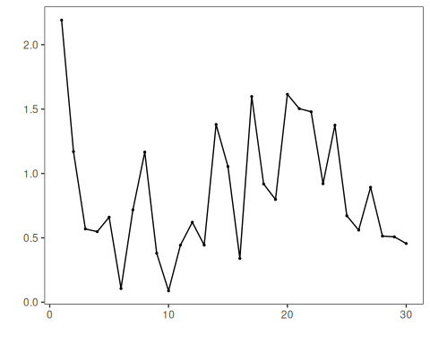
# L2 aggregation of residual magnitude
v2 <- hutils$har_distance_l2(values)
har_plot(harbinger(), v2)
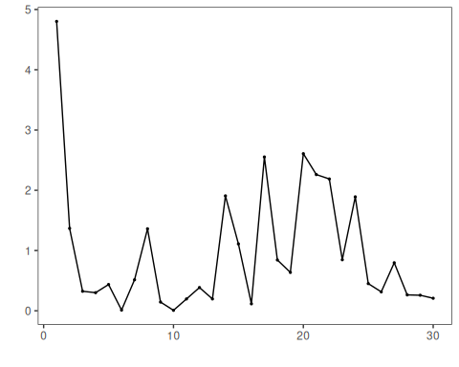

References
- Tukey, J. W. (1977). Exploratory Data Analysis. Addison‑Wesley. (IQR/boxplot heuristics underpin some thresholding rules)
- Shewhart, W. A. (1931). Economic Control of Quality of Manufactured Product. D. Van Nostrand. (three‑sigma rule)

