Objective
The goal of this notebook is to present a complete Harbinger workflow: loading an example dataset, configuring the method used in the notebook, running the analysis, and interpreting the resulting outputs and plots.

Method at a glance
This notebook showcases motif discovery (repeated subsequences) using Harbinger’s unified interface and base plotting. Across synthetic and ECG datasets, we fit a detector, run discovery, and plot results. The aim is to build intuition for how motifs (and related discords) appear in time series and how Matrix Profile/SAX-based methods surface them.

What you will do
- understand the purpose of the example and when the technique is useful
- follow the workflow from data loading to model fitting and detection
- inspect the evaluation outputs and the diagnostic plots produced by Harbinger

Walkthrough
# Install Harbinger (if needed)
#install.packages("harbinger")
# Load required packages
library(daltoolbox)
library(harbinger)
# Load motif example datasets and create a base object
data(examples_motifs)
model <- harbinger()
# Simple synthetic motif dataset
dataset <- examples_motifs$simple
model <- fit(model, dataset$serie)
detection <- detect(model, dataset$serie)
har_plot(model, dataset$serie, detection, dataset$event)
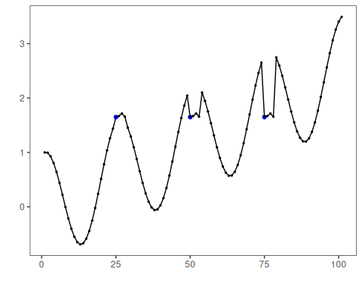
# ECG sample: MIT-BIH record 100
dataset <- examples_motifs$mitdb100
model <- fit(model, dataset$serie)
detection <- detect(model, dataset$serie)
har_plot(model, dataset$serie, detection, dataset$event)
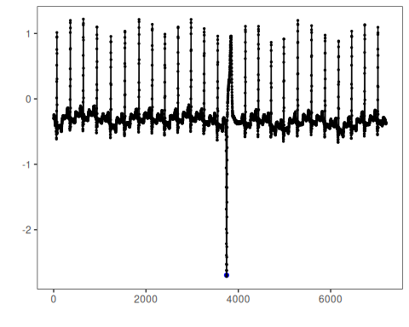
# ECG sample: MIT-BIH record 102
dataset <- examples_motifs$mitdb102
model <- fit(model, dataset$serie)
detection <- detect(model, dataset$serie)
har_plot(model, dataset$serie, detection, dataset$event)
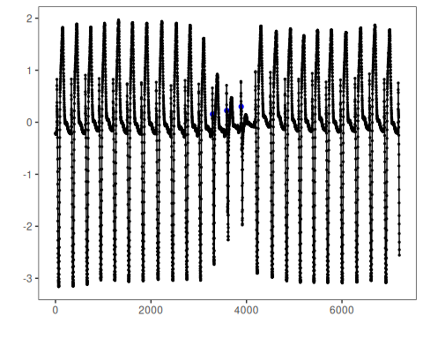

References
- Yeh, C.-C. M., et al. (2016). Matrix Profile I/II: All-pairs similarity joins and scalable time series motif/discord discovery. IEEE ICDM.
- Tavenard, R., et al. (2020). tsmp: The Matrix Profile in R. The R Journal. doi:10.32614/RJ-2020-021
- Lin, J., Keogh, E., Lonardi, S., Chiu, B. (2007). A symbolic representation of time series, with implications for streaming algorithms. DMKD, 15, 107–144.

