Objective
This notebook demonstrates discord (anomaly) discovery using Matrix Profile with the STOMP algorithm via hdis_mp(mode = "stomp", ...). Discords are subsequences maximally dissimilar to the rest. Steps: load packages/data, visualize, define the discord model (subsequence length and count), fit, detect, evaluate, and plot.

Method at a glance
STOMP motif discovery: Matrix Profile-based discord discovery identifies rare subsequences whose nearest-neighbor distance is large. STOMP approximates the profile via random order calculations for scalability.

What you will do
- understand the purpose of the example and when the technique is useful
- follow the workflow from data loading to model fitting and detection
- inspect the evaluation outputs and the diagnostic plots produced by Harbinger

Walkthrough
# Install Harbinger (only once, if needed)
#install.packages("harbinger")
# Load required packages
library(daltoolbox)
library(harbinger)
# Load example datasets bundled with harbinger
data(examples_motifs)
# Select an ECG time series with annotated anomalies
dataset <- examples_motifs$mitdb102
head(dataset)
## serie event symbol
## 102992 -0.215 FALSE N
## 102993 -0.210 FALSE N
## 102994 -0.215 FALSE N
## 102995 -0.230 FALSE N
## 102996 -0.220 FALSE N
## 102997 -0.200 FALSE N
# Plot the time series
har_plot(harbinger(), dataset$serie)
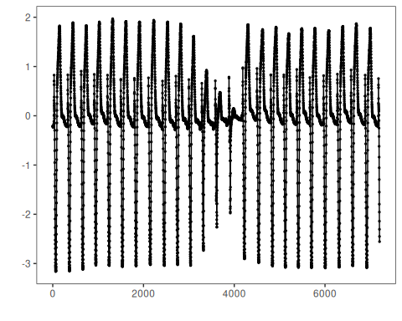
# Define Matrix Profile discord model (STOMP)
# - w: subsequence length (window)
# - qtd: number of discords to retrieve
model <- hdis_mp(mode = "stomp", w = 25, qtd = 10)
# Fit the model
model <- fit(model, dataset$serie)
# Detect discords
suppressMessages(detection <- detect(model, dataset$serie))
# Show only timestamps flagged as events
print(detection |> dplyr::filter(event==TRUE))
## idx event type seq seqlen
## 1 2602 TRUE motif 1 25
## 2 3844 TRUE motif 1 25
## 3 4017 TRUE motif 1 25
## 4 6135 TRUE motif 1 25
# Evaluate detections against ground-truth labels
evaluation <- evaluate(model, detection$event, dataset$event)
print(evaluation$confMatrix)
## event
## detection TRUE FALSE
## TRUE 0 4
## FALSE 3 7195
# Plot detections over the series
har_plot(model, dataset$serie, detection, dataset$event)
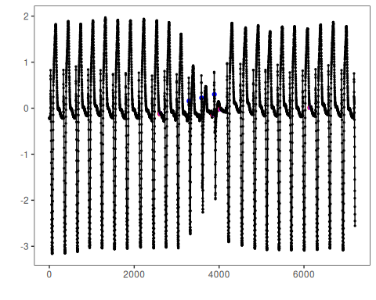

References
- Yeh, C.-C. M., et al. (2016). Matrix Profile I/II: All-pairs similarity joins and scalable time series motif/discord discovery. IEEE ICDM.
- Tavenard, R., et al. (2020). tsmp: The Matrix Profile in R. The R Journal. doi:10.32614/RJ-2020-021

