Objective
This notebook demonstrates motif discovery using Matrix Profile with the STAMP algorithm via hmo_mp("stamp", ...). It finds repeated subsequences (motifs) in a time series. Steps: load packages/data, visualize the series, define the motif model (subsequence length and number of motifs), fit, detect, evaluate, and plot.

Method at a glance
STAMP motif discovery: Matrix Profile methods compute, for each subsequence, the distance to its nearest neighbor subsequence, enabling efficient discovery of repeated patterns (motifs). STAMP uses random sampling to approximate the Matrix Profile with scalability to long series. In Harbinger this is provided via tsmp and wrapped by hmo_mp().

What you will do
- understand the purpose of the example and when the technique is useful
- follow the workflow from data loading to model fitting and detection
- inspect the evaluation outputs and the diagnostic plots produced by Harbinger

Walkthrough
# Install Harbinger (only once, if needed)
#install.packages("harbinger")
# Load required packages
library(daltoolbox)
library(harbinger)
# Load example datasets bundled with harbinger
data(examples_motifs)
# Select a simple example time series
dataset <- examples_motifs$simple
head(dataset)
## serie event
## 1 1.0000000 FALSE
## 2 0.9939124 FALSE
## 3 0.9275826 FALSE
## 4 0.8066889 FALSE
## 5 0.6403023 FALSE
## 6 0.4403224 FALSE
# Plot the time series
har_plot(harbinger(), dataset$serie)
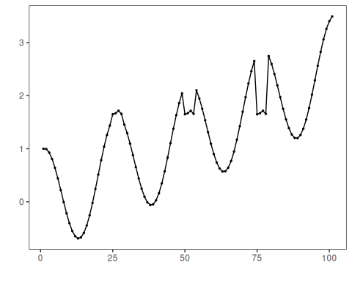
# Define Matrix Profile (STAMP) motif model
# - first arg: algorithm name
# - second arg: subsequence length (window)
# - third arg: number of motifs to retrieve
model <- hmo_mp("stamp", 4, 3)
# Fit the model
model <- fit(model, dataset$serie)
# Detect motifs
detection <- detect(model, dataset$serie)
## Finished in 0.02 secs
# Show only timestamps flagged as events
print(detection |> dplyr::filter(event==TRUE))
## idx event type seq seqlen
## 1 6 TRUE motif 3 4
## 2 19 TRUE motif 2 4
## 3 25 TRUE motif 1 4
## 4 31 TRUE motif 3 4
## 5 44 TRUE motif 2 4
## 6 56 TRUE motif 3 4
## 7 69 TRUE motif 2 4
## 8 75 TRUE motif 1 4
## 9 81 TRUE motif 3 4
## 10 94 TRUE motif 2 4
# Evaluate detections against ground-truth labels
evaluation <- evaluate(model, detection$event, dataset$event)
print(evaluation$confMatrix)
## event
## detection TRUE FALSE
## TRUE 2 8
## FALSE 1 90
# Plot detections over the series
har_plot(model, dataset$serie, detection, dataset$event)
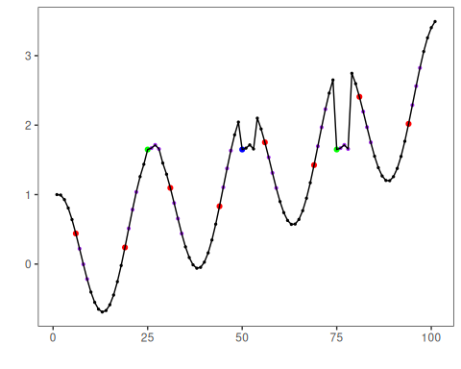

References
- Yeh, C.-C. M., et al. (2016). Matrix Profile I/II: All-pairs similarity joins and scalable time series motif/discord discovery. IEEE ICDM.
- Tavenard, R., et al. (2020). tsmp: The Matrix Profile in R. The R Journal. doi:10.32614/RJ-2020-021

