Objective
This notebook demonstrates variable-length motif discovery with Matrix Profile using hmo_mp("valmod", ...). VALMOD searches for recurring patterns across a range of subsequence lengths. Steps: load packages/data, visualize, define the model (min/max lengths and count), fit, detect, evaluate, and plot.

Method at a glance
VALMOD motif discovery: VALMOD maintains the Matrix Profile under streaming updates, enabling motif discovery in evolving series. It computes nearest-neighbor distances for subsequences efficiently.

What you will do
- understand the purpose of the example and when the technique is useful
- follow the workflow from data loading to model fitting and detection
- inspect the evaluation outputs and the diagnostic plots produced by Harbinger

Walkthrough
# Install Harbinger (only once, if needed)
#install.packages("harbinger")
# Load required packages
library(daltoolbox)
library(harbinger)
# Load example datasets bundled with harbinger
data(examples_motifs)
# Select a simple example time series
dataset <- examples_motifs$simple
head(dataset)
## serie event
## 1 1.0000000 FALSE
## 2 0.9939124 FALSE
## 3 0.9275826 FALSE
## 4 0.8066889 FALSE
## 5 0.6403023 FALSE
## 6 0.4403224 FALSE
# Plot the time series
har_plot(harbinger(), dataset$serie)
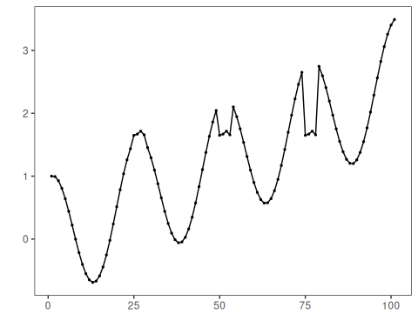
# Define Matrix Profile (VALMOD) motif model
# - second arg: min subsequence length (window)
# - third arg: number of motifs to retrieve
model <- hmo_mp("valmod", 4, 3)
# Fit the model
model <- fit(model, dataset$serie)
# Detect motifs
detection <- detect(model, dataset$serie)
## max_number_motifs_found -1
## min_number_motifs_found -1
## Finished in 0.02 secs
# Show only timestamps flagged as events
print(detection |> dplyr::filter(event==TRUE))
## idx event type seq seqlen
## 1 6 TRUE motif 3 4
## 2 19 TRUE motif 2 4
## 3 25 TRUE motif 1 4
## 4 31 TRUE motif 3 4
## 5 44 TRUE motif 2 4
## 6 50 TRUE motif 1 4
## 7 56 TRUE motif 3 4
## 8 69 TRUE motif 2 4
## 9 75 TRUE motif 1 4
## 10 81 TRUE motif 3 4
## 11 94 TRUE motif 2 4
# Evaluate detections against ground-truth labels
evaluation <- evaluate(model, detection$event, dataset$event)
print(evaluation$confMatrix)
## event
## detection TRUE FALSE
## TRUE 3 8
## FALSE 0 90
# Plot detections over the series
har_plot(model, dataset$serie, detection, dataset$event)
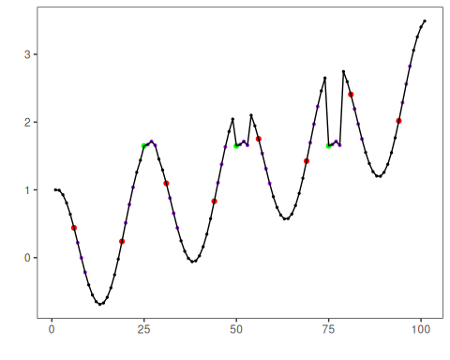

References
- Yeh, C.-C. M., et al. (2016). Matrix Profile I/II: All-pairs similarity joins and scalable time series motif/discord discovery. IEEE ICDM.
- Tavenard, R., et al. (2020). tsmp: The Matrix Profile in R. The R Journal. doi:10.32614/RJ-2020-021

