Objective
XSAX extends SAX to a larger alphanumeric alphabet, enabling finer symbolic resolution for motif discovery. In this tutorial we:
- Load and visualize a motif dataset
- Configure hmo_xsax(a, w, qtd) and run detection
- Inspect and evaluate motif occurrences

Method at a glance
XSAX motif discovery: XSAX extends SAX to a larger alphanumeric alphabet, allowing finer symbolic resolution. Motifs are frequent symbolic words or closely related patterns.

What you will do
- understand the purpose of the example and when the technique is useful
- follow the workflow from data loading to model fitting and detection
- inspect the evaluation outputs and the diagnostic plots produced by Harbinger

Walkthrough
# Install Harbinger (if needed)
#install.packages("harbinger")
# Load required packages
library(daltoolbox)
library(harbinger)
# Load example motif datasets
data(examples_motifs)
# Select the simple motif dataset
dataset <- examples_motifs$simple
head(dataset)
## serie event
## 1 1.0000000 FALSE
## 2 0.9939124 FALSE
## 3 0.9275826 FALSE
## 4 0.8066889 FALSE
## 5 0.6403023 FALSE
## 6 0.4403224 FALSE
# Plot the raw time series
har_plot(harbinger(), dataset$serie)
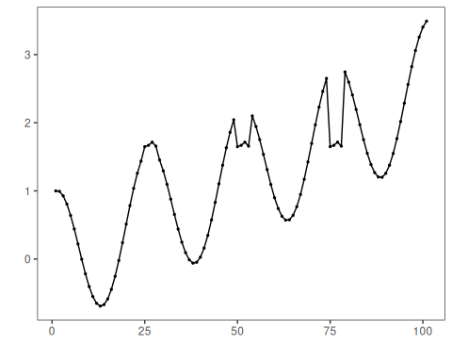
# Configure XSAX motif discovery (alphabet=37, word=3, min occurrences=3)
model <- hmo_xsax(37, 3, 3)
# Fit the detector (learns binning thresholds)
model <- fit(model, dataset$serie)
# Run motif discovery
detection <- detect(model, dataset$serie)
# Show detected motif starts
print(detection |> dplyr::filter(event == TRUE))
## idx event type seq seqlen
## 1 25 TRUE motif 0N0P0R 3
## 2 50 TRUE motif 0N0P0R 3
## 3 75 TRUE motif 0N0P0R 3
# Evaluate detections against labels
evaluation <- evaluate(model, detection$event, dataset$event)
print(evaluation$confMatrix)
## event
## detection TRUE FALSE
## TRUE 3 0
## FALSE 0 98
# Plot motifs and ground truth
har_plot(model, dataset$serie, detection, dataset$event)
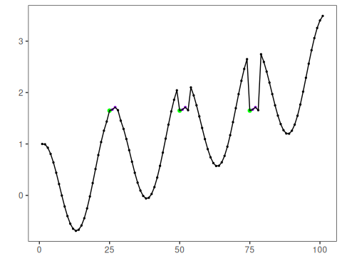

References
- Ogasawara, E., Salles, R., Porto, F., Pacitti, E. Event Detection in Time Series. Springer, 2025. doi:10.1007/978-3-031-75941-3

