Objective
This notebook explains how to use mas() as a simple moving-average transformation for time series. The goal is to help the reader understand what the smoother does, how the order parameter changes the result, and why smoothing can be useful before downstream tasks such as change-point detection.

Method at a glance
mas() computes a simple moving average. Each output point is the average of a local window of consecutive observations. As a transformation, it reduces short-term noise and makes broader movement patterns easier to inspect.

What you will do
- load an example time series
- inspect the original series
- compute moving-average smoothers with different window sizes
- compare the original and smoothed versions visually
- understand the trade-off between smoothness and temporal detail
- see why smoothing is often used before a modeling step

Walkthrough
# Install Harbinger (if needed)
#install.packages("harbinger")
# Load required packages
library(harbinger)
# Load example change-point datasets
data(examples_changepoints)
# Select a simple change-point dataset
dataset <- examples_changepoints$simple
head(dataset)
## serie event
## 1 0.00 FALSE
## 2 0.25 FALSE
## 3 0.50 FALSE
## 4 0.75 FALSE
## 5 1.00 FALSE
## 6 1.25 FALSE
# Plot the original time series
har_plot(harbinger(), dataset$serie, event = dataset$event)
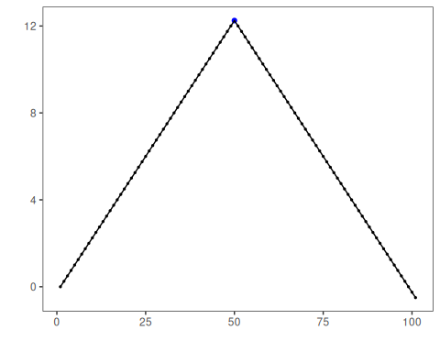
# Compute smoothers with two different window sizes
ma_5 <- mas(dataset$serie, order = 5)
ma_15 <- mas(dataset$serie, order = 15)
# Inspect the first smoothed values
head(ma_5)
## Time Series:
## Start = 1
## End = 6
## Frequency = 1
## [1] 0.50 0.75 1.00 1.25 1.50 1.75
head(ma_15)
## Time Series:
## Start = 1
## End = 6
## Frequency = 1
## [1] 1.75 2.00 2.25 2.50 2.75 3.00
# Plot the 5-point moving average
har_plot(
harbinger(),
as.numeric(ma_5),
event = dataset$event[5:length(dataset$event)]
)
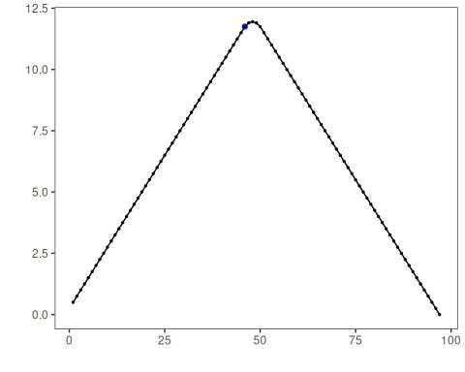
# Plot the 15-point moving average
har_plot(
harbinger(),
as.numeric(ma_15),
event = dataset$event[15:length(dataset$event)]
)
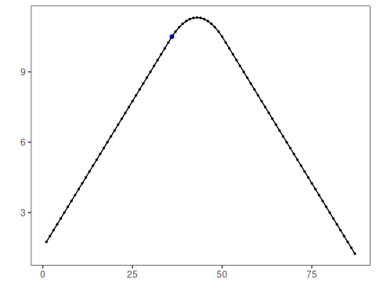

References
- Shumway, R. H., Stoffer, D. S. Time Series Analysis and Its Applications. Springer.

