Objective
This notebook demonstrates the trans_sax() transformation. The goal is to show how a numeric time series can be converted into a symbolic representation that is easier to compare, summarize, and use in motif or discord analysis.

Method at a glance
SAX, or Symbolic Aggregate approXimation, z-normalizes a series and discretizes it into a finite alphabet. Instead of working directly with the raw values, we work with symbolic codes that preserve coarse shape information.

What you will do
- load a motif example series from Harbinger
- inspect the original numeric signal
- configure a SAX transformer with a chosen alphabet size
- transform the series into symbols
- compare the numeric and symbolic views of the same signal

Walkthrough
# Install Harbinger (if needed)
#install.packages("harbinger")
# Load required packages
library(daltoolbox)
library(harbinger)
# Load example motif datasets
data(examples_motifs)
# Select a simple motif dataset
dataset <- examples_motifs$simple
head(dataset)
## serie event
## 1 1.0000000 FALSE
## 2 0.9939124 FALSE
## 3 0.9275826 FALSE
## 4 0.8066889 FALSE
## 5 0.6403023 FALSE
## 6 0.4403224 FALSE
# Plot the original time series
har_plot(harbinger(), dataset$serie, event = dataset$event)
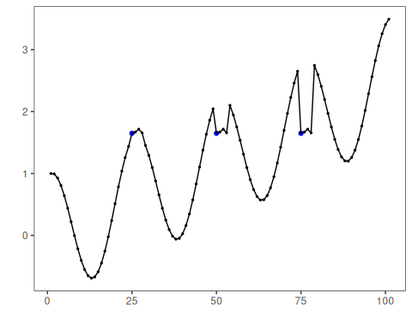
# Configure the SAX transformer
model <- trans_sax(alpha = 8)
# Fit and transform the numeric series into symbols
model <- fit(model, dataset$serie)
sax_series <- transform(model, dataset$serie)
# Inspect the first symbolic values
head(sax_series, 20)
## [1] "D" "D" "D" "C" "C" "B" "B" "B" "A" "A" "A" "A" "A" "A" "A" "A" "A" "A" "B" "B"
# Compare original values with SAX symbols
comparison <- data.frame(
idx = seq_along(dataset$serie),
value = dataset$serie,
sax = sax_series
)
head(comparison, 20)
## idx value sax
## 1 1 1.000000000 D
## 2 2 0.993912422 D
## 3 3 0.927582562 D
## 4 4 0.806688869 C
## 5 5 0.640302306 C
## 6 6 0.440322362 B
## 7 7 0.220737202 B
## 8 8 -0.003246056 B
## 9 9 -0.216146837 A
## 10 10 -0.403173623 A
## 11 11 -0.551143616 A
## 12 12 -0.649302379 A
## 13 13 -0.689992497 A
## 14 14 -0.669129676 A
## 15 15 -0.586456687 A
## 16 16 -0.445559357 A
## 17 17 -0.253643621 A
## 18 18 -0.021087490 A
## 19 19 0.239204201 B
## 20 20 0.512602153 B

References
- Lin, J., Keogh, E., Lonardi, S., Chiu, B. (2007). A symbolic representation of time series, with implications for streaming algorithms. Data Mining and Knowledge Discovery, 15, 107-144.

