Objective
This notebook demonstrates trans_xsax(), an extended symbolic transformation for time series. The goal is to show how XSAX increases symbolic resolution relative to SAX by using a larger alphabet.

Method at a glance
XSAX follows the same general idea as SAX: normalize the series and discretize it into symbols. The difference is that XSAX uses a larger alphanumeric alphabet, which allows a finer symbolic partition of the values.

What you will do
- load an example motif series from Harbinger
- inspect the original numeric sequence
- configure an XSAX transformer
- transform the series into a richer symbolic encoding
- compare the numeric values with the symbolic codes

Walkthrough
# Install Harbinger (if needed)
#install.packages("harbinger")
# Load required packages
library(daltoolbox)
library(harbinger)
# Load example motif datasets
data(examples_motifs)
# Select a simple motif dataset
dataset <- examples_motifs$simple
head(dataset)
## serie event
## 1 1.0000000 FALSE
## 2 0.9939124 FALSE
## 3 0.9275826 FALSE
## 4 0.8066889 FALSE
## 5 0.6403023 FALSE
## 6 0.4403224 FALSE
# Plot the original time series
har_plot(harbinger(), dataset$serie, event = dataset$event)
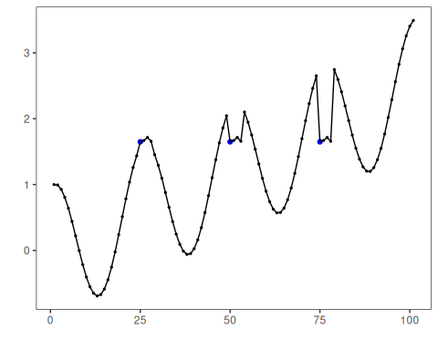
# Configure the XSAX transformer
model <- trans_xsax(alpha = 16)
# Fit and transform the numeric series into an extended symbolic representation
model <- fit(model, dataset$serie)
xsax_series <- transform(model, dataset$serie)
# Inspect the first symbolic values
head(xsax_series, 20)
## [1] "6" "6" "6" "5" "4" "3" "2" "2" "1" "0" "0" "0" "0" "0" "0" "0" "1" "1" "2" "3"
# Compare original values with XSAX symbols
comparison <- data.frame(
idx = seq_along(dataset$serie),
value = dataset$serie,
xsax = xsax_series
)
head(comparison, 20)
## idx value xsax
## 1 1 1.000000000 6
## 2 2 0.993912422 6
## 3 3 0.927582562 6
## 4 4 0.806688869 5
## 5 5 0.640302306 4
## 6 6 0.440322362 3
## 7 7 0.220737202 2
## 8 8 -0.003246056 2
## 9 9 -0.216146837 1
## 10 10 -0.403173623 0
## 11 11 -0.551143616 0
## 12 12 -0.649302379 0
## 13 13 -0.689992497 0
## 14 14 -0.669129676 0
## 15 15 -0.586456687 0
## 16 16 -0.445559357 0
## 17 17 -0.253643621 1
## 18 18 -0.021087490 1
## 19 19 0.239204201 2
## 20 20 0.512602153 3

References
- Ogasawara, E., Salles, R., Porto, F., Pacitti, E. Event Detection in Time Series. Springer, 2025. doi:10.1007/978-3-031-75941-3

