Objective
This tutorial introduces the core Harbinger workflow on a small labeled anomaly series. The goal is to help the reader see the minimum sequence of actions: load data, create a model, detect events, inspect the output, and plot the result.

Method at a glance
We use the default harbinger() model as a first contact with the package interface. The emphasis here is not on a specific detection technique, but on understanding the common workflow shared by many Harbinger objects.

What you will do
- load a bundled example dataset
- inspect the structure of the series and event labels
- create the default Harbinger model
- run detection
- visualize the detected events

Walkthrough
# Install Harbinger (if needed)
# install.packages("harbinger")
# Load the package
library(harbinger)
# Load a small labeled anomaly dataset distributed with the package
data(examples_anomalies)
dataset <- examples_anomalies$simple
head(dataset)
## serie event
## 1 1.0000000 FALSE
## 2 0.9689124 FALSE
## 3 0.8775826 FALSE
## 4 0.7316889 FALSE
## 5 0.5403023 FALSE
## 6 0.3153224 FALSE
# Plot the series with the known labeled events
har_plot(harbinger(), dataset$serie, event = dataset$event)
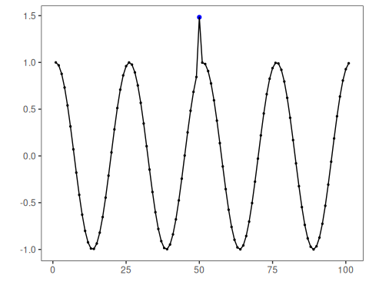
# Create the default Harbinger detector
model <- harbinger()
# Run detection on the series
detection <- detect(model, dataset$serie)
head(detection)
## idx event type
## 1 1 FALSE
## 2 2 FALSE
## 3 3 FALSE
## 4 4 FALSE
## 5 5 FALSE
## 6 6 FALSE
# Plot detections against the labeled events
har_plot(model, dataset$serie, detection, dataset$event)


References
- Ogasawara, E., Salles, R., Porto, F., Pacitti, E. Event Detection in Time Series. Springer, 2025. doi:10.1007/978-3-031-75941-3

