Objective
This tutorial demonstrates how har_plot() helps inspect time series before and after detection. The goal is to show how plotting supports interpretation in both univariate and multivariate settings.

Method at a glance
Visualization is part of the analysis workflow in Harbinger. A quick plot can reveal trends, level shifts, bursts, repeated patterns, and labeled events before a detector is even configured.

What you will do
- plot a univariate anomaly series with labels
- plot a multivariate dataset by selecting one signal column
- compare how the same plotting interface works in both cases

Walkthrough
library(harbinger)
# Univariate example
data(examples_anomalies)
uni <- examples_anomalies$simple
har_plot(harbinger(), uni$serie, event = uni$event)
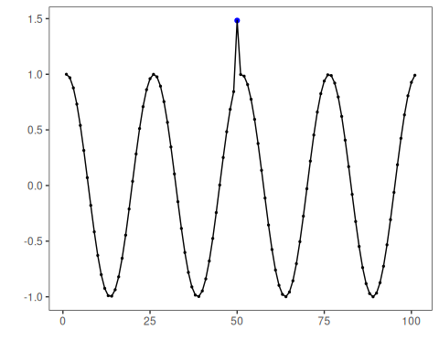
# Multivariate example from the 3W benchmark
data(oil_3w_Type_1)
oil_3w_Type_1 <- loadfulldata(oil_3w_Type_1)
first_mv <- oil_3w_Type_1[[1]]
meta_cols <- c("idx", "event", "type", "seq", "seqlen")
signal_cols <- setdiff(names(first_mv), meta_cols)
signal_cols
## [1] "p_pdg" "p_tpt" "t_tpt" "p_mon_ckp" "t_jus_ckp" "p_jus_ckgl" "qgl"
# Plot only the first signal column of the multivariate series
har_plot(
harbinger(),
first_mv[[signal_cols[1]]],
event = first_mv$event
)
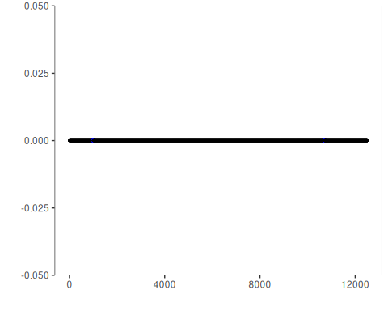

References
- Ogasawara, E., Salles, R., Porto, F., Pacitti, E. Event Detection in Time Series. Springer, 2025. doi:10.1007/978-3-031-75941-3

