Objective
This tutorial introduces anomaly detection with a very simple and interpretable baseline: hanr_histogram(). The goal is to help the reader understand what a detector does before moving to model-based methods.

Method at a glance
hanr_histogram() builds a histogram of observed values and marks points as anomalies when they fall in very low-density bins or outside the observed range. It is useful as a first baseline because it focuses on the empirical distribution of the series.

What you will do
- load a labeled anomaly dataset
- run the histogram-based detector
- inspect which points were flagged
- compare detections against the ground truth

Walkthrough
library(daltoolbox)
library(harbinger)
data(examples_anomalies)
dataset <- examples_anomalies$simple
har_plot(harbinger(), dataset$serie, event = dataset$event)
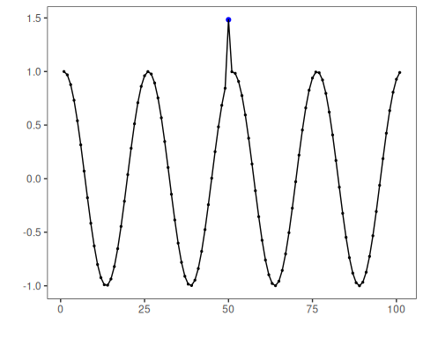
# Configure a simple baseline detector
model <- hanr_histogram(density_threshold = 0.05)
detection <- detect(model, dataset$serie)
head(detection)
## idx event type
## 1 1 TRUE anomaly
## 2 2 FALSE
## 3 3 FALSE
## 4 4 FALSE
## 5 5 FALSE
## 6 6 FALSE
# Compare detections with the labeled events
evaluation <- evaluate(model, detection$event, dataset$event)
evaluation$confMatrix
## event
## detection TRUE FALSE
## TRUE 1 1
## FALSE 0 99
# Plot detections and labels together
har_plot(model, dataset$serie, detection, dataset$event)
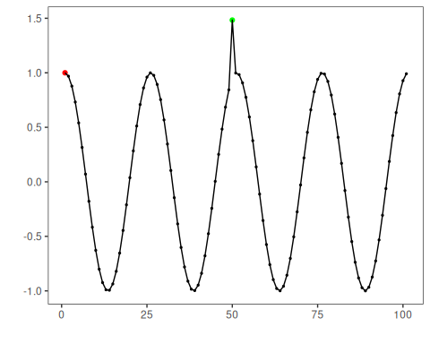

References
- Ogasawara, E., Salles, R., Porto, F., Pacitti, E. Event Detection in Time Series. Springer, 2025. doi:10.1007/978-3-031-75941-3

