Objective
This tutorial introduces a model-based anomaly detector using hanr_arima(). The goal is to show how Harbinger can detect unusual behavior by modeling expected dynamics and then analyzing residual deviations.

Method at a glance
hanr_arima() fits an ARIMA model to the series, computes residual magnitudes, and flags unusually large residuals as anomalies. This moves from a simple distribution-based baseline to a temporal model that tries to explain normal behavior first.

What you will do
- fit an ARIMA-based detector
- run anomaly detection on a labeled series
- inspect the evaluation output
- plot residual magnitudes and thresholds

Walkthrough
library(daltoolbox)
library(harbinger)
data(examples_anomalies)
dataset <- examples_anomalies$simple
# Configure and fit the ARIMA-based detector
model <- hanr_arima()
model <- fit(model, dataset$serie)
# Detect anomalies from model residuals
detection <- detect(model, dataset$serie)
head(detection)
## idx event type
## 1 1 FALSE
## 2 2 FALSE
## 3 3 FALSE
## 4 4 FALSE
## 5 5 FALSE
## 6 6 FALSE
# Evaluate against the ground truth
evaluation <- evaluate(model, detection$event, dataset$event)
evaluation$confMatrix
## event
## detection TRUE FALSE
## TRUE 1 0
## FALSE 0 100
# Plot detections on the original series
har_plot(model, dataset$serie, detection, dataset$event)
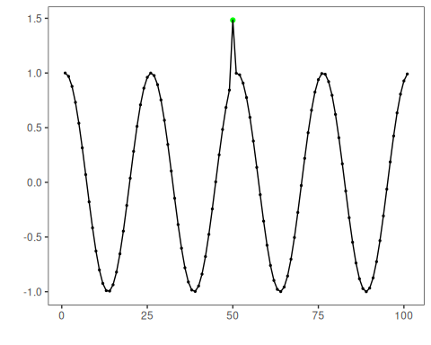
# Plot the residual signal used by the detector
har_plot(
model,
attr(detection, "res"),
detection,
dataset$event,
yline = attr(detection, "threshold")
)
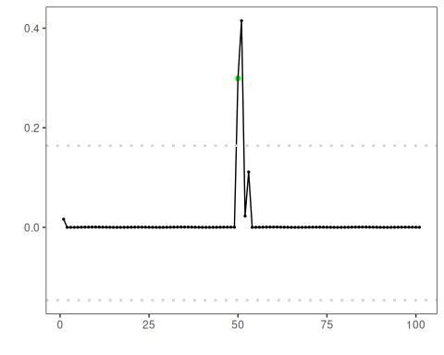

References
- Box, G. E. P., Jenkins, G. M., Reinsel, G. C., Ljung, G. M. (2015). Time Series Analysis: Forecasting and Control. Wiley.

