Objective
This tutorial introduces change-point detection with hcp_amoc(). The goal is to show how Harbinger handles structural changes, which differ from isolated anomalies because the objective is to locate a transition in the behavior of the series.

Method at a glance
hcp_amoc() searches for a single most significant change point. This is a good first method for learning because it is simple, focused, and works well as an entry point before more complex segmentation techniques.

What you will do
- load a change-point dataset
- run a single-change detector
- inspect the detected location
- plot the result against the labeled event

Walkthrough
library(harbinger)
data(examples_changepoints)
dataset <- examples_changepoints$simple
head(dataset)
## serie event
## 1 0.00 FALSE
## 2 0.25 FALSE
## 3 0.50 FALSE
## 4 0.75 FALSE
## 5 1.00 FALSE
## 6 1.25 FALSE
# Plot the original series with the known change point
har_plot(harbinger(), dataset$serie, event = dataset$event)
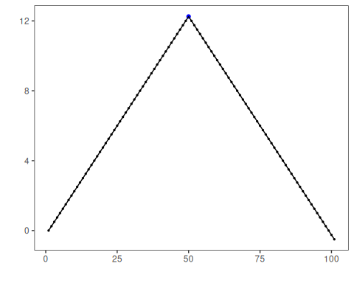
# Configure and run the AMOC detector
model <- hcp_amoc()
detection <- detect(model, dataset$serie)
detection
## idx event type
## 1 1 FALSE
## 2 2 FALSE
## 3 3 FALSE
## 4 4 FALSE
## 5 5 FALSE
## 6 6 FALSE
## 7 7 FALSE
## 8 8 FALSE
## 9 9 FALSE
## 10 10 FALSE
## 11 11 FALSE
## 12 12 FALSE
## 13 13 FALSE
## 14 14 FALSE
## 15 15 FALSE
## 16 16 FALSE
## 17 17 FALSE
## 18 18 FALSE
## 19 19 FALSE
## 20 20 FALSE
## 21 21 FALSE
## 22 22 FALSE
## 23 23 FALSE
## 24 24 FALSE
## 25 25 FALSE
## 26 26 FALSE
## 27 27 FALSE
## 28 28 FALSE
## 29 29 FALSE
## 30 30 FALSE
## 31 31 FALSE
## 32 32 FALSE
## 33 33 FALSE
## 34 34 FALSE
## 35 35 FALSE
## 36 36 FALSE
## 37 37 FALSE
## 38 38 FALSE
## 39 39 FALSE
## 40 40 FALSE
## 41 41 FALSE
## 42 42 FALSE
## 43 43 FALSE
## 44 44 FALSE
## 45 45 FALSE
## 46 46 FALSE
## 47 47 FALSE
## 48 48 FALSE
## 49 49 FALSE
## 50 50 FALSE
## 51 51 FALSE
## 52 52 FALSE
## 53 53 FALSE
## 54 54 FALSE
## 55 55 FALSE
## 56 56 FALSE
## 57 57 FALSE
## 58 58 FALSE
## 59 59 FALSE
## 60 60 FALSE
## 61 61 FALSE
## 62 62 FALSE
## 63 63 FALSE
## 64 64 FALSE
## 65 65 FALSE
## 66 66 FALSE
## 67 67 FALSE
## 68 68 FALSE
## 69 69 FALSE
## 70 70 FALSE
## 71 71 FALSE
## 72 72 FALSE
## 73 73 FALSE
## 74 74 FALSE
## 75 75 FALSE
## 76 76 FALSE
## 77 77 FALSE
## 78 78 FALSE
## 79 79 FALSE
## 80 80 FALSE
## 81 81 FALSE
## 82 82 FALSE
## 83 83 FALSE
## 84 84 TRUE changepoint
## 85 85 FALSE
## 86 86 FALSE
## 87 87 FALSE
## 88 88 FALSE
## 89 89 FALSE
## 90 90 FALSE
## 91 91 FALSE
## 92 92 FALSE
## 93 93 FALSE
## 94 94 FALSE
## 95 95 FALSE
## 96 96 FALSE
## 97 97 FALSE
## 98 98 FALSE
## 99 99 FALSE
## 100 100 FALSE
## 101 101 FALSE
# Plot detections against the labeled event
har_plot(model, dataset$serie, detection, dataset$event)
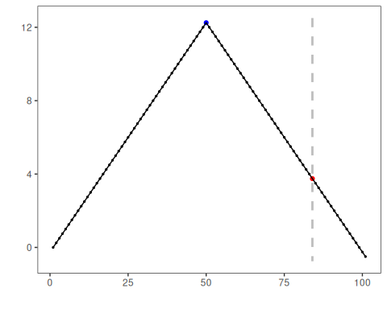

References
- Killick, R., Eckley, I. A. changepoint: An R Package for Changepoint Analysis. Journal of Statistical Software, 58(3), 2014.

