Objective
This tutorial shows how mas() can be used as a transformation before a modeling step. The goal is to understand how smoothing removes part of the local variation and exposes broader movement patterns in the series.

Method at a glance
mas() computes a simple moving average. A short window keeps more local detail, while a larger window produces a smoother signal. This is useful before visual inspection, feature extraction, or downstream detection.

What you will do
- load a time series
- compute moving averages with two window sizes
- compare the original and transformed versions
- interpret the effect of the smoothing window

Walkthrough
library(harbinger)
data(examples_changepoints)
dataset <- examples_changepoints$simple
# Original signal
har_plot(harbinger(), dataset$serie, event = dataset$event)
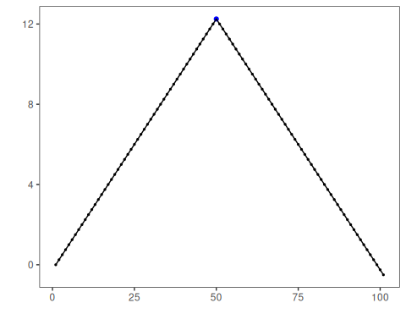
# Two smoothing levels
ma_5 <- mas(dataset$serie, order = 5)
ma_15 <- mas(dataset$serie, order = 15)
# Plot the smoother with a smaller window
har_plot(harbinger(), as.numeric(ma_5), event = dataset$event[5:length(dataset$event)])
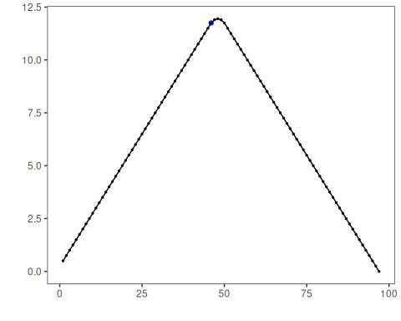
# Plot the smoother with a larger window
har_plot(harbinger(), as.numeric(ma_15), event = dataset$event[15:length(dataset$event)])
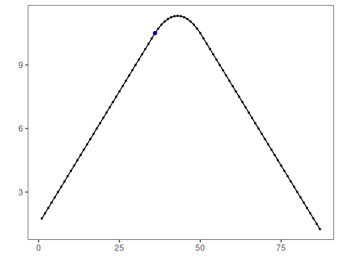

References
- Shumway, R. H., Stoffer, D. S. Time Series Analysis and Its Applications. Springer.

