Objective
This tutorial introduces symbolic transformations for time series with trans_sax() and trans_xsax(). The goal is to show how a numeric series can be re-encoded into symbols before motif or discord analysis.

Method at a glance
SAX and XSAX discretize the series into symbolic codes. SAX uses a compact alphabet, while XSAX allows a larger one. Both can simplify comparison and highlight shape patterns that are easier to study symbolically than numerically.

What you will do
- load a motif example series
- transform the signal with SAX
- transform the same signal with XSAX
- compare the first symbolic values returned by each method

Walkthrough
library(daltoolbox)
library(harbinger)
data(examples_motifs)
dataset <- examples_motifs$simple
har_plot(harbinger(), dataset$serie, event = dataset$event)
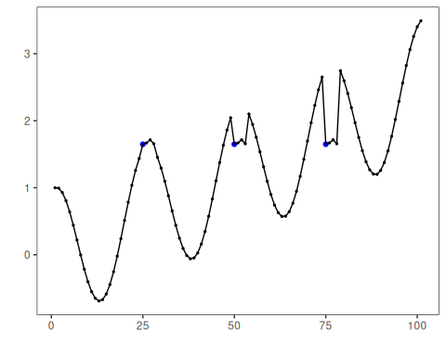
# SAX uses a compact symbolic alphabet
sax_model <- trans_sax(alpha = 8)
sax_model <- fit(sax_model, dataset$serie)
sax_series <- transform(sax_model, dataset$serie)
head(sax_series, 20)
## [1] "D" "D" "D" "C" "C" "B" "B" "B" "A" "A" "A" "A" "A" "A" "A" "A" "A" "A" "B" "B"
# XSAX uses a larger alphabet for finer symbolic resolution
xsax_model <- trans_xsax(alpha = 16)
xsax_model <- fit(xsax_model, dataset$serie)
xsax_series <- transform(xsax_model, dataset$serie)
head(xsax_series, 20)
## [1] "6" "6" "6" "5" "4" "3" "2" "2" "1" "0" "0" "0" "0" "0" "0" "0" "1" "1" "2" "3"
# Compare the symbolic encodings side by side
head(
data.frame(
value = dataset$serie,
sax = sax_series,
xsax = xsax_series
),
20
)
## value sax xsax
## 1 1.000000000 D 6
## 2 0.993912422 D 6
## 3 0.927582562 D 6
## 4 0.806688869 C 5
## 5 0.640302306 C 4
## 6 0.440322362 B 3
## 7 0.220737202 B 2
## 8 -0.003246056 B 2
## 9 -0.216146837 A 1
## 10 -0.403173623 A 0
## 11 -0.551143616 A 0
## 12 -0.649302379 A 0
## 13 -0.689992497 A 0
## 14 -0.669129676 A 0
## 15 -0.586456687 A 0
## 16 -0.445559357 A 0
## 17 -0.253643621 A 1
## 18 -0.021087490 A 1
## 19 0.239204201 B 2
## 20 0.512602153 B 3

References
- Lin, J., Keogh, E., Lonardi, S., Chiu, B. (2007). A symbolic representation of time series, with implications for streaming algorithms. Data Mining and Knowledge Discovery, 15, 107-144.

