Objective
This tutorial closes the guided path with repeated-pattern and rare-pattern analysis. The goal is to show that Harbinger is not limited to anomaly or change-point detection: it also supports motif discovery and symbolic pattern analysis.

Method at a glance
Motifs are repeated subsequences, while discords are unusual subsequences. In this first contact, we use a motif example series and run a symbolic motif-oriented method so the reader can connect the earlier transformation tutorials with downstream sequence analysis.

What you will do
- load a motif example series
- run a symbolic motif method
- inspect the detected subsequences
- plot the result

Walkthrough
library(daltoolbox)
library(harbinger)
data(examples_motifs)
dataset <- examples_motifs$simple
har_plot(harbinger(), dataset$serie, event = dataset$event)
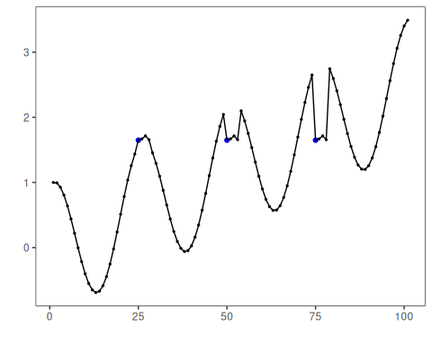
# Configure a symbolic motif detector
model <- hmo_sax(8, 15, 3)
model <- fit(model, dataset$serie)
detection <- detect(model, dataset$serie)
head(detection)
## idx event type seq seqlen
## 1 1 FALSE NA 15
## 2 2 FALSE NA 15
## 3 3 FALSE NA 15
## 4 4 FALSE NA 15
## 5 5 FALSE NA 15
## 6 6 FALSE NA 15
# Plot the motif-oriented result
har_plot(model, dataset$serie, detection, dataset$event)


References
- Lin, J., Keogh, E., Lonardi, S., Chiu, B. (2007). A symbolic representation of time series, with implications for streaming algorithms. Data Mining and Knowledge Discovery, 15, 107-144.
- Ogasawara, E., Salles, R., Porto, F., Pacitti, E. Event Detection in Time Series. Springer, 2025. doi:10.1007/978-3-031-75941-3

