Objective
This notebook introduces the Numenta Anomaly Benchmark datasets exposed by Harbinger. For each NAB dataset object, it demonstrates how to load the full collection with loadfulldata(), count the available series, inspect the structure, and plot the first available signal with har_plot().

Method at a glance
The focus is on dataset inspection. NAB is often used as a benchmark family, so this notebook helps the reader understand the shape of each object before choosing a detection workflow. To avoid overly long figures, each plot uses at most the first 1000 observations of the first series.

What you will do
- load each NAB object with data() and loadfulldata()
- count how many series are available in the full dataset
- verify that the first series is univariate
- plot a short preview of the first signal and its labels

Helper Functions
library(harbinger)
dataset_summary <- function(x) {
first_series <- x[[1]]
meta_cols <- c("idx", "event", "type", "seq", "seqlen")
signal_cols <- setdiff(names(first_series), meta_cols)
dataset_type <- if ("value" %in% names(first_series) || length(signal_cols) == 1) "univariate" else "multivariate"
plot_column <- if ("value" %in% names(first_series)) "value" else signal_cols[1]
list(
n_series = length(x),
dataset_type = dataset_type,
signal_cols = signal_cols,
plot_column = plot_column,
preview_size = min(1000, nrow(first_series)),
first_series = first_series
)
}
show_dataset <- function(x, name) {
info <- dataset_summary(x)
cat("Dataset:", name, "\n")
cat("Number of series:", info$n_series, "\n")
cat("Dataset type:", info$dataset_type, "\n")
cat("Signals in the first series:", paste(info$signal_cols, collapse = ", "), "\n")
cat("Column plotted with har_plot():", info$plot_column, "\n")
cat("Plot preview length:", info$preview_size, "observations\n")
invisible(info)
}
plot_dataset_preview <- function(info) {
preview <- info$first_series[seq_len(info$preview_size), , drop = FALSE]
har_plot(
harbinger(),
preview[[info$plot_column]],
event = preview$event
)
}

nab_artificialWithAnomaly
data(nab_artificialWithAnomaly)
nab_artificialWithAnomaly <- loadfulldata(nab_artificialWithAnomaly)
nab_artificial_info <- show_dataset(nab_artificialWithAnomaly, "nab_artificialWithAnomaly")
## Dataset: nab_artificialWithAnomaly
## Number of series: 5
## Dataset type: univariate
## Signals in the first series: value
## Column plotted with har_plot(): value
## Plot preview length: 1000 observations
plot_dataset_preview(nab_artificial_info)
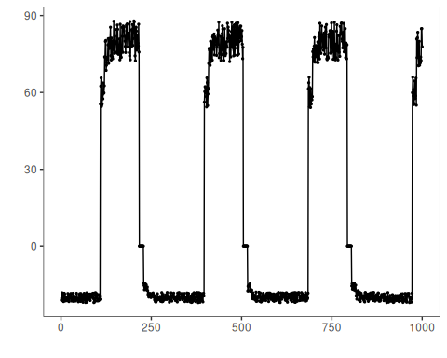

nab_realAdExchange
data(nab_realAdExchange)
nab_realAdExchange <- loadfulldata(nab_realAdExchange)
nab_adexchange_info <- show_dataset(nab_realAdExchange, "nab_realAdExchange")
## Dataset: nab_realAdExchange
## Number of series: 6
## Dataset type: univariate
## Signals in the first series: value
## Column plotted with har_plot(): value
## Plot preview length: 1000 observations
plot_dataset_preview(nab_adexchange_info)
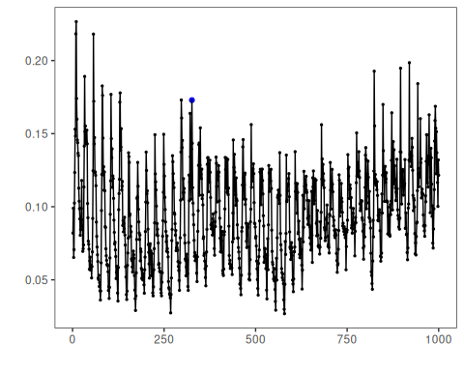

nab_realAWSCloudwatch
data(nab_realAWSCloudwatch)
nab_realAWSCloudwatch <- loadfulldata(nab_realAWSCloudwatch)
nab_aws_info <- show_dataset(nab_realAWSCloudwatch, "nab_realAWSCloudwatch")
## Dataset: nab_realAWSCloudwatch
## Number of series: 6
## Dataset type: univariate
## Signals in the first series: value
## Column plotted with har_plot(): value
## Plot preview length: 1000 observations
plot_dataset_preview(nab_aws_info)
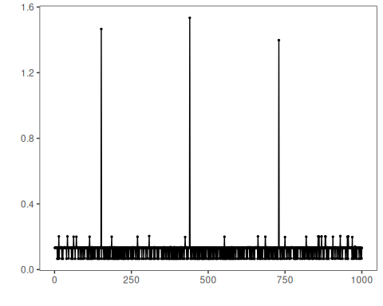

nab_realKnownCause
data(nab_realKnownCause)
nab_realKnownCause <- loadfulldata(nab_realKnownCause)
nab_known_info <- show_dataset(nab_realKnownCause, "nab_realKnownCause")
## Dataset: nab_realKnownCause
## Number of series: 7
## Dataset type: univariate
## Signals in the first series: value
## Column plotted with har_plot(): value
## Plot preview length: 1000 observations
plot_dataset_preview(nab_known_info)
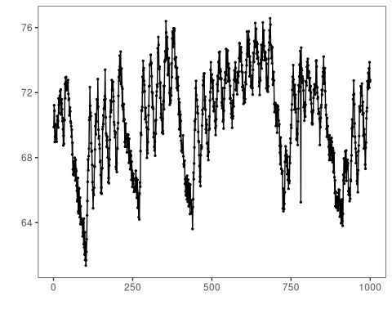

nab_realTraffic
data(nab_realTraffic)
nab_realTraffic <- loadfulldata(nab_realTraffic)
nab_traffic_info <- show_dataset(nab_realTraffic, "nab_realTraffic")
## Dataset: nab_realTraffic
## Number of series: 7
## Dataset type: univariate
## Signals in the first series: value
## Column plotted with har_plot(): value
## Plot preview length: 1000 observations
plot_dataset_preview(nab_traffic_info)
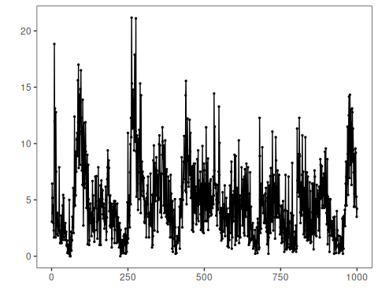

nab_realTweets
data(nab_realTweets)
nab_realTweets <- loadfulldata(nab_realTweets)
nab_tweets_info <- show_dataset(nab_realTweets, "nab_realTweets")
## Dataset: nab_realTweets
## Number of series: 10
## Dataset type: univariate
## Signals in the first series: value
## Column plotted with har_plot(): value
## Plot preview length: 1000 observations
plot_dataset_preview(nab_tweets_info)
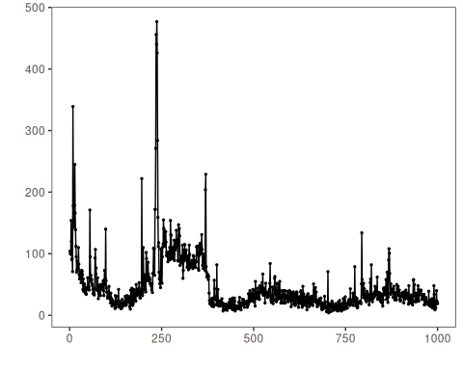

References
- Lavin, A., Ahmad, S. (2015). Evaluating real-time anomaly detection algorithms: the Numenta Anomaly Benchmark.
- Ogasawara, E., Salles, R., Porto, F., Pacitti, E. Event Detection in Time Series. Springer, 2025. doi:10.1007/978-3-031-75941-3

