Objective
This notebook demonstrates how to inspect the UCR Anomaly Archive datasets distributed by Harbinger. Each example loads the full dataset with loadfulldata(), counts the available series, identifies the structure, and plots the first signal with har_plot().

Method at a glance
The emphasis is on understanding the data layout before applying an event-detection method. The same inspection pattern is repeated for each UCR dataset object. To keep the figures didactic, only the first 1000 observations of the preview series are plotted.

What you will do
- load each UCR dataset object and expand it to the full collection
- count the number of series available
- inspect the first series and confirm the signal column
- plot a short preview of the first signal and its labels

Helper Functions
library(harbinger)
dataset_summary <- function(x) {
first_series <- x[[1]]
meta_cols <- c("idx", "event", "type", "seq", "seqlen")
signal_cols <- setdiff(names(first_series), meta_cols)
dataset_type <- if ("value" %in% names(first_series) || length(signal_cols) == 1) "univariate" else "multivariate"
plot_column <- if ("value" %in% names(first_series)) "value" else signal_cols[1]
list(
n_series = length(x),
dataset_type = dataset_type,
signal_cols = signal_cols,
plot_column = plot_column,
preview_size = min(1000, nrow(first_series)),
first_series = first_series
)
}
show_dataset <- function(x, name) {
info <- dataset_summary(x)
cat("Dataset:", name, "\n")
cat("Number of series:", info$n_series, "\n")
cat("Dataset type:", info$dataset_type, "\n")
cat("Signals in the first series:", paste(info$signal_cols, collapse = ", "), "\n")
cat("Column plotted with har_plot():", info$plot_column, "\n")
cat("Plot preview length:", info$preview_size, "observations\n")
invisible(info)
}
plot_dataset_preview <- function(info) {
preview <- info$first_series[seq_len(info$preview_size), , drop = FALSE]
har_plot(
harbinger(),
preview[[info$plot_column]],
event = preview$event
)
}

ucr_ecg
data(ucr_ecg)
ucr_ecg <- loadfulldata(ucr_ecg)
ucr_ecg_info <- show_dataset(ucr_ecg, "ucr_ecg")
## Dataset: ucr_ecg
## Number of series: 10
## Dataset type: univariate
## Signals in the first series: value
## Column plotted with har_plot(): value
## Plot preview length: 1000 observations
plot_dataset_preview(ucr_ecg_info)
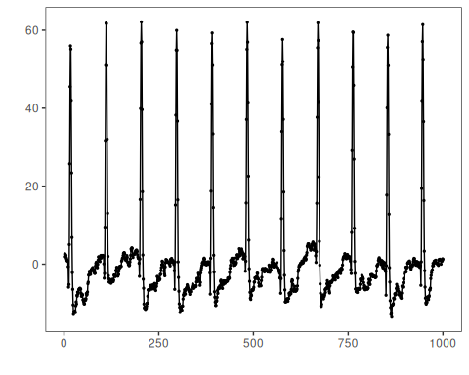

ucr_nasa
data(ucr_nasa)
ucr_nasa <- loadfulldata(ucr_nasa)
ucr_nasa_info <- show_dataset(ucr_nasa, "ucr_nasa")
## Dataset: ucr_nasa
## Number of series: 11
## Dataset type: univariate
## Signals in the first series: value
## Column plotted with har_plot(): value
## Plot preview length: 1000 observations
plot_dataset_preview(ucr_nasa_info)
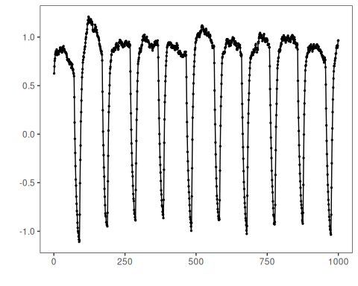

ucr_int_bleeding
data(ucr_int_bleeding)
ucr_int_bleeding <- loadfulldata(ucr_int_bleeding)
ucr_bleeding_info <- show_dataset(ucr_int_bleeding, "ucr_int_bleeding")
## Dataset: ucr_int_bleeding
## Number of series: 10
## Dataset type: univariate
## Signals in the first series: value
## Column plotted with har_plot(): value
## Plot preview length: 1000 observations
plot_dataset_preview(ucr_bleeding_info)
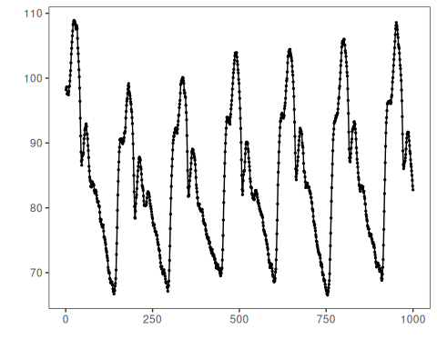

ucr_power_demand
data(ucr_power_demand)
ucr_power_demand <- loadfulldata(ucr_power_demand)
ucr_power_info <- show_dataset(ucr_power_demand, "ucr_power_demand")
## Dataset: ucr_power_demand
## Number of series: 11
## Dataset type: univariate
## Signals in the first series: value
## Column plotted with har_plot(): value
## Plot preview length: 1000 observations
plot_dataset_preview(ucr_power_info)
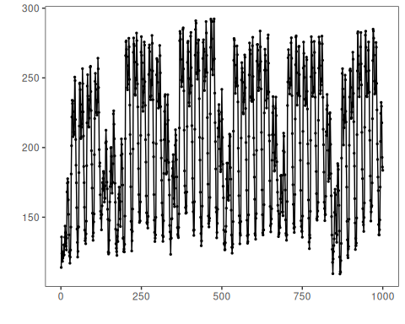

References
- UCR Time Series Anomaly Archive.
- Ogasawara, E., Salles, R., Porto, F., Pacitti, E. Event Detection in Time Series. Springer, 2025. doi:10.1007/978-3-031-75941-3

