Objective
This notebook introduces the multivariate 3W oil-well datasets bundled through Harbinger. For each dataset object, it loads the full collection with loadfulldata(), reports how many series are available, confirms that the collection is multivariate, and plots the first sensor column from the first series with har_plot().

Method at a glance
This is a data-inspection notebook aimed at multivariate industrial series. The key point is to show how to identify the sensor columns and choose a first variable for visual inspection. To keep the plots readable, each preview uses at most the first 1000 observations.

What you will do
- load each 3W dataset object and expand it to the full collection
- count the number of multivariate series available
- inspect the first-series sensor columns
- plot a short preview of the first sensor column together with its labels

Helper Functions
library(harbinger)
dataset_summary <- function(x) {
first_series <- x[[1]]
meta_cols <- c("idx", "event", "type", "seq", "seqlen")
signal_cols <- setdiff(names(first_series), meta_cols)
dataset_type <- if ("value" %in% names(first_series) || length(signal_cols) == 1) "univariate" else "multivariate"
plot_column <- if ("value" %in% names(first_series)) "value" else signal_cols[1]
list(
n_series = length(x),
dataset_type = dataset_type,
signal_cols = signal_cols,
plot_column = plot_column,
preview_size = min(1000, nrow(first_series)),
first_series = first_series
)
}
show_dataset <- function(x, name) {
info <- dataset_summary(x)
cat("Dataset:", name, "\n")
cat("Number of series:", info$n_series, "\n")
cat("Dataset type:", info$dataset_type, "\n")
cat("Signals in the first series:", paste(info$signal_cols, collapse = ", "), "\n")
cat("Column plotted with har_plot():", info$plot_column, "\n")
cat("Plot preview length:", info$preview_size, "observations\n")
invisible(info)
}
plot_dataset_preview <- function(info) {
preview <- info$first_series[seq_len(info$preview_size), , drop = FALSE]
har_plot(
harbinger(),
preview[[info$plot_column]],
event = preview$event
)
}

oil_3w_Type_1
data(oil_3w_Type_1)
oil_3w_Type_1 <- loadfulldata(oil_3w_Type_1)
oil_type_1_info <- show_dataset(oil_3w_Type_1, "oil_3w_Type_1")
## Dataset: oil_3w_Type_1
## Number of series: 5
## Dataset type: multivariate
## Signals in the first series: p_pdg, p_tpt, t_tpt, p_mon_ckp, t_jus_ckp, p_jus_ckgl, qgl
## Column plotted with har_plot(): p_pdg
## Plot preview length: 1000 observations
plot_dataset_preview(oil_type_1_info)
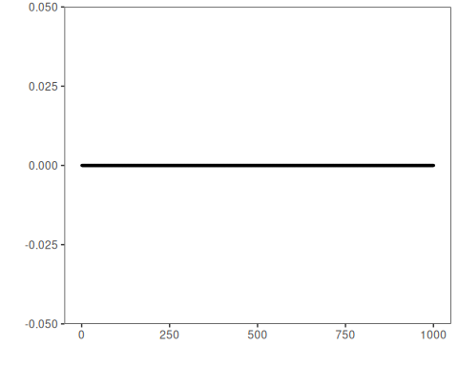

oil_3w_Type_2
data(oil_3w_Type_2)
oil_3w_Type_2 <- loadfulldata(oil_3w_Type_2)
oil_type_2_info <- show_dataset(oil_3w_Type_2, "oil_3w_Type_2")
## Dataset: oil_3w_Type_2
## Number of series: 6
## Dataset type: multivariate
## Signals in the first series: p_pdg, p_tpt, t_tpt, p_mon_ckp, t_jus_ckp, p_jus_ckgl, qgl
## Column plotted with har_plot(): p_pdg
## Plot preview length: 1000 observations
plot_dataset_preview(oil_type_2_info)


oil_3w_Type_4
data(oil_3w_Type_4)
oil_3w_Type_4 <- loadfulldata(oil_3w_Type_4)
oil_type_4_info <- show_dataset(oil_3w_Type_4, "oil_3w_Type_4")
## Dataset: oil_3w_Type_4
## Number of series: 3
## Dataset type: multivariate
## Signals in the first series: p_jus_ckgl, p_mon_ckp, p_pdg, p_tpt, qgl, t_jus_ckp, t_pdg, t_tpt
## Column plotted with har_plot(): p_jus_ckgl
## Plot preview length: 1000 observations
plot_dataset_preview(oil_type_4_info)
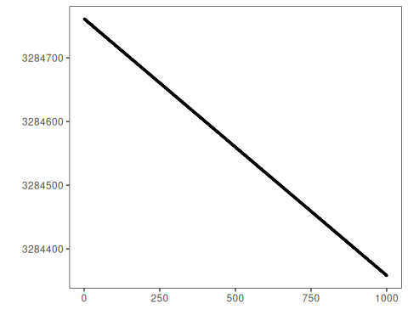

oil_3w_Type_5
data(oil_3w_Type_5)
oil_3w_Type_5 <- loadfulldata(oil_3w_Type_5)
oil_type_5_info <- show_dataset(oil_3w_Type_5, "oil_3w_Type_5")
## Dataset: oil_3w_Type_5
## Number of series: 12
## Dataset type: multivariate
## Signals in the first series: p_pdg, p_tpt, t_tpt, p_mon_ckp, t_jus_ckp, p_jus_ckgl, qgl
## Column plotted with har_plot(): p_pdg
## Plot preview length: 1000 observations
plot_dataset_preview(oil_type_5_info)
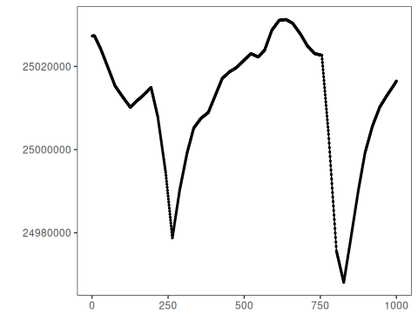

oil_3w_Type_6
data(oil_3w_Type_6)
oil_3w_Type_6 <- loadfulldata(oil_3w_Type_6)
oil_type_6_info <- show_dataset(oil_3w_Type_6, "oil_3w_Type_6")
## Dataset: oil_3w_Type_6
## Number of series: 6
## Dataset type: multivariate
## Signals in the first series: P_PDG, P_TPT, T_TPT, P_MON_CKP, T_JUS_CKP, P_JUS_CKGL, QGL
## Column plotted with har_plot(): P_PDG
## Plot preview length: 1000 observations
plot_dataset_preview(oil_type_6_info)


oil_3w_Type_7
data(oil_3w_Type_7)
oil_3w_Type_7 <- loadfulldata(oil_3w_Type_7)
oil_type_7_info <- show_dataset(oil_3w_Type_7, "oil_3w_Type_7")
## Dataset: oil_3w_Type_7
## Number of series: 4
## Dataset type: multivariate
## Signals in the first series: P_PDG, P_TPT, T_TPT, P_MON_CKP, T_JUS_CKP, P_JUS_CKGL, QGL
## Column plotted with har_plot(): P_PDG
## Plot preview length: 1000 observations
plot_dataset_preview(oil_type_7_info)


oil_3w_Type_8
data(oil_3w_Type_8)
oil_3w_Type_8 <- loadfulldata(oil_3w_Type_8)
oil_type_8_info <- show_dataset(oil_3w_Type_8, "oil_3w_Type_8")
## Dataset: oil_3w_Type_8
## Number of series: 3
## Dataset type: multivariate
## Signals in the first series: p_pdg, p_tpt, t_tpt, p_mon_ckp, p_jus_ckgl, qgl
## Column plotted with har_plot(): p_pdg
## Plot preview length: 1000 observations
plot_dataset_preview(oil_type_8_info)


References
- 3W dataset documentation from the UCI Machine Learning Repository.
- Ogasawara, E., Salles, R., Porto, F., Pacitti, E. Event Detection in Time Series. Springer, 2025. doi:10.1007/978-3-031-75941-3

