Objective
This tutorial shows supervised anomaly detection with an SVM classifier over a labeled train/test split.
Steps: - Load and visualize the dataset - Normalize, train SVM, evaluate on train and test - Plot detections and residual magnitudes

Method at a glance
SVM classification anomaly detector: Supervised anomaly detection with an SVM classifier trained on labeled events; positive-class probabilities above a threshold correspond to detected events.

What you will do
- understand the purpose of the example and when the technique is useful
- follow the workflow from data loading to model fitting and detection
- inspect the evaluation outputs and the diagnostic plots produced by Harbinger

Prepare the Example
This setup anchors the notebook in the specific series used to examine 26-classification-hanc_ml_svm. The semantic point is the one stated above: sVM classification anomaly detector: Supervised anomaly detection with an SVM classifier trained on labeled events; positive-class probabilities above a threshold correspond to detected events, so the raw signal needs to be visible before any fitting step hides that structure behind model output.
# Install Harbinger (if needed)
#install.packages("harbinger")
# Load required packages
library(daltoolbox)
library(harbinger)
# Load example anomaly datasets
data(examples_anomalies)
# Select the train/test dataset
dataset <- examples_anomalies$tt
head(dataset)
## serie event
## 1 1.0000000 FALSE
## 2 0.9689124 FALSE
## 3 0.8775826 FALSE
## 4 0.7316889 FALSE
## 5 0.5403023 FALSE
## 6 0.3153224 FALSE

Interpret the Result Visually
This first visual pass establishes what the method should react to in the raw series. Keep the method summary in mind here, because sVM classification anomaly detector: Supervised anomaly detection with an SVM classifier trained on labeled events; positive-class probabilities above a threshold correspond to detected events and the plot tells you whether that structure is clean, weak, local, repeated, or mixed with other effects.
# Plot the raw time series
har_plot(harbinger(), dataset$serie)
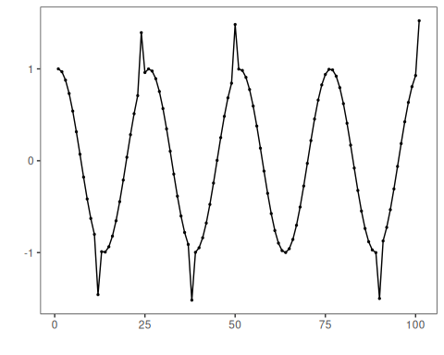

Configure the Method
The choices below turn the central modeling idea into concrete parameters. They matter because sVM classification anomaly detector: Supervised anomaly detection with an SVM classifier trained on labeled events; positive-class probabilities above a threshold correspond to detected events, so each argument controls how strongly the method will emphasize that pattern when it later produces event classifications.
# Split into train/test and normalize features
train <- dataset[1:80,]
test <- dataset[-(1:80),]
norm <- minmax()
norm <- fit(norm, train)
train_n <- transform(norm, train)
summary(train_n)
## serie event
## Min. :0.0000 Mode :logical
## 1st Qu.:0.2859 FALSE:76
## Median :0.5348 TRUE :4
## Mean :0.5221
## 3rd Qu.:0.7587
## Max. :1.0000
# Configure SVM classifier
model <- hanc_ml(cla_svm("event", c("FALSE", "TRUE"), epsilon = 0.0, cost = 20.000))
# Fit on training data and evaluate on train
model <- fit(model, train_n)
detection <- detect(model, train_n)
print(detection |> dplyr::filter(event == TRUE))
## idx event type
## 1 12 TRUE anomaly
## 2 24 TRUE anomaly
## 3 38 TRUE anomaly
## 4 50 TRUE anomaly
evaluation <- evaluate(model, detection$event, as.logical(train_n$event))
print(evaluation$confMatrix)
## event
## detection TRUE FALSE
## TRUE 4 0
## FALSE 0 76

Interpret the Result Visually
This visual check puts the model output back on top of the original signal. What matters now is whether the highlighted event classifications line up with the structure suggested by the method, which is the real semantic test of whether the example is teaching the right lesson.
# Plot training detections
har_plot(model, train_n$serie, detection, as.logical(train_n$event))
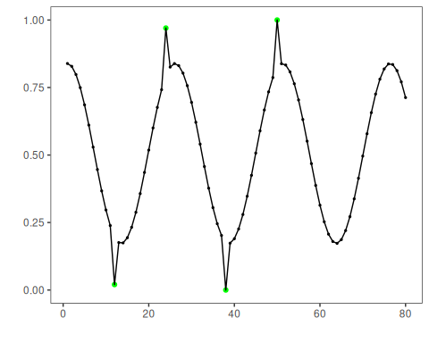

Run the Core Analysis
This is the moment where the notebook tests its central assumption on actual data. After applying 26-classification-hanc_ml_svm, the important question is whether the resulting event classifications really correspond to the pattern implied by the method description above, rather than to arbitrary numerical variation.
# Prepare normalized test set
test_n <- transform(norm, test)
# Detect and evaluate on test
detection <- detect(model, test_n)
print(detection |> dplyr::filter(event == TRUE))
## idx event type
## 1 10 TRUE anomaly
## 2 21 TRUE anomaly
evaluation <- evaluate(model, detection$event, as.logical(test_n$event))
print(evaluation$confMatrix)
## event
## detection TRUE FALSE
## TRUE 2 0
## FALSE 0 19

Interpret the Result Visually
This visual check puts the model output back on top of the original signal. What matters now is whether the highlighted event classifications line up with the structure suggested by the method, which is the real semantic test of whether the example is teaching the right lesson.
# Plot test detections
har_plot(model, test_n$serie, detection, as.logical(test_n$event))
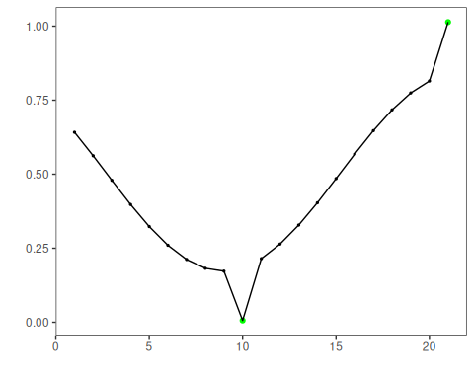
# Plot residual magnitude and decision threshold
har_plot(model, attr(detection, "res"), detection, test_n$event, yline = attr(detection, "threshold"))
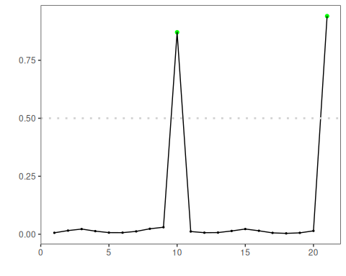

References
- Bishop, C. M. (2006). Pattern Recognition and Machine Learning. Springer.

