Objective
This notebook demonstrates change-point detection with a linear-regression-based ChangeFinder (hcp_cf_lr). The method scores short-term prediction residuals and flags structural changes when the residual pattern becomes persistent.

Method at a glance
ChangeFinder with linear regression models residual deviations, smooths the score over time, and applies a threshold to highlight structural changes. Thresholding is handled by harutils().

What you will do
- load the example data and inspect the raw series
- configure the detector with a sliding window
- fit the model, detect change points, evaluate the result, and plot the output

Prepare the Example
This setup anchors the notebook in the specific series used to examine hcp_cf_lr. The key idea is that the detector works on residual deviations, so the raw signal should be visible before any fitting step hides that structure behind model output.
source(url("https://raw.githubusercontent.com/cefet-rj-dal/harbinger/master/examples/seed.R"))
# Install Harbinger (only once, if needed)
#install.packages("harbinger")
# Load required packages
library(daltoolbox)
library(harbinger)
# Load example datasets bundled with harbinger
data(examples_changepoints)
# Select the same labeled series used in the AMOC example
dataset <- examples_changepoints$complex
head(dataset)
## serie event
## 1 0.3129618 FALSE
## 2 0.5944808 FALSE
## 3 0.8162731 FALSE
## 4 0.9560557 FALSE
## 5 0.9997847 FALSE
## 6 0.9430667 FALSE

Interpret the Result Visually
This first visual pass establishes what the method should react to in the raw series. Keep the method summary in mind here, because the plot reveals whether the signal contains clean, weak, local, repeated, or mixed structural changes.
# Plot the time series
har_plot(harbinger(), dataset$serie)
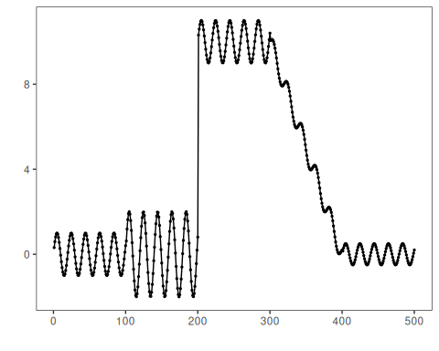

Configure the Method
The choices below turn the central modeling idea into concrete parameters. Each argument controls how strongly the method emphasizes residual shifts when it produces change-point candidates.
# Define the ChangeFinder-LR model
# - sw_size controls the sliding window length
model <- hcp_cf_lr(sw_size = 10)
# Fit the model
set_example_seed()
model <- fit(model, dataset$serie)

Run the Core Analysis
This is the moment where the notebook tests its central assumption on actual data. After applying hcp_cf_lr, the question is whether the resulting change-point candidates correspond to the residual pattern described above rather than to arbitrary numerical variation.
# Detect change-points
detection <- detect(model, dataset$serie)
# Show only timestamps flagged as events
print(detection |> dplyr::filter(event == TRUE))
## idx event type
## 1 232 TRUE changepoint

Evaluate What Was Found
The evaluation asks whether the change-point candidates produced by hcp_cf_lr match the labeled structure on this dataset. Read the scores as evidence about the method’s assumptions in practice, not as detached summary numbers.
# Evaluate detections against ground-truth labels
evaluation <- evaluate(model, detection$event, dataset$event)
print(evaluation$confMatrix)
## event
## detection TRUE FALSE
## TRUE 0 1
## FALSE 4 495

Interpret the Result Visually
This visual check puts the model output back on top of the original signal. What matters now is whether the highlighted change-point candidates line up with the structure suggested by the method, which is the real semantic test of whether the example is teaching the right lesson.
# Plot detections over the series
har_plot(model, dataset$serie, detection, dataset$event)
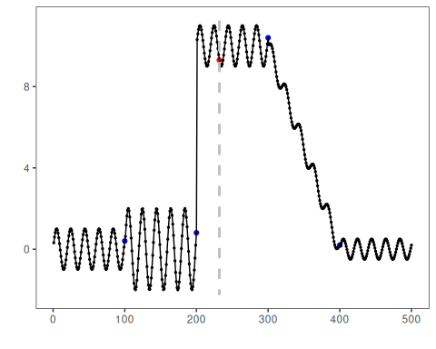
# Plot residual scores and threshold
har_plot(model, attr(detection, "res"), detection, dataset$event, yline = attr(detection, "threshold"))
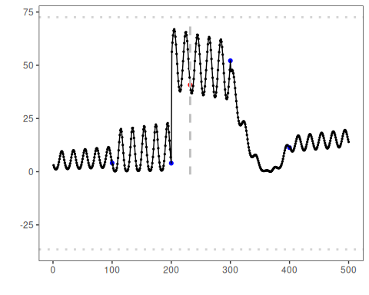

References
- Takeuchi, J., Yamanishi, K. (2006). A unifying framework for detecting outliers and change points from time series. IEEE TKDE. doi:10.1109/TKDE.2006.1599387

