Custom Sequence-Anomaly Detector

Objective
The goal of this example is to show a customization that is especially important for collective or sequence anomalies: the detector should return the anomalous range itself, not only a single representative timestamp inside that range.
This notebook complements the custom range-aware evaluator. The two ideas belong together: if the target phenomenon is an anomalous interval, both detection and evaluation should operate on intervals.

Why this method matters
Many anomaly workflows start by scoring each timestamp separately and then applying a candidate-selection rule that keeps only one point per contiguous group. That is often acceptable for isolated point anomalies, but it can be a poor representation for collective anomalies.
When the anomaly is a sequence, collapsing the whole segment to one point creates two problems:
- it hides the duration of the abnormal behavior;
- it makes it harder to use interval-aware metrics and to reason about overlap with the ground truth.
This custom example therefore focuses on a different candidate-selection philosophy: once an anomalous run is detected, keep the full run.

Method at a glance
The detector computes a rolling median baseline and a rolling MAD scale. It then converts each observation into a robust local z-score. Consecutive points whose score exceeds a threshold are grouped into anomalous runs, and only runs with at least min_run points are kept.
The key customization is not only the scoring function, but the candidate-selection rule: instead of choosing the first or highest point in each group, the detector marks the whole contiguous interval as anomalous.

Prepare the Example
This setup anchors the notebook in the specific series used to examine 03-sequence-custom_sequence_anomaly. The semantic point is the one stated above: the detector computes a rolling median baseline and a rolling MAD scale, so the raw signal needs to be visible before any fitting step hides that structure behind model output.
source(url("https://raw.githubusercontent.com/cefet-rj-dal/harbinger/master/examples/seed.R"))
# installation
# install.packages(c("harbinger", "daltoolbox"))
library(daltoolbox)
library(harbinger)

Define the Support Structures
The code below defines the smallest Harbinger contract needed to express the idea behind this example. Read it in semantic terms: the goal is to encode that the detector computes a rolling median baseline and a rolling MAD scale while still returning objects that Harbinger can plot and evaluate like any native method.
hanr_sequence_mad_custom <- function(window_size = 11, z_threshold = 3, min_run = 3) {
obj <- harbinger()
obj$window_size <- window_size
obj$z_threshold <- z_threshold
obj$min_run <- min_run
class(obj) <- append("hanr_sequence_mad_custom", class(obj))
obj
}
detect.hanr_sequence_mad_custom <- function(obj, serie, ...) {
obj <- obj$har_store_refs(obj, serie)
y <- as.numeric(obj$serie)
k <- obj$window_size
if (k %% 2 == 0) {
k <- k + 1
}
baseline <- zoo::rollmedian(y, k = k, fill = NA, align = "center")
local_mad <- zoo::rollapply(
y,
width = k,
FUN = function(v) stats::mad(v, constant = 1),
fill = NA,
align = "center"
)
# Use the nearest observed values on the borders so the whole series can be scored
baseline <- zoo::na.locf(baseline, na.rm = FALSE)
baseline <- zoo::na.locf(baseline, fromLast = TRUE, na.rm = FALSE)
local_mad <- zoo::na.locf(local_mad, na.rm = FALSE)
local_mad <- zoo::na.locf(local_mad, fromLast = TRUE, na.rm = FALSE)
local_mad[local_mad == 0 | is.na(local_mad)] <- 1e-8
score <- abs(y - baseline) / local_mad
raw_flags <- score > obj$z_threshold
# Build contiguous runs of TRUE values and keep only sufficiently long runs
idx_true <- which(raw_flags)
runs <- if (length(idx_true) == 0) list(integer(0)) else split(idx_true, cumsum(c(1, diff(idx_true) != 1)))
range_flags <- rep(FALSE, length(y))
for (run in runs) {
if (length(run) >= obj$min_run) {
range_flags[run] <- TRUE
}
}
detection <- obj$har_restore_refs(obj, anomalies = range_flags, res = score)
attr(detection, "threshold") <- obj$z_threshold
detection
}
To compare interval-aware evaluation in the same notebook, we define a small range-based evaluator that scores overlap between detected ranges and true ranges.
har_eval_range_custom <- function(alpha = 0.5) {
obj <- daltoolbox::dal_base()
obj$alpha <- alpha
class(obj) <- append("har_eval_range_custom", class(obj))
obj
}
to_ranges <- function(flags) {
flags <- as.logical(flags)
flags[is.na(flags)] <- FALSE
idx <- which(flags)
if (length(idx) == 0) {
return(data.frame(start = integer(0), end = integer(0), length = integer(0)))
}
groups <- split(idx, cumsum(c(1, diff(idx) != 1)))
starts <- vapply(groups, min, integer(1))
ends <- vapply(groups, max, integer(1))
data.frame(start = starts, end = ends, length = ends - starts + 1)
}
range_overlap <- function(a_start, a_end, b_start, b_end) {
max(0, min(a_end, b_end) - max(a_start, b_start) + 1)
}
evaluate.har_eval_range_custom <- function(obj, detection, event, ...) {
det_ranges <- to_ranges(detection)
evt_ranges <- to_ranges(event)
if (nrow(det_ranges) == 0 || nrow(evt_ranges) == 0) {
return(list(precision = 0, recall = 0, F1 = 0, alpha = obj$alpha))
}
recall_scores <- numeric(nrow(evt_ranges))
for (i in seq_len(nrow(evt_ranges))) {
overlaps <- mapply(
range_overlap,
evt_ranges$start[i], evt_ranges$end[i],
det_ranges$start, det_ranges$end
)
best_overlap <- max(overlaps)
existence_reward <- as.numeric(best_overlap > 0)
overlap_reward <- best_overlap / evt_ranges$length[i]
recall_scores[i] <- obj$alpha * existence_reward + (1 - obj$alpha) * overlap_reward
}
precision_scores <- numeric(nrow(det_ranges))
for (i in seq_len(nrow(det_ranges))) {
overlaps <- mapply(
range_overlap,
det_ranges$start[i], det_ranges$end[i],
evt_ranges$start, evt_ranges$end
)
precision_scores[i] <- max(overlaps) / det_ranges$length[i]
}
precision <- mean(precision_scores)
recall <- mean(recall_scores)
F1 <- if ((precision + recall) == 0) 0 else 2 * precision * recall / (precision + recall)
list(precision = precision, recall = recall, F1 = F1, alpha = obj$alpha)
}
We use the sequence example because it naturally motivates collective anomaly detection.

Interpret the Result Visually
This first visual pass establishes what the method should react to in the raw series. Keep the method summary in mind here, because the detector computes a rolling median baseline and a rolling MAD scale and the plot tells you whether that structure is clean, weak, local, repeated, or mixed with other effects.
data(examples_anomalies)
dataset <- examples_anomalies$sequence
har_plot(harbinger(), dataset$serie, event = dataset$event)
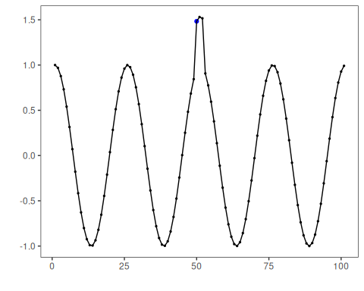

Run the Core Analysis
This is the moment where the notebook tests its central assumption on actual data. After applying 03-sequence-custom_sequence_anomaly, the important question is whether the resulting anomaly flags really correspond to the pattern implied by the method description above, rather than to arbitrary numerical variation.
model <- hanr_sequence_mad_custom(window_size = 9, z_threshold = 2.5, min_run = 2)
detection <- detect(model, dataset$serie)
head(detection[detection$event, ])
## idx event type
## 51 51 TRUE anomaly
## 52 52 TRUE anomaly

Interpret the Result Visually
This visual check puts the model output back on top of the original signal. What matters now is whether the highlighted anomaly flags line up with the structure suggested by the method, which is the real semantic test of whether the example is teaching the right lesson.
# Plot the detected anomalous interval against the labeled sequence anomaly
har_plot(model, dataset$serie, detection, dataset$event)
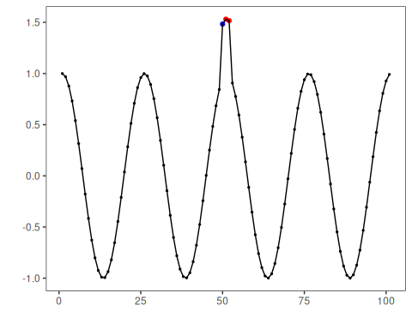

Evaluate What Was Found
The evaluation asks whether the anomaly flags produced by 03-sequence-custom_sequence_anomaly match the labeled structure on this dataset. Read the scores as evidence about the method’s assumptions in practice, not as detached summary numbers.
# Compare pointwise and range-aware evaluation
evaluate(har_eval(), detection$event, dataset$event)$confMatrix
## event
## detection TRUE FALSE
## TRUE 0 2
## FALSE 1 98
evaluate(har_eval_range_custom(alpha = 0.5), detection$event, dataset$event)
## $precision
## [1] 0
##
## $recall
## [1] 0
##
## $F1
## [1] 0
##
## $alpha
## [1] 0.5
This example makes the modeling choice explicit: sequence anomalies are better represented as ranges. Once the detector returns the whole anomalous interval, the downstream plots and the range-aware evaluator become much more informative.

References
- Chandola, V., Banerjee, A., Kumar, V. (2009). Anomaly Detection: A Survey. ACM Computing Surveys, 41(3), 15.
- Sorbo, S., Ruocco, M. (2024). Navigating the metric maze: a taxonomy of evaluation metrics for anomaly detection in time series. Data Mining and Knowledge Discovery, 38, 1027-1068. https://doi.org/10.1007/s10618-023-00988-8

