Objective
SAX (Symbolic Aggregate approXimation) maps z-normalized values to symbols; recurring words indicate motifs. In this example we:
- Load and visualize a motif dataset
- Configure hmo_sax(a, w, qtd) and run detection
- Inspect and evaluate motif occurrences

Method at a glance
SAX motif discovery: SAX (Symbolic Aggregate approXimation) discretizes z-normalized subsequences into symbolic words using breakpoints derived from a Gaussian distribution. Motifs emerge as frequently occurring words or closely related symbolic patterns. Harbinger wraps SAX-based discovery and returns motif locations for plotting and evaluation.

What you will do
- understand the purpose of the example and when the technique is useful
- follow the workflow from data loading to model fitting and detection
- inspect the evaluation outputs and the diagnostic plots produced by Harbinger

Prepare the Example
This setup anchors the notebook in the specific series used to examine hmo_sax(a, w, qtd). The semantic point is the one stated above: sAX motif discovery: SAX (Symbolic Aggregate approXimation) discretizes z-normalized subsequences into symbolic words using breakpoints derived from a Gaussian distribution, so the raw signal needs to be visible before any fitting step hides that structure behind model output.
source(url("https://raw.githubusercontent.com/cefet-rj-dal/harbinger/master/examples/seed.R"))
# Install Harbinger (if needed)
#install.packages("harbinger")
# Load required packages
library(daltoolbox)
library(harbinger)
# Load example motif datasets
data(examples_motifs)
# Select the simple motif dataset
dataset <- examples_motifs$simple
head(dataset)
## serie event
## 1 1.0000000 FALSE
## 2 0.9939124 FALSE
## 3 0.9275826 FALSE
## 4 0.8066889 FALSE
## 5 0.6403023 FALSE
## 6 0.4403224 FALSE

Interpret the Result Visually
This first visual pass establishes what the method should react to in the raw series. Keep the method summary in mind here, because sAX motif discovery: SAX (Symbolic Aggregate approXimation) discretizes z-normalized subsequences into symbolic words using breakpoints derived from a Gaussian distribution and the plot tells you whether that structure is clean, weak, local, repeated, or mixed with other effects.
# Plot the raw time series
har_plot(harbinger(), dataset$serie)
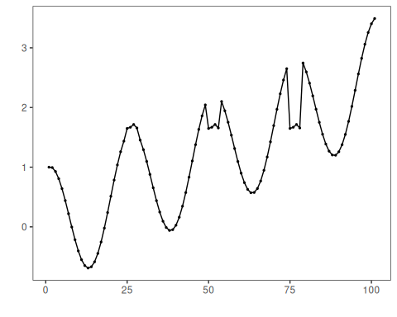

Configure the Method
The choices below turn the central modeling idea into concrete parameters. They matter because sAX motif discovery: SAX (Symbolic Aggregate approXimation) discretizes z-normalized subsequences into symbolic words using breakpoints derived from a Gaussian distribution, so each argument controls how strongly the method will emphasize that pattern when it later produces motif candidates.
# Configure SAX-based motif discovery (alphabet=26, word=3, min occurrences=3)
model <- hmo_sax(26, 3, 3)
# Fit the detector (learns binning thresholds)
set_example_seed()
model <- fit(model, dataset$serie)

Run the Core Analysis
This is the moment where the notebook tests its central assumption on actual data. After applying hmo_sax(a, w, qtd), the important question is whether the resulting motif candidates really correspond to the pattern implied by the method description above, rather than to arbitrary numerical variation.
# Run motif discovery
detection <- detect(model, dataset$serie)
# Show detected motif starts
print(detection |> dplyr::filter(event == TRUE))
## idx event type seq seqlen
## 1 25 TRUE motif QST 3
## 2 50 TRUE motif QST 3
## 3 75 TRUE motif QST 3

Evaluate What Was Found
The evaluation asks whether the motif candidates produced by hmo_sax(a, w, qtd) match the labeled structure on this dataset. Read the scores as evidence about the method’s assumptions in practice, not as detached summary numbers.
# Evaluate detections against labels
evaluation <- evaluate(model, detection$event, dataset$event)
print(evaluation$confMatrix)
## event
## detection TRUE FALSE
## TRUE 3 0
## FALSE 0 98

Interpret the Result Visually
This visual check puts the model output back on top of the original signal. What matters now is whether the highlighted motif candidates line up with the structure suggested by the method, which is the real semantic test of whether the example is teaching the right lesson.
# Plot motifs and ground truth
har_plot(model, dataset$serie, detection, dataset$event)
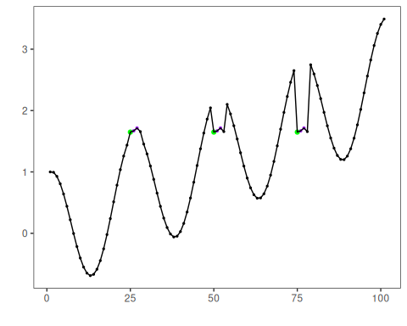

References
- Lin, J., Keogh, E., Lonardi, S., Chiu, B. (2007). A symbolic representation of time series, with implications for streaming algorithms. Data Mining and Knowledge Discovery, 15, 107-144.

