Objective
AMOC (At Most One Change) detects a single, most significant change point in a univariate time series. In this tutorial we will:
- Load a synthetic dataset with ground-truth change points
- Visualize the series
- Configure and run the AMOC detector (hcp_amoc)
- Inspect detections and evaluate against ground truth
- Plot the detections over the series

Method at a glance
AMOC: AMOC targets a single most significant change point in a univariate series by optimizing a cost function over all possible change locations. It is appropriate when at most one structural break is expected. This wraps the AMOC method from the changepoint package.

What you will do
- understand the purpose of the example and when the technique is useful
- follow the workflow from data loading to model fitting and detection
- inspect the evaluation outputs and the diagnostic plots produced by Harbinger

Prepare the Example
This setup anchors the notebook in the specific series used to examine hcp_amoc. The semantic point is the one stated above: aMOC: AMOC targets a single most significant change point in a univariate series by optimizing a cost function over all possible change locations, so the raw signal needs to be visible before any fitting step hides that structure behind model output.
source(url("https://raw.githubusercontent.com/cefet-rj-dal/harbinger/master/examples/seed.R"))
# Install Harbinger (if needed)
#install.packages("harbinger")
# Load required packages
library(daltoolbox)
library(harbinger)
# Load example change-point datasets
data(examples_changepoints)
# Select a dataset ("complex" contains multiple regimes)
dataset <- examples_changepoints$complex
head(dataset)
## serie event
## 1 0.3129618 FALSE
## 2 0.5944808 FALSE
## 3 0.8162731 FALSE
## 4 0.9560557 FALSE
## 5 0.9997847 FALSE
## 6 0.9430667 FALSE

Interpret the Result Visually
This first visual pass establishes what the method should react to in the raw series. Keep the method summary in mind here, because aMOC: AMOC targets a single most significant change point in a univariate series by optimizing a cost function over all possible change locations and the plot tells you whether that structure is clean, weak, local, repeated, or mixed with other effects.
# Plot the time series to visualize regime changes
har_plot(harbinger(), dataset$serie)
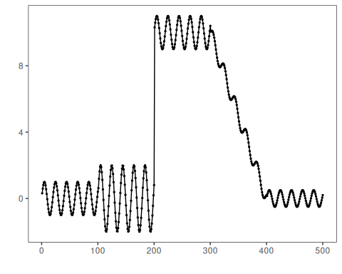

Configure the Method
The choices below turn the central modeling idea into concrete parameters. They matter because aMOC: AMOC targets a single most significant change point in a univariate series by optimizing a cost function over all possible change locations, so each argument controls how strongly the method will emphasize that pattern when it later produces change-point candidates.
# Configure the AMOC change-point detector (single change)
model <- hcp_amoc()
# Fit the detector (no training required, keeps parameters on object)
set_example_seed()
model <- fit(model, dataset$serie)

Run the Core Analysis
This is the moment where the notebook tests its central assumption on actual data. After applying hcp_amoc, the important question is whether the resulting change-point candidates really correspond to the pattern implied by the method description above, rather than to arbitrary numerical variation.
# Run detection over the full series
detection <- detect(model, dataset$serie)
# Show detected change-point indices
print(detection |> dplyr::filter(event == TRUE))
## idx event type
## 1 389 TRUE changepoint

Evaluate What Was Found
The evaluation asks whether the change-point candidates produced by hcp_amoc match the labeled structure on this dataset. Read the scores as evidence about the method’s assumptions in practice, not as detached summary numbers.
# Evaluate detections against the labeled events
evaluation <- evaluate(model, detection$event, dataset$event)
print(evaluation$confMatrix)
## event
## detection TRUE FALSE
## TRUE 0 1
## FALSE 4 495

Interpret the Result Visually
This visual check puts the model output back on top of the original signal. What matters now is whether the highlighted change-point candidates line up with the structure suggested by the method, which is the real semantic test of whether the example is teaching the right lesson.
# Plot detections and ground truth on top of the series
har_plot(model, dataset$serie, detection, dataset$event)
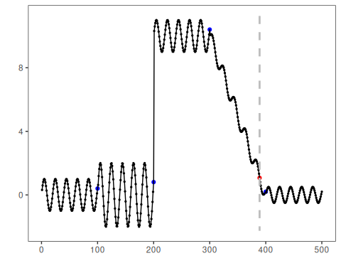

References
- Hinkley, D. V. (1970). Inference about the change-point in a sequence of random variables. Biometrika, 57(1), 1-17. doi:10.1093/biomet/57.1.1
- Killick, R., Fearnhead, P., Eckley, I. A. (2012). Optimal detection of changepoints with a linear computational cost. Journal of the American Statistical Association, 107(500), 1590-1598.

