Objective
The goal of this notebook is to present a complete Harbinger workflow: loading an example dataset, configuring the method used in the notebook, running the analysis, and interpreting the resulting outputs and plots.

Method at a glance
This notebook provides quick end-to-end demonstrations of the default harbinger() pipeline across diverse datasets (nonstationarity, global temperature monthly/yearly, multivariate, and weather). For each dataset we: fit the default pipeline, run detection, and plot detections over the series. The goal is to illustrate Harbinger’s unified interface for anomalies, change points, and motifs, and how it builds on DAL Toolbox models.

What you will do
- understand the purpose of the example and when the technique is useful
- follow the workflow from data loading to model fitting and detection
- inspect the evaluation outputs and the diagnostic plots produced by Harbinger

Prepare the Example
This setup anchors the notebook in the specific series used to examine harbinger(). The semantic point is the one stated above: this notebook provides quick end-to-end demonstrations of the default harbinger() pipeline across diverse datasets (nonstationarity, global temperature monthly/yearly, multivariate, and weather), so the raw signal needs to be visible before any fitting step hides that structure behind model output.
source(url("https://raw.githubusercontent.com/cefet-rj-dal/harbinger/master/examples/seed.R"))
# Install Harbinger (only once, if needed)
#install.packages("harbinger")
# Load required packages
library(daltoolbox)
library(harbinger)

Configure the Method
The choices below turn the central modeling idea into concrete parameters. They matter because this notebook provides quick end-to-end demonstrations of the default harbinger() pipeline across diverse datasets (nonstationarity, global temperature monthly/yearly, multivariate, and weather), so each argument controls how strongly the method will emphasize that pattern when it later produces workflow outputs.
# Load example datasets bundled with harbinger
data(examples_harbinger)
model <- harbinger()
# Example: nonstationarity time series
dataset <- examples_harbinger$nonstationarity
set_example_seed()
model <- fit(model, dataset$serie)
detection <- detect(model, dataset$serie)
har_plot(model, dataset$serie, detection, dataset$event)
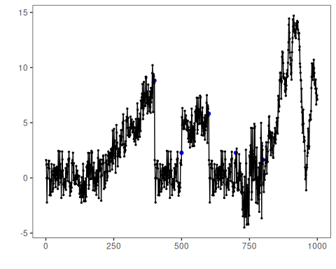
# Example: global temperature (yearly)
dataset <- examples_harbinger$global_temperature_yearly
set_example_seed()
model <- fit(model, dataset$serie)
detection <- detect(model, dataset$serie)
har_plot(model, dataset$serie, detection, dataset$event)
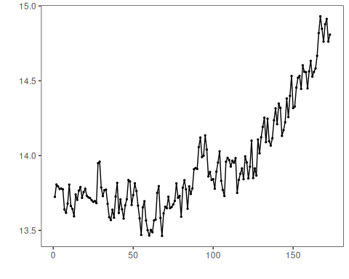
# Example: global temperature (monthly)
dataset <- examples_harbinger$global_temperature_monthly
set_example_seed()
model <- fit(model, dataset$serie)
detection <- detect(model, dataset$serie)
har_plot(model, dataset$serie, detection, dataset$event)
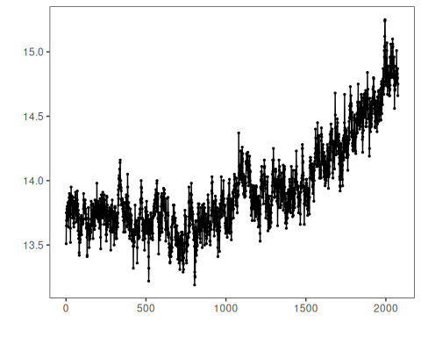
# Example: multidimensional time series
dataset <- examples_harbinger$multidimensional
set_example_seed()
model <- fit(model, dataset$serie)
detection <- detect(model, dataset$serie)
har_plot(model, dataset$serie, detection, dataset$event)
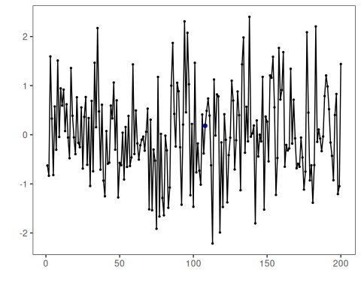
set_example_seed()
model <- fit(model, dataset$x)
detection <- detect(model, dataset$x)
har_plot(model, dataset$x, detection, dataset$event)
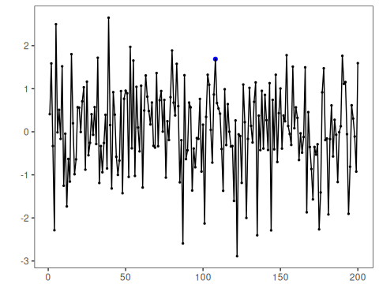
# Example: Seattle weekly temperature time series
dataset <- examples_harbinger$seattle_week
set_example_seed()
model <- fit(model, dataset$serie)
detection <- detect(model, dataset$serie)
har_plot(model, dataset$serie, detection, dataset$event)
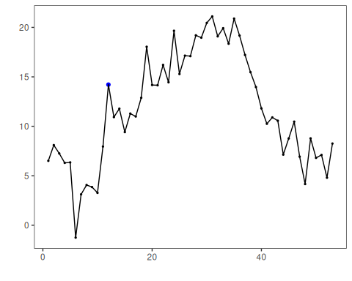
# Example: Seattle daily temperature time series
dataset <- examples_harbinger$seattle_daily
set_example_seed()
model <- fit(model, dataset$serie)
detection <- detect(model, dataset$serie)
har_plot(model, dataset$serie, detection, dataset$event)
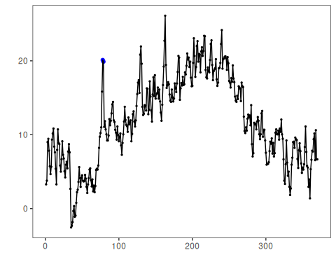

References
- Ogasawara, E., Salles, R., Porto, F., Pacitti, E. Event Detection in Time Series. Springer, 2025. doi:10.1007/978-3-031-75941-3
- DAL Toolbox documentation: https://cefet-rj-dal.github.io/daltoolbox/

