Objective
The goal of this notebook is to present a complete Harbinger workflow: loading an example dataset, configuring the method used in the notebook, running the analysis, and interpreting the resulting outputs and plots.

Method at a glance
This notebook illustrates typical change-point scenarios (single break, multiple breaks, variance/volatility shifts) and how Harbinger visualizes detected change locations. We use the unified pipeline to fit, detect, and plot across datasets, highlighting when classic (AMOC/BinSeg/PELT) or regression-based (GFT/Chow) approaches are appropriate.

What you will do
- understand the purpose of the example and when the technique is useful
- follow the workflow from data loading to model fitting and detection
- inspect the evaluation outputs and the diagnostic plots produced by Harbinger

Prepare the Example
This setup anchors the notebook in the specific series used to examine harbinger(). The semantic point is the one stated above: this notebook illustrates typical change-point scenarios (single break, multiple breaks, variance/volatility shifts) and how Harbinger visualizes detected change locations, so the raw signal needs to be visible before any fitting step hides that structure behind model output.
source(url("https://raw.githubusercontent.com/cefet-rj-dal/harbinger/master/examples/seed.R"))
# Install Harbinger (if needed)
#install.packages("harbinger")
# Load required packages
library(daltoolbox)
library(harbinger)

Configure the Method
The choices below turn the central modeling idea into concrete parameters. They matter because this notebook illustrates typical change-point scenarios (single break, multiple breaks, variance/volatility shifts) and how Harbinger visualizes detected change locations, so each argument controls how strongly the method will emphasize that pattern when it later produces workflow outputs.
# Load change-point example datasets and create a base object
data(examples_changepoints)
model <- harbinger()
# Simple change point
dataset <- examples_changepoints$simple
set_example_seed()
model <- fit(model, dataset$serie)
detection <- detect(model, dataset$serie)
har_plot(model, dataset$serie, detection, dataset$event)
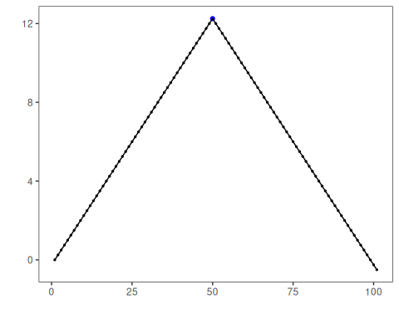
# Sinusoidal pattern with regime shift
dataset <- examples_changepoints$sinusoidal
set_example_seed()
model <- fit(model, dataset$serie)
detection <- detect(model, dataset$serie)
har_plot(model, dataset$serie, detection, dataset$event)
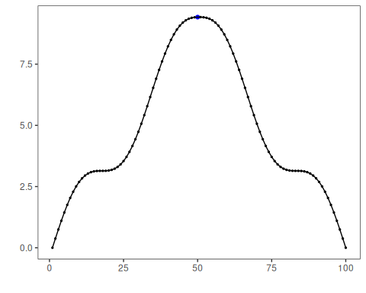
# Incremental trend changes
dataset <- examples_changepoints$incremental
set_example_seed()
model <- fit(model, dataset$serie)
detection <- detect(model, dataset$serie)
har_plot(model, dataset$serie, detection, dataset$event)
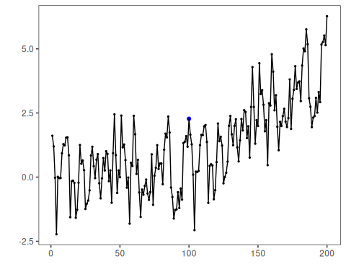
# Abrupt level shift
dataset <- examples_changepoints$abrupt
set_example_seed()
model <- fit(model, dataset$serie)
detection <- detect(model, dataset$serie)
har_plot(model, dataset$serie, detection, dataset$event)
## Don't know how to automatically pick scale for object of type <ts>. Defaulting to continuous.
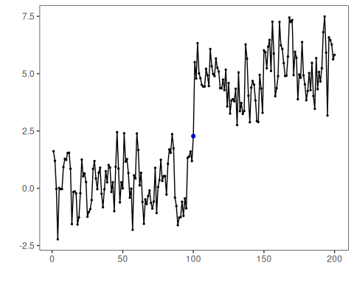
# Volatility (variance) change
dataset <- examples_changepoints$volatility
set_example_seed()
model <- fit(model, dataset$serie)
detection <- detect(model, dataset$serie)
har_plot(model, dataset$serie, detection, dataset$event)
## Don't know how to automatically pick scale for object of type <ts>. Defaulting to continuous.
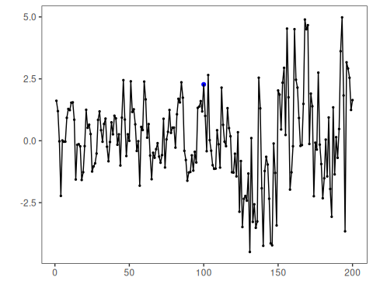
# Increasing amplitude
dataset <- examples_changepoints$increasing_amplitude
set_example_seed()
model <- fit(model, dataset$serie)
detection <- detect(model, dataset$serie)
har_plot(model, dataset$serie, detection, dataset$event)
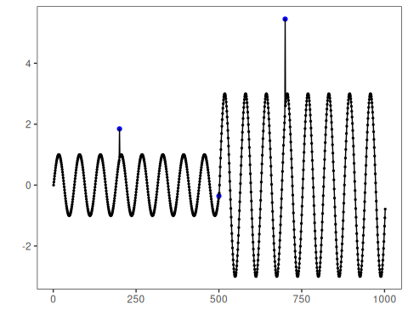
# Complex multi-regime series
dataset <- examples_changepoints$complex
set_example_seed()
model <- fit(model, dataset$serie)
detection <- detect(model, dataset$serie)
har_plot(model, dataset$serie, detection, dataset$event)
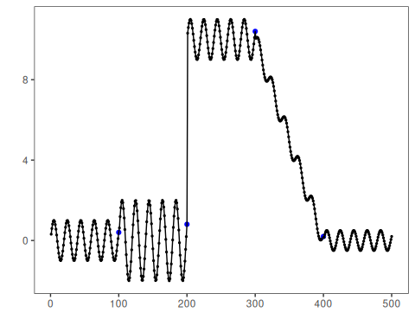

References
- Hinkley, D. V. (1970). Inference about the change-point in a sequence of random variables. Biometrika, 57(1), 1-17.
- Killick, R., Fearnhead, P., Eckley, I. A. (2012). Optimal detection of changepoints with a linear computational cost. JASA, 107(500), 1590-1598.
- Zeileis, A., Leisch, F., Kleiber, C., Hornik, K. (2002). strucchange: An R package for testing for structural change in linear regression models. JSS, 7(2). doi:10.18637/jss.v007.i02

