Objective
The goal of this notebook is to present a complete Harbinger workflow: loading an example dataset, configuring the method used in the notebook, running the analysis, and interpreting the resulting outputs and plots.

Method at a glance
SoftED provides soft evaluation by matching detections to ground truth within tolerance windows and assigning partial credit. This notebook shows how to compute both hard and soft metrics and when soft evaluation is more appropriate (e.g., temporal uncertainty around event onset).

What you will do
- understand the purpose of the example and when the technique is useful
- follow the workflow from data loading to model fitting and detection
- inspect the evaluation outputs and the diagnostic plots produced by Harbinger
Contract note - In this workflow, hanr_ml() already forces the wrapped predict() result to a plain vector before residual scoring.

Prepare the Example
This setup anchors the notebook in the specific series used to examine har_eval_soft(). The semantic point is the one stated above: softED provides soft evaluation by matching detections to ground truth within tolerance windows and assigning partial credit, so the raw signal needs to be visible before any fitting step hides that structure behind model output.
source(url("https://raw.githubusercontent.com/cefet-rj-dal/harbinger/master/examples/seed.R"))
# Install Harbinger (if needed)
#install.packages("harbinger")
# Load required packages
library(daltoolbox)
library(harbinger)
# Load example anomaly datasets
data(examples_anomalies)
# Select a simple anomaly dataset
dataset <- examples_anomalies$simple
head(dataset)
## serie event
## 1 1.0000000 FALSE
## 2 0.9689124 FALSE
## 3 0.8775826 FALSE
## 4 0.7316889 FALSE
## 5 0.5403023 FALSE
## 6 0.3153224 FALSE

Interpret the Result Visually
This first visual pass establishes what the method should react to in the raw series. Keep the method summary in mind here, because softED provides soft evaluation by matching detections to ground truth within tolerance windows and assigning partial credit and the plot tells you whether that structure is clean, weak, local, repeated, or mixed with other effects.
# Plot the raw time series
har_plot(harbinger(), dataset$serie)
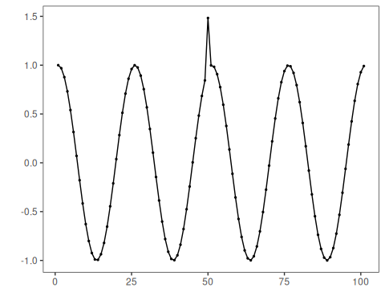

Configure the Method
The choices below turn the central modeling idea into concrete parameters. They matter because softED provides soft evaluation by matching detections to ground truth within tolerance windows and assigning partial credit, so each argument controls how strongly the method will emphasize that pattern when it later produces evaluation outputs.
# Configure a simple MLP regressor-based anomaly detector
model <- hanr_ml(tspredit::ts_mlp(tspredit::ts_norm_gminmax(), input_size = 5, size = 3, decay = 0))
# Fit the detector
set_example_seed()
model <- fit(model, dataset$serie)

Run the Core Analysis
This is the moment where the notebook tests its central assumption on actual data. After applying har_eval_soft(), the important question is whether the resulting evaluation outputs really correspond to the pattern implied by the method description above, rather than to arbitrary numerical variation.
# Run detection
detection <- detect(model, dataset$serie)
# Inspect detected anomaly indices
print(detection |> dplyr::filter(event == TRUE))
## idx event type
## 1 50 TRUE anomaly

Evaluate What Was Found
The evaluation asks whether the evaluation outputs produced by har_eval_soft() match the labeled structure on this dataset. Read the scores as evidence about the method’s assumptions in practice, not as detached summary numbers.
# Hard evaluation
evaluation <- evaluate(model, detection$event, dataset$event, evaluation = har_eval())
print(evaluation$confMatrix)
## event
## detection TRUE FALSE
## TRUE 1 0
## FALSE 0 100
# Soft evaluation (SoftED) with tolerance window sw_size = 5
result <- evaluate(model, detection$event, dataset$event, evaluation = har_eval_soft(sw_size = 5))
print(result$confMatrix)
## event
## detection TRUE FALSE
## TRUE 1 0
## FALSE 0 100
# Evaluation can also be performed directly without a model object
result <- evaluate(har_eval_soft(sw_size = 5), detection$event, dataset$event)
print(result$confMatrix)
## event
## detection TRUE FALSE
## TRUE 1 0
## FALSE 0 100

References
- Salles, R., Lima, J., Reis, M., Coutinho, R., Pacitti, E., Masseglia, F., Akbarinia, R., Chen, C., Garibaldi, J., Porto, F., Ogasawara, E. (2024). SoftED: Metrics for soft evaluation of time series event detection. Computers and Industrial Engineering. doi:10.1016/j.cie.2024.110728

