Objective
XSAX extends SAX to a larger alphanumeric alphabet, enabling finer symbolic resolution for motif discovery. In this tutorial we:
- Load and visualize a motif dataset
- Configure hmo_xsax(a, w, qtd) and run detection
- Inspect and evaluate motif occurrences

Method at a glance
XSAX motif discovery: XSAX extends SAX to a larger alphanumeric alphabet, allowing finer symbolic resolution. Motifs are frequent symbolic words or closely related patterns.

What you will do
- understand the purpose of the example and when the technique is useful
- follow the workflow from data loading to model fitting and detection
- inspect the evaluation outputs and the diagnostic plots produced by Harbinger

Prepare the Example
This setup anchors the notebook in the specific series used to examine hmo_xsax(a, w, qtd). The semantic point is the one stated above: xSAX motif discovery: XSAX extends SAX to a larger alphanumeric alphabet, allowing finer symbolic resolution, so the raw signal needs to be visible before any fitting step hides that structure behind model output.
source(url("https://raw.githubusercontent.com/cefet-rj-dal/harbinger/master/examples/seed.R"))
# Install Harbinger (if needed)
#install.packages("harbinger")
# Load required packages
library(daltoolbox)
library(harbinger)
# Load example motif datasets
data(examples_motifs)
# Select the simple motif dataset
dataset <- examples_motifs$simple
head(dataset)
## serie event
## 1 1.0000000 FALSE
## 2 0.9939124 FALSE
## 3 0.9275826 FALSE
## 4 0.8066889 FALSE
## 5 0.6403023 FALSE
## 6 0.4403224 FALSE

Interpret the Result Visually
This first visual pass establishes what the method should react to in the raw series. Keep the method summary in mind here, because xSAX motif discovery: XSAX extends SAX to a larger alphanumeric alphabet, allowing finer symbolic resolution and the plot tells you whether that structure is clean, weak, local, repeated, or mixed with other effects.
# Plot the raw time series
har_plot(harbinger(), dataset$serie)
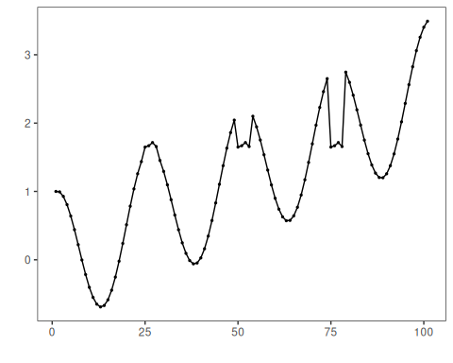

Configure the Method
The choices below turn the central modeling idea into concrete parameters. They matter because xSAX motif discovery: XSAX extends SAX to a larger alphanumeric alphabet, allowing finer symbolic resolution, so each argument controls how strongly the method will emphasize that pattern when it later produces motif candidates.
# Configure XSAX motif discovery (alphabet=37, word=3, min occurrences=3)
model <- hmo_xsax(37, 3, 3)
# Fit the detector (learns binning thresholds)
set_example_seed()
model <- fit(model, dataset$serie)

Run the Core Analysis
This is the moment where the notebook tests its central assumption on actual data. After applying hmo_xsax(a, w, qtd), the important question is whether the resulting motif candidates really correspond to the pattern implied by the method description above, rather than to arbitrary numerical variation.
# Run motif discovery
detection <- detect(model, dataset$serie)
# Show detected motif starts
print(detection |> dplyr::filter(event == TRUE))
## idx event type seq seqlen
## 1 25 TRUE motif 0N0P0R 3
## 2 50 TRUE motif 0N0P0R 3
## 3 75 TRUE motif 0N0P0R 3

Evaluate What Was Found
The evaluation asks whether the motif candidates produced by hmo_xsax(a, w, qtd) match the labeled structure on this dataset. Read the scores as evidence about the method’s assumptions in practice, not as detached summary numbers.
# Evaluate detections against labels
evaluation <- evaluate(model, detection$event, dataset$event)
print(evaluation$confMatrix)
## event
## detection TRUE FALSE
## TRUE 3 0
## FALSE 0 98

Interpret the Result Visually
This visual check puts the model output back on top of the original signal. What matters now is whether the highlighted motif candidates line up with the structure suggested by the method, which is the real semantic test of whether the example is teaching the right lesson.
# Plot motifs and ground truth
har_plot(model, dataset$serie, detection, dataset$event)
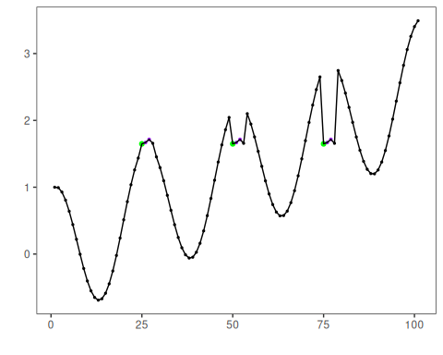

References
- Ogasawara, E., Salles, R., Porto, F., Pacitti, E. Event Detection in Time Series. Springer, 2025. doi:10.1007/978-3-031-75941-3

