Objective
This notebook explains how to use mas() as a simple moving-average transformation for time series. The goal is to help the reader understand what the smoother does, how the order parameter changes the result, and why smoothing can be useful before downstream tasks such as change-point detection.

Method at a glance
mas() computes a simple moving average. Each output point is the average of a local window of consecutive observations. As a transformation, it reduces short-term noise and makes broader movement patterns easier to inspect.

What you will do
- load an example time series
- inspect the original series
- compute moving-average smoothers with different window sizes
- compare the original and smoothed versions visually
- understand the trade-off between smoothness and temporal detail
- see why smoothing is often used before a modeling step

Prepare the Example
This setup anchors the notebook in the specific series used to examine 01-smoothing-mas. The semantic point is the one stated above: mas() computes a simple moving average, so the raw signal needs to be visible before any fitting step hides that structure behind model output.
source(url("https://raw.githubusercontent.com/cefet-rj-dal/harbinger/master/examples/seed.R"))
# Install Harbinger (if needed)
#install.packages("harbinger")
# Load required packages
library(harbinger)
# Load example change-point datasets
data(examples_changepoints)
# Select a simple change-point dataset
dataset <- examples_changepoints$simple
head(dataset)
## serie event
## 1 0.00 FALSE
## 2 0.25 FALSE
## 3 0.50 FALSE
## 4 0.75 FALSE
## 5 1.00 FALSE
## 6 1.25 FALSE

Interpret the Result Visually
This first visual pass establishes what the method should react to in the raw series. Keep the method summary in mind here, because mas() computes a simple moving average and the plot tells you whether that structure is clean, weak, local, repeated, or mixed with other effects.
# Plot the original time series
har_plot(harbinger(), dataset$serie, event = dataset$event)
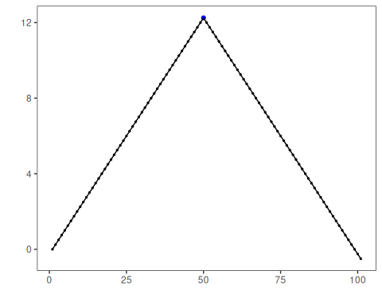

Configure the Method
The choices below turn the central modeling idea into concrete parameters. They matter because mas() computes a simple moving average, so each argument controls how strongly the method will emphasize that pattern when it later produces transformed outputs.
# Compute smoothers with two different window sizes
ma_5 <- mas(dataset$serie, order = 5)
ma_15 <- mas(dataset$serie, order = 15)
# Inspect the first smoothed values
head(ma_5)
## Time Series:
## Start = 1
## End = 6
## Frequency = 1
## [1] 0.50 0.75 1.00 1.25 1.50 1.75
head(ma_15)
## Time Series:
## Start = 1
## End = 6
## Frequency = 1
## [1] 1.75 2.00 2.25 2.50 2.75 3.00

Interpret the Result Visually
This visual check puts the model output back on top of the original signal. What matters now is whether the highlighted transformed outputs line up with the structure suggested by the method, which is the real semantic test of whether the example is teaching the right lesson.
# Plot the 5-point moving average
har_plot(
harbinger(),
as.numeric(ma_5),
event = dataset$event[5:length(dataset$event)]
)
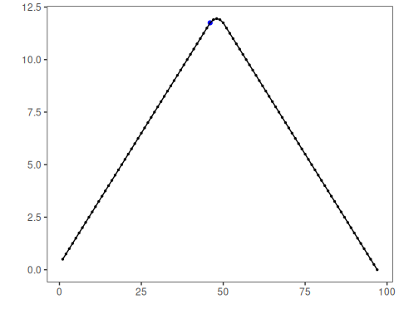
# Plot the 15-point moving average
har_plot(
harbinger(),
as.numeric(ma_15),
event = dataset$event[15:length(dataset$event)]
)
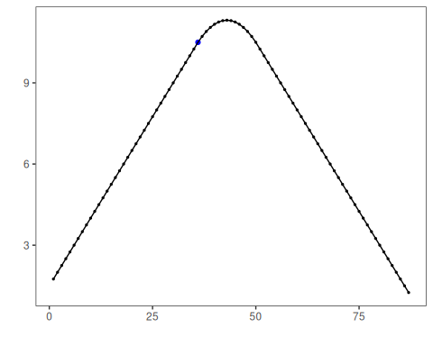

References
- Shumway, R. H., Stoffer, D. S. Time Series Analysis and Its Applications. Springer.

