Objective
This notebook demonstrates anomaly detection with an adversarial autoencoder (han_autoencoder(..., autoenc_adv_ed, ...)). The model learns a robust latent representation; anomalies yield higher reconstruction error. Steps: load packages/data, visualize, define the architecture/epochs, fit, detect, evaluate, and plot.

Method at a glance
Adversarial Autoencoder (encode-decode): An adversarial autoencoder (AAE) augments a standard encoder-decoder with an adversarial objective on the latent code. The encoder maps each input window into a latent vector and the decoder attempts to reconstruct the original window. In parallel, a discriminator is trained to distinguish latent samples produced by the encoder from samples drawn from a chosen prior distribution (e.g., Gaussian). The encoder is trained to fool the discriminator, aligning the aggregated posterior of the latent space with the prior. This regularization encourages the model to represent normal time-series patterns on a compact manifold and to reconstruct them well. Windows that deviate from this learned manifold (anomalies) typically yield larger reconstruction errors. In this example, windows are scored by reconstruction error and events are flagged when the score exceeds a learned threshold.

What you will do
- understand the purpose of the example and when the technique is useful
- follow the workflow from data loading to model fitting and detection
- inspect the evaluation outputs and the diagnostic plots produced by Harbinger

Prepare the Example
This setup anchors the notebook in the specific series used to examine han_autoencoder(..., autoenc_adv_ed, ...). The semantic point is the one stated above: adversarial Autoencoder (encode-decode): An adversarial autoencoder (AAE) augments a standard encoder-decoder with an adversarial objective on the latent code, so the raw signal needs to be visible before any fitting step hides that structure behind model output.
# Install Harbinger (only once, if needed)
#install.packages("harbinger")
# Load required packages
library(daltoolbox)
library(daltoolboxdp)
library(harbinger)
# Load example datasets bundled with harbinger
data(examples_anomalies)
# Select a simple synthetic time series with labeled anomalies
dataset <- examples_anomalies$simple
head(dataset)
## serie event
## 1 1.0000000 FALSE
## 2 0.9689124 FALSE
## 3 0.8775826 FALSE
## 4 0.7316889 FALSE
## 5 0.5403023 FALSE
## 6 0.3153224 FALSE

Interpret the Result Visually
This first visual pass establishes what the method should react to in the raw series. Keep the method summary in mind here, because adversarial Autoencoder (encode-decode): An adversarial autoencoder (AAE) augments a standard encoder-decoder with an adversarial objective on the latent code and the plot tells you whether that structure is clean, weak, local, repeated, or mixed with other effects.
# Plot the time series
har_plot(harbinger(), dataset$serie)
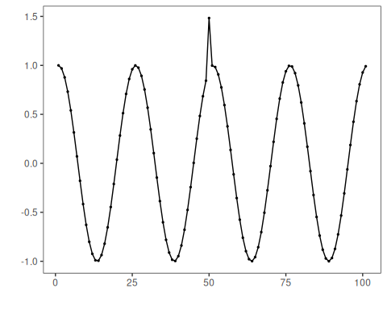

Configure the Method
The choices below turn the central modeling idea into concrete parameters. They matter because adversarial Autoencoder (encode-decode): An adversarial autoencoder (AAE) augments a standard encoder-decoder with an adversarial objective on the latent code, so each argument controls how strongly the method will emphasize that pattern when it later produces reconstruction-based anomaly flags.
# Define adversarial autoencoder-based detector (autoenc_adv_ed)
model <- han_autoencoder(3, 2, autoenc_adv_ed, epochs = 100)
# Fit the model
model <- fit(model, dataset$serie)

Run the Core Analysis
This is the moment where the notebook tests its central assumption on actual data. After applying han_autoencoder(..., autoenc_adv_ed, ...), the important question is whether the resulting reconstruction-based anomaly flags really correspond to the pattern implied by the method description above, rather than to arbitrary numerical variation.
# Detect anomalies (reconstruction error -> events)
detection <- detect(model, dataset$serie)
# Show only timestamps flagged as events
print(detection |> dplyr::filter(event==TRUE))
## [1] idx event type
## <0 rows> (or 0-length row.names)

Evaluate What Was Found
The evaluation asks whether the reconstruction-based anomaly flags produced by han_autoencoder(..., autoenc_adv_ed, ...) match the labeled structure on this dataset. Read the scores as evidence about the method’s assumptions in practice, not as detached summary numbers.
# Evaluate detections against ground-truth labels
evaluation <- evaluate(model, detection$event, dataset$event)
print(evaluation$confMatrix)
## event
## detection TRUE FALSE
## TRUE 0 0
## FALSE 1 100

Interpret the Result Visually
This visual check puts the model output back on top of the original signal. What matters now is whether the highlighted reconstruction-based anomaly flags line up with the structure suggested by the method, which is the real semantic test of whether the example is teaching the right lesson.
# Plot detections over the series
har_plot(model, dataset$serie, detection, dataset$event)
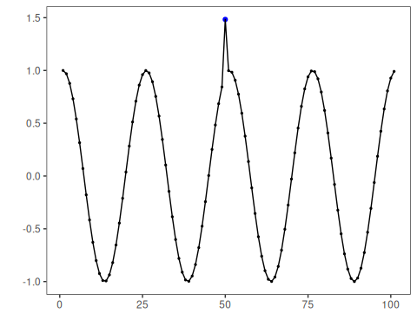
# Plot residual scores and threshold
har_plot(model, attr(detection, "res"), detection, dataset$event, yline = attr(detection, "threshold"))
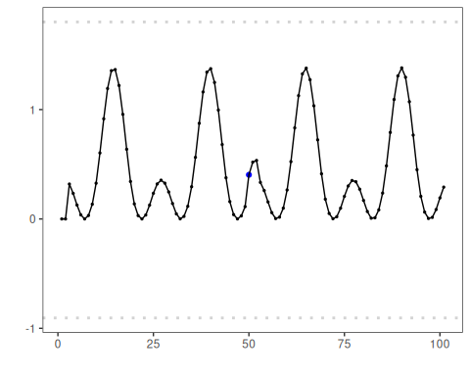

References
- Makhzani, A., Shlens, J., Jaitly, N., Goodfellow, I., & Frey, B. (2016). Adversarial Autoencoders. arXiv:1511.05644.
- Chalapathy, R., & Chawla, S. (2019). Deep Learning for Anomaly Detection: A Survey. arXiv:1901.03407.

